DecisionWorks

Product reference manual

**Title:**

**Subtitle:**

Contents

1. Configure Settings 3

Manage Settings 3

Manage File Upload 4

2. Design Reports 7

Data source Definition 7

Functional Area Configuration 10

Functional Area – Analysis Configuration 11

Enterprise Reports 16

Viewing the enterprise reports list 16

Creating Enterprise Reports 18

Designing enterprise reports 29

Adhoc Report 65

Creation of Adhoc Reports 65

Creating reports using Stored Procedures 65

Creating reports using Views 74

Creating reports using Queries 78

Configure a Drill down report 86

Enabling Pivot Grid 119

Analytical Report 120

AR – ER Drill through Configuration 148

3. Package Reports 150

4. Deploy Reports 151

Import to componentized RDW 151

Import to Classic RDW 151

5. Security 152

Specify Report Permissions 152

Specify Data Security 155

6. Manage Reports 159

7. Schedule Report 164

Manage Schedule 164

Schedule Report 166

View Schedule 170

# Configure Settings

## Manage Settings

This UI list the general settings for the different categories. The settings are classified as follows,

* Optional Settings, the user can enable or disable these settings.
* User Defined Settings, the user can specify the value for these settings.

The UI can be launched with the menu sequence as follows.

#### 

#### 

Specify the following fields to search for a report:

***Category*** Select the type of the Category.

The system displays the settings of the category chosen as follows,

**Optional Settings:**

***Category*** List the category type.

***Property Name*** List the optional settings for the selected category.

***Map***  Specifies the setting is enabled or not.

**User Defined Settings:**

***Category*** List the category type.

***Property Name*** List the user defined settings for the selected category.

***Value***  Specifies the value (user defined) for the setting.

***Accepted Values*** List the possible values for the settings, if any.

Click the **SAVE** button to save the specified value for the Optional and User Defined settings.

## Manage File Upload

The user can upload the following files to the server. Also download/update/delete the files already uploaded.

* Google Cloud Print Files (*.p12).
* Digital Signatures Files (*.pfx).

The UI can be launched with the menu sequence as follows.

### Google Cloud Print Files (*.p12):

Google Cloud Print helps to connect to various printers over the web. You may print any type of application using any web-connected devices like phones, tablet, PCs, etc., using a GCP Account. The GCP files uploaded here will be available under ***Printer Settings*** *in* ***Schedule Report***UI to print a report while scheduling.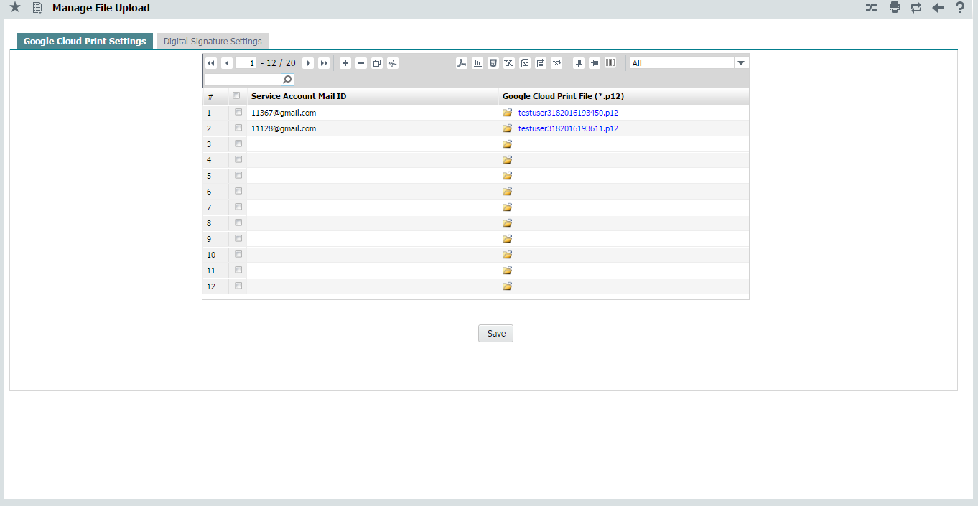

On screen launch, the system displays the following fields:

Service Account Mail Id The Service Account Mail ID configured to the printer for cloud printing.

Google Cloud Print File (*.p12) The GCP file associated to the service account mail id specified. Click the  icon to launch the upload window & upload file. Click the file name to download the file.

Click the **SAVE** button to save GCP Details.

### Digital Signature Files (*.pfx):

A digital signature is an electronic form of a signature that can be used to authenticate the identity of the sender of a message or the signer of a document, and also ensure that the original content of the message or document that has been sent is unchanged. Digital signatures are easily transportable and cannot be imitated by someone else. The Certificate files uploaded here will be available under ***Digital Signature*** in ***Report Settings*** *UI* during***Report Configuration****,* to enable digital signature for a report.

#### 

On screen launch, the system displays the following fields:

Digital Signature Name The Unique name to identify the Digital Signature.

***Certificate File (*.pfx)*** The Certificate file used to sign the document digitally.

Click the  icon to launch the upload window & upload file. Click the filename to download the file.

Password Password of the certificate.

Reason Specifies the reason.

Location Specifies the Location.

Is Visible Specifies the visibility of the Digital Signature.

Is Default Specifies whether the signature is default. Only one Digital Signature can be set to default among the list.

Signature Page Position Position of the Digital Signature in the page.

Position X Specify the x axis position of the Digital Signature.

Position Y Specify the y axis position of the Digital Signature.

Height Height of the Digital Signature.

Width Width of the Digital Signature.

Digital Signatory Name of the Digital Signatory.

Click the SAVE button to save the Digital Signature details.

### Upload Files:

Browse the file and click upload button. File will be uploaded to server, in the path configured, with the system generated file id as shown below.

**SystemGeneratedFileID:** UserName + TimeStamp(DDMMYYYYHHMMSS).

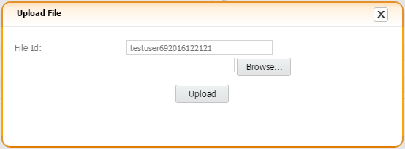

# 

# 2. Design Reports

## Data source Definition

**Prerequisite Tasks**

Database server should have been configured

**Overview of configuring data source**

This activity facilitates the user to create a reference to a data source in the application from where various reports can be launched. The data sources can be of type, namely, Database. The name of the provider and server details for the selected data source can be entered here. The Database option is applicable for Enterprise reports.

Depending on your security rights, you can add, modify or delete data source details. Data sources can be deleted only if they are not used in any report configuration.

### Viewing the data source

Select the **DW Report Configuration** option under the **DW Report Design** submenu from the **Design process** menu.



This page displays a list of existing data sources in drop down list.

The system displays the Data source Configuration page on the left pane as shown below:

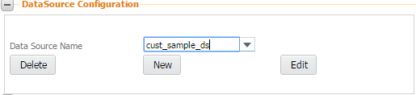

### Creating a data source

**To define a new data source, click the New button.**

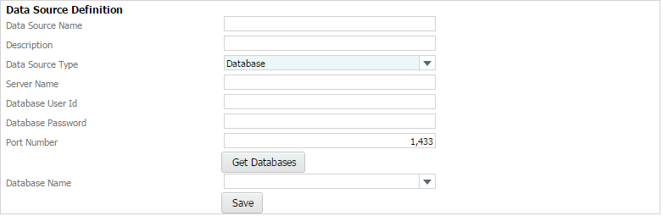

Enter the following fields in the right pane:

Data Source Name A unique name assigned to a data source. Mandatory.

Description The description of the data source.

Data Source Type Select the type of data source from the drop-down list box. The system displays “Database”.

Server Name The name of the database server .Mandatory

Database User Id A unique ID assigned to a user for the database server. Mandatory

Database Password The password for the user ID for the database server.

Port Number The port number for connecting to the data source. Mandatory

**Click the Get Databases button to get the database details.**

**Database Name** The system displays all databases in the drop-down list box.

Click the **Save** button to save the data source details.

### Edit the data source

Choose **Data Source name** from drop-down list box and Click the **Edit button** to modify the data source detail.

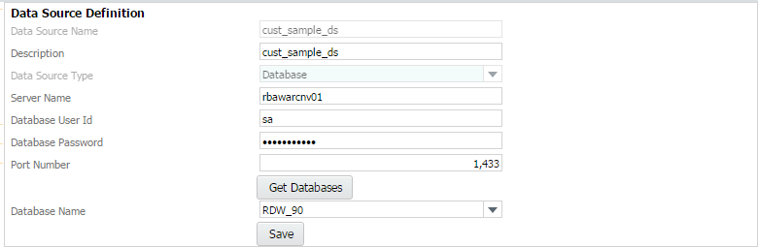

To modify the following fields:

Description The description of the data source.

Server Name The name of the database server .Mandatory

Database User Id A unique ID assigned to a user for the database server. Mandatory

Database Password The password for the user ID for the database server.

Port Number The port number for connecting to the data source. Mandatory

**Click the Get Databases button to get the database details.**

**Database Name** The system displays all databases in the drop-down list box.

Click the **Save** button to save the modified data Source details.

### Deleting the data source

Choose **Data Source name** from drop-down list box and Click the **Delete button** to delete the data source detail.

Data sources can be deleted only if they are not used in any report configuration.

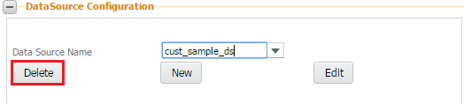

## Functional Area Configuration

**Prerequisite Tasks**

Data sources should have been defined

**Overview of configuring functional areas**

This activity enables the user to create functional areas and map them to data sources for generating reports. The system retrieves the data for the reports from the defined data sources for the specified functional areas. Functional area is a logical / business name for the department in an organization. For example, Sales, HR, Finance, Marketing are the functional areas in an organization. A functional area can have maximum of one data source for every data source type.

### Viewing the functional area details

This page displays a list of functional areas in drop-down list box

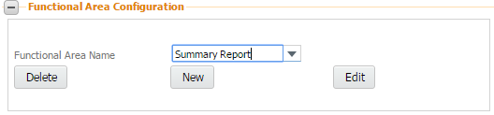

The system displays the following fields:

Functional Area Name Created functional Area name listed in drop- down list box.

***Delete*** Click on **delete** button, Functional Area can be deleted only if they are not used in any report configuration.

New Click on New button, user can create new functional area.

Edit Click on Edit button, user can modify the functional area definition.

### Creating a functional area

Click the **New** button system will display below screen.

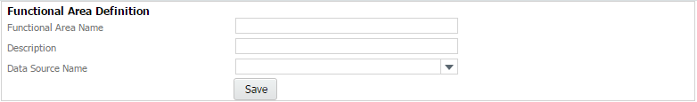

Enter the following fields:

Functional Area Name A unique name assigned to a functional area. Mandatory.

Description The description of the functional area.

Data source Name to select the data source that you want to map to the functional area.

**Click the Save button to save the functional area details.**

The new functional area details are saved.

## Functional Area – Analysis Configuration

**Prerequisite Tasks**

Database should have been created and restored

**Overview of configuring functional areas**

This activity enables the user to create functional areas and map them to data source for generating reports. The system retrieves the data for the reports from the defined data source for the specified functional areas.

Functional area is a logical / business name for the department in an organization. For example, Sales, HR, Finance, Marketing are the functional areas in an organization. A functional area can have maximum of one data source for every data source type.

### Viewing the functional area – analysis configuration details

This page displays a list of functional areas after searching for and fetching them using the Search facility.

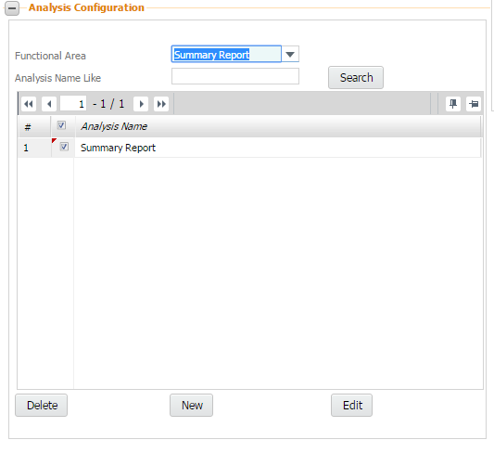

The system displays the Functional Area – Analysis Configuration page.

The user can search for functional area by selecting from the drop-down list box.

Enter the following fields in the Functional Area – Analysis:

Functional Area A unique name assigned to the functional area. The database data source mapped to the functional area is displayed.

Analysis Name like user can search the analysis name against the chosen Functional Area from the drop-down list box.

Click the Search button to fetch the **Analysis Name** details.

The system displays the following details of already defined functional areas in the Functional Area – Analysis Configuration page:

Functional Area A unique name assigned to the functional area.

Description The description of the functional area.

Analysis Name The database data source mapped to the functional area is displayed.

**Click the Functional Area link to view the configuration details.**

The system launches the “Functional Area – Analysis Configuration page that displays the entire details.

### Analysis Configuration

**Click the New button to create a new Analysis.**

The system displays the details of the Analysis Configuration page.

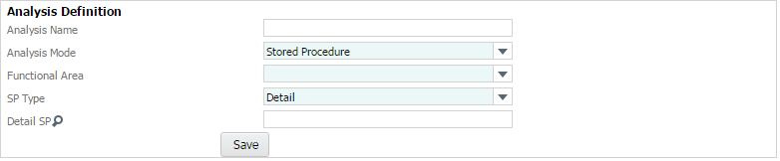

Analysis Name The name of the analysis of the functional area that is mapped to the stored procedure or query or web service.

Analysis Mode The mode of execution can be either a stored procedure or or web service or View or query.

Functional Area Select functional area name from drop-down list.

SP type Select, the section of the report to which the stored procedure is attached from the drop-down list box. The drop-down list box contains the following options: “Details” and “Header”.

Header/Detail SP analysis can attach one Header and detail Sp. multiple header / detail SP not allowed. Click on lens icon, it will launch the stored procedure list screen. User can select the SP and click the OK button.

***Stored Procedure List*** The system launches the Stored Procedures List page.

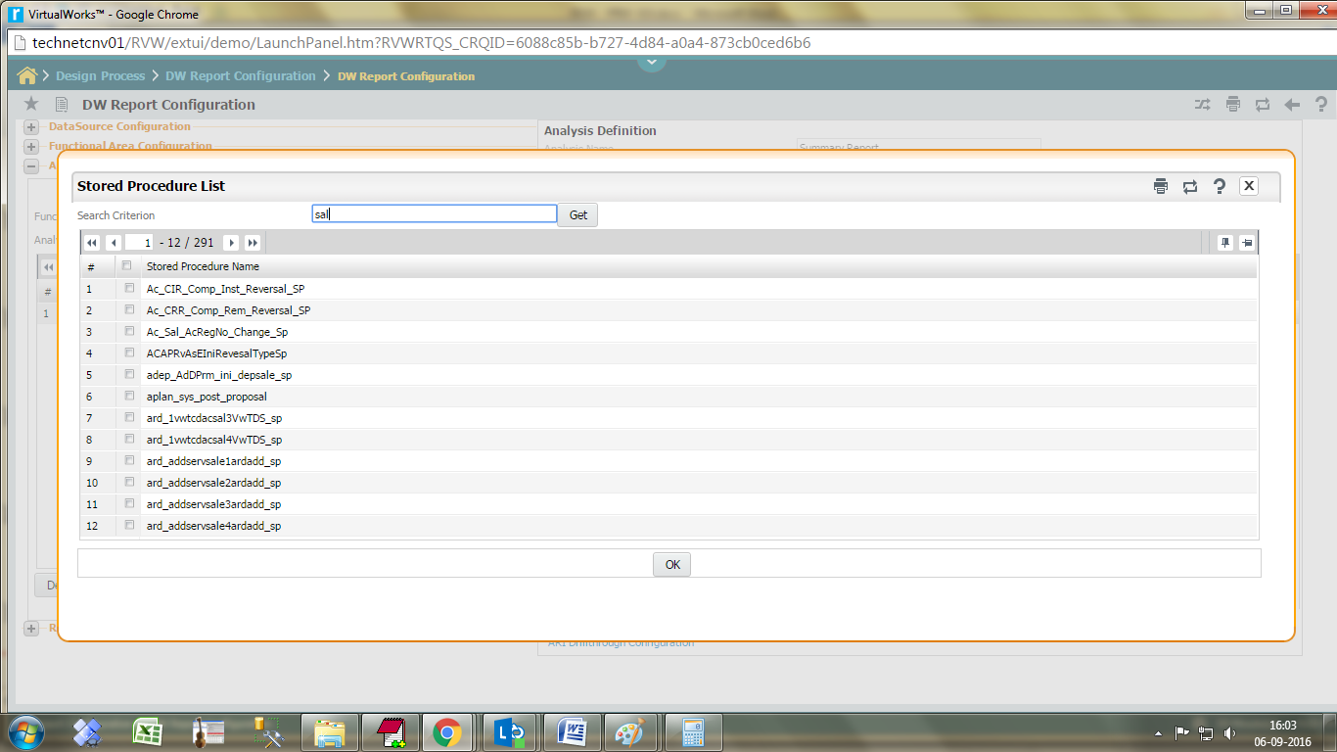

Click the save button to save the Analysis configuration details.

### Edit Analysis Configuration

Select functional area and click the search button.  
Choose analysis name from grid and click the edit button.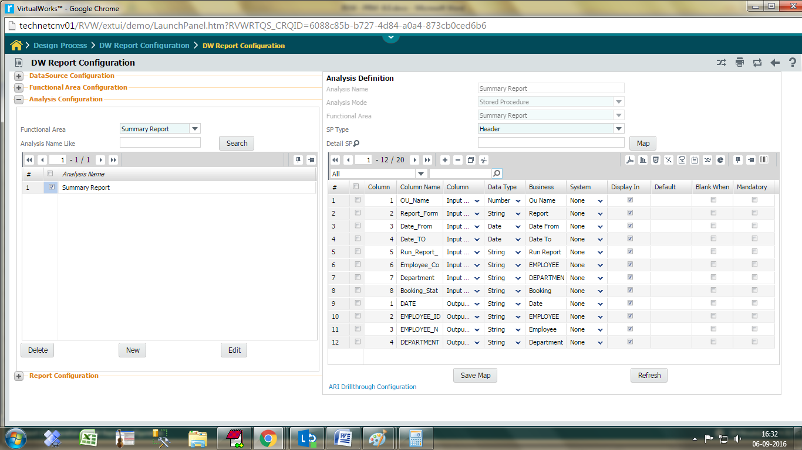

#### Stored Procedures– Business Terms mapping

This page enables the user to select the business terms to be mapped to the stored procedure column name. The user can also create new business terms through the same page. The Input parameter and the Output parameter details will be defaulted automatically. The Output column (select the columns given in the stored procedure) alone needs to be specified here additionally. The Business Term will be automatically defaulted based on the Input parameter and the Output parameter names.

The system launches the SP/XML Columns – Business Terms Mapping page.

Enter the following fields in the multiline:

Column Number A unique number to identify the column of the stored procedure. Mandatory

SP Column Name A unique name assigned to a stored procedure/XML. Mandatory

Column Type Select an appropriate option from the drop-down list box to indicate the column type for the SP column name being defined. The system displays “Input Param”, “Out Param” and “Output Column” as options.

Data Type Select an appropriate option from the drop-down list box to indicate the data type for the SP column name being defined. The system displays “String”, “Number”, “Currency” and “Date” as options.

Business Term Click the  icon displayed to select the business term that you want to map to the stored procedure column name. The system launches the Business Terms List page from which you can select the business term that you want to map to the stored procedure column name.

**Click the OK button.**

The system saves the selected SP column names and returns to the main page.

## Enterprise Reports

The Enterprise reports option allows you to attach Documents Reports for specific functional areas, for example, Sales, Human Resources or Marketing. You can specify the name and description of the report and map it to a functional area. These reports are linked to Balanced Scorecard or Goals. The attached reports can be viewed through the Configure and Monitor modules where the user can manipulate the data to simulate various what-if scenarios.

Document types such as Excel, DOC, PPT or any other document (for example, Notepad (.TXT) file) that has already been created can be attached as a report. The attached reports are displayed in the Monitor-Reports and Dashboard pages where the user can manipulate the data to simulate various what-if scenarios.

The Data source Definition component can be used to define the data source for launching reports, map organization units to the data sources, define functional areas to be mapped to the data sources, define business terms for stored procedures to be mapped to the data sources (applicable for Enterprise Reports) and define business terms for cubes to be mapped to the data sources (applicable for Warehouse Analytical Reports).

The reporting solution also allows the user to define new reports, choose the desired dimensions with various levels and measures in the context of Analytical Reports and design the page layout and formatting and set the sequence parameters for a report for enterprise reports.

When you attach a report, the system automatically fetches the list of parameters in that report and displays them in the Report Parameters table. You can specify the Display name and the default value for each parameter. While launching the report, on the Report Parameters screen, the system substitutes the user-defined parameter with the system-defined parameter.

The reports can be attached to an organization unit (OU) through the Configure module. The defined reports can be seen in Monitor module.

Alternatively, you can design reports using the report designer feature of Business Decisions. Using this feature, the user can configure the layout of the report, define the data source and do the formatting as well.

## Viewing the enterprise reports list

This page displays a list of reports after searching for and fetching them using the Search facility based on the user access rights.

Select the Enterprise Reports option from the Configure menu.

The system displays the Enterprise Reports List page.

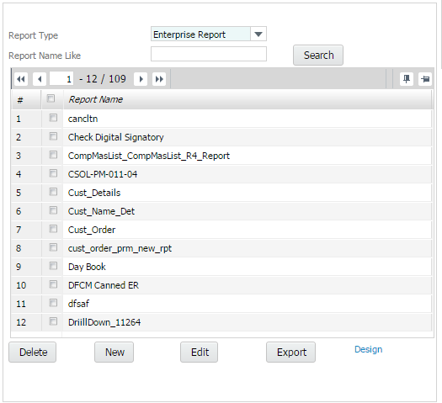

The user can search for report by using operators like "AND" or "OR" from the drop-down list box.

**Select ‘group by this field’ option from the drop down box given in each of the column headers**

The listed reports will get grouped based on the column headers available

**Click the clear grouping button to ungroup the reports.**

The grouped reports in the list will resume to default position

Enter the following fields in the Report List page to search for a report:

Select Select whether you want to search for the Report Name, Description, Customized, Author, Created By or Modified By from the drop-down list box.

Criterion Enter any leading values for the Report Name, Description, Customized, Author, Created By or Modified By that you wish to fetch. You can use wild card characters such as "%" along with a few letters to search more efficiently.

**Click the Get button to fetch the report details.**

The system displays the reports matching your search criteria in the table below.

The system displays the following details of already defined reports in the Enterprise Reports List page:

Report Name The name of the report.

Description The description of the report.

Functional Area The name of functional area to which the report belongs.

Report Type Specify base or customized report.

Author The name of the author

Created by The name of the user who created the report.

Created on The date on which the report was first created

Modified By The name of the user who last modified the report.

Modified On The date on which the report was last modified

## Creating Enterprise Reports

**Click the New button to define a new enterprise report.**

The system displays the Enterprise Report Definition page.

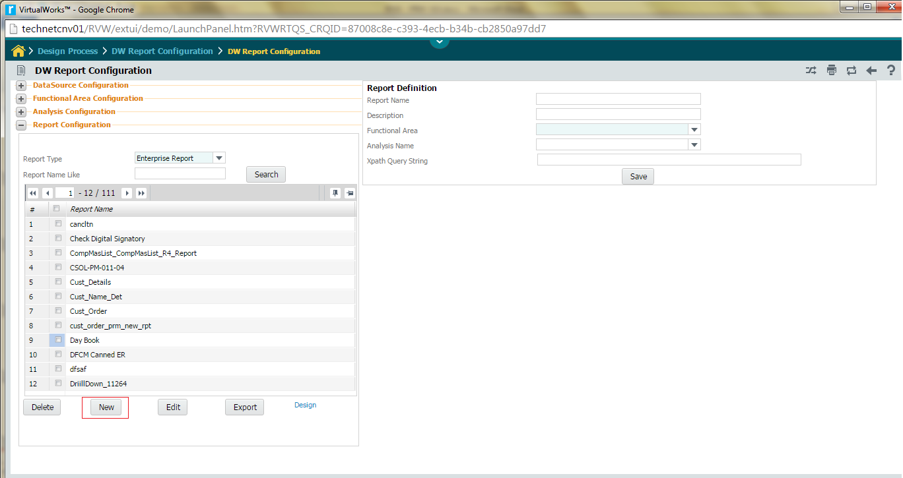

Enter the following fields in right pane.

Report Name The name of the enterprise report. Mandatory.

Report Description The description of the enterprise report.

Functional Area to select the functional area that you want to map to the report.. Mandatory.

Analysis Name to select the Analysis Name that you want to map to the report. Mandatory.

Xpath Query String Type xpath for service based report. Default value is (empty)

**Click the Save button to save the details.**

**Editing Enterprise Reports**

**Click the Edit button to modify the enterprise report.**

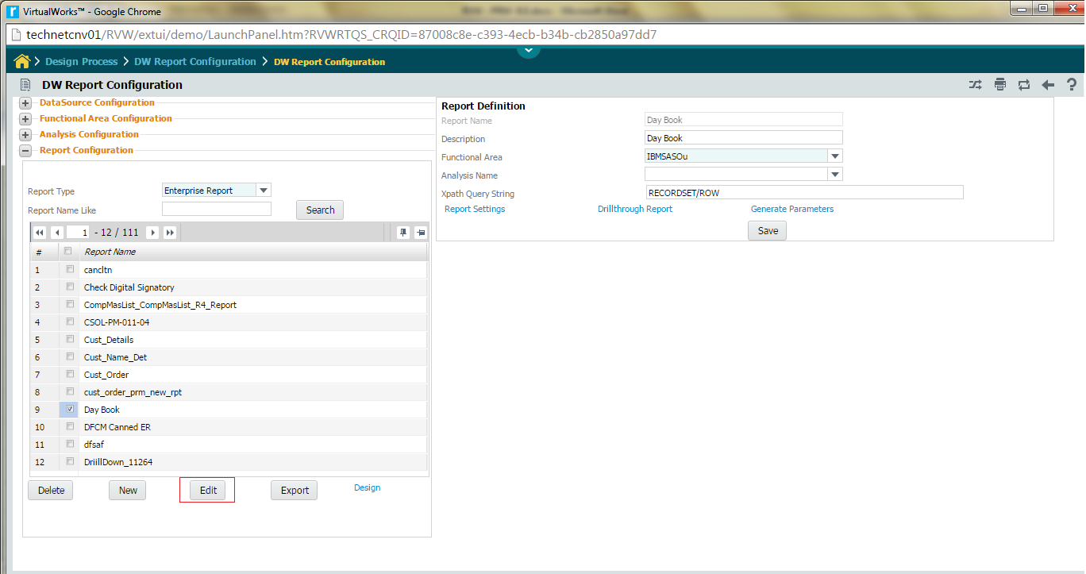

#### The following fields are available in right pane.

Report Description The description of the enterprise report.

Functional Area to select the functional area that you want to map to the report.. Mandatory.

Analysis Name to select the Analysis Name that you want to map to the report. Mandatory.

Xpath Query String Type xpath for service based report. Default value is (empty)

#### Report Settings system allows user to set Page level settings, layout, digital signature, output format and report types.

#### Drill through Report Help to define a drill through report. A drill through report is like a sub-report which is launched on demand from the main report

**Generate Parameters** This will auto generate the parameter screen from the configuration information given in sub screen

#### Defining Report settings for the report

The system launches the report Settings page.

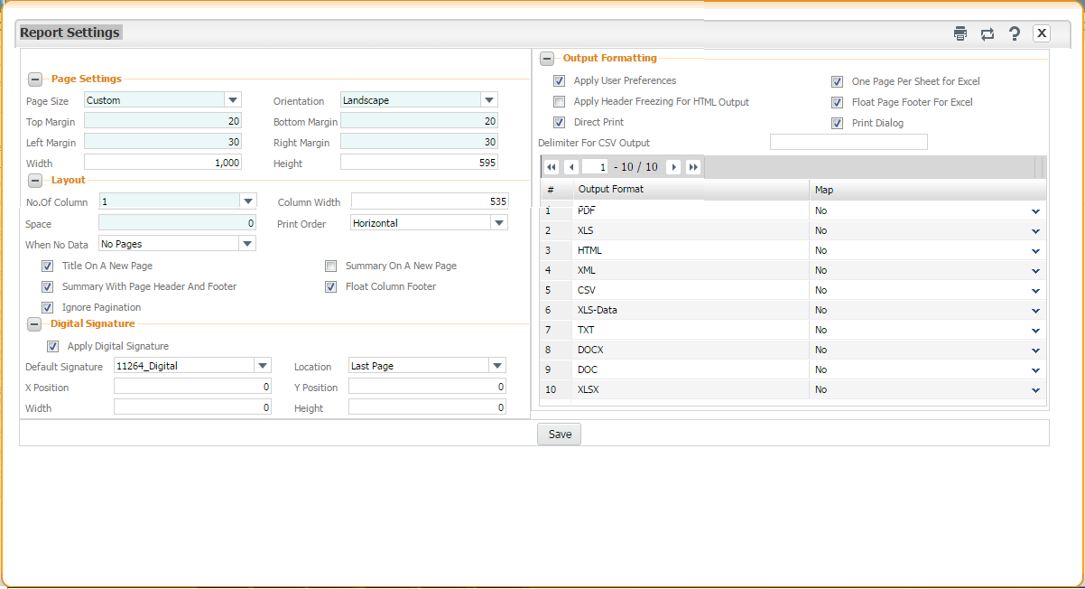

**Page Settings:**

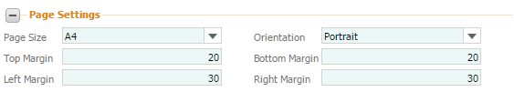

**Page Size** Select the paper size from drop down list

Orientation Select the orientation for printing the report from the drop-down list box. The system displays “Portrait” and “Landscape” as options.

Top Margin The top margin that you want to set for the report in pixels.

Bottom Margin The bottom margin that you want to set for the report in pixels.

Left Margin The left margin that you want to set for the report in pixels.

Right Margin The right margin that you want to set for the report in pixels.

Click the save button to save the page settings for the report.

**Layout settings:**

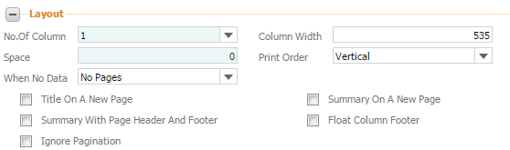

***Columns*** could specify the number of columns require.

***Column Width***  could specify the width of each of the columns

***Column Space***  can specify the white space in between the columns

***When No Data*** Select the data to be displayed when there is no data for the report

Print Order Select order in which the report pages should be printed from the drop-down list box. The system displays “Vertical” and “Horizontal” as options.

Title on a new page Select the checkbox if you want the title of the report to be printed on a new page.

Summary on a new page Select the checkbox if you want the summary of the report to be printed on a new page.

***Summary with page header and footer*** This option specifies if the summary band is accompanied by the page header and the page footer;

***Floating column footer*** This option allow to force the printing of the column footer band immediately after the last detail band (or group footer) and not at the end of the column. This option is used, for example, when you want to create tables using the report elements;

IgnorePagination  the report will be generated in a single page.

**Click the save button to save the Layout settings for the report.**

#### Digital signature

A digital signature is an electronic form of a signature that can be used to authenticate the identity of the sender of a message or the signer of a document, and also ensure that the original content of the message or document that has been sent is unchanged. Digital signatures are easily transportable and cannot be imitated by someone else.

Note: This is available for reports generated in PDF format only.

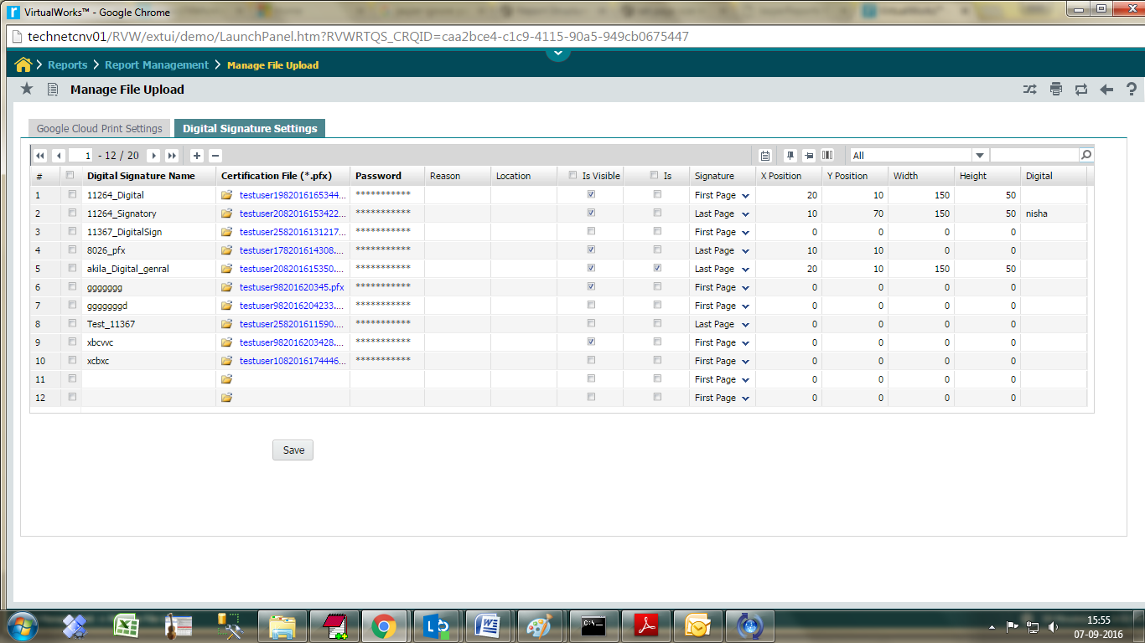

For embedding a digital signature in the report, the following are to be done;

Go to Reports 🡪 Report Management -> Manage File Upload

Go to Digital signature settings tab and upload the certification file (.pfx) and save.

Go to Report configuration

1. Choose a report.
2. Click edit button.
3. Click on Report Settings link.
4. Digital signature – Tick the box apply digital signature.
5. Select the digital signature name from drop-down list and save.
6. Launch the report and check PDF document digitally signed.

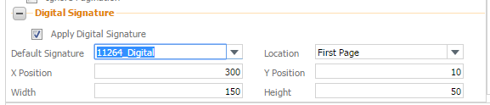

**Apply Digital Signature:** Enable Digital Signature for the report.

**Default Signature:** user can choose a signature from drop-down list.

**Location**: The location where this signature will be created either first page or last page.

**X – Position** enter the position in points to place the digital signature from the left.

**Y- Position** enter the position in points to place digital signature from the bottom

**Width**  enter in points the desired width of the inserted digital signature field. This applies only if you are setting the X and Y coordinates.

**Height**  enter in points the desired height of the inserted digital signature field. This applies only if you are setting the X and Y coordinates.

**Output Formatting:**

Output formatting configuration settings screen is given below:

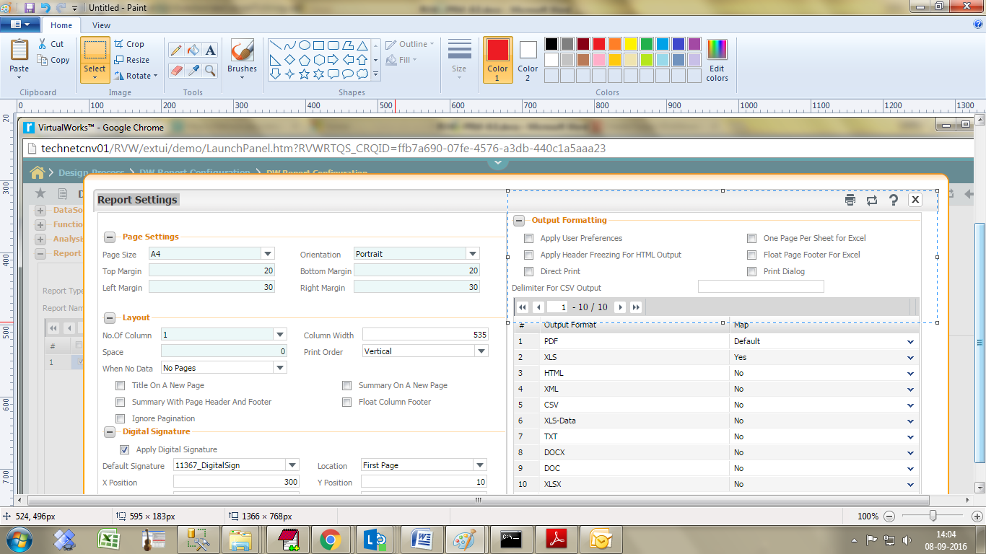

Apply user preferences Click the checkbox to enable the user preference option.

### One page per sheet for Excel Click the checkbox to enable the one page per sheet for excel. Apply Header Freezing For HTML Output Click the checkbox to enable the header freezing for HTML

Float Page Footer For Excel Click the checkbox to enable the option allow to force the printing of the column footer band immediately after the last detail band (or group footer) and not at the end of the column.

Direct Print Click the checkbox to enable the option to directly print the report without launching.

Print Dialog Click the checkbox to enable the option to show the print dialog while send the document for direct print.

Delimiter for csv output Click the checkbox to enable the delimiter in csv output.

### Report Types:

Enterprise report will support below output format.

Default report type is PDF and XLS set as Yes in map column, all other report type set as No.

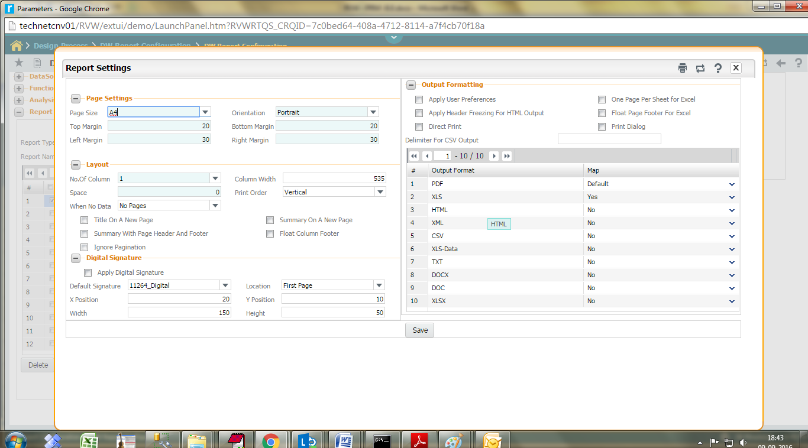

### Drill through Reports

A drill through report is like a sub-report which is launched on demand from the main report

Click on the link, the following popup screen is displayed:

Left pane display all reports, user can map one or more reports to choose map in grid. And click Map button.

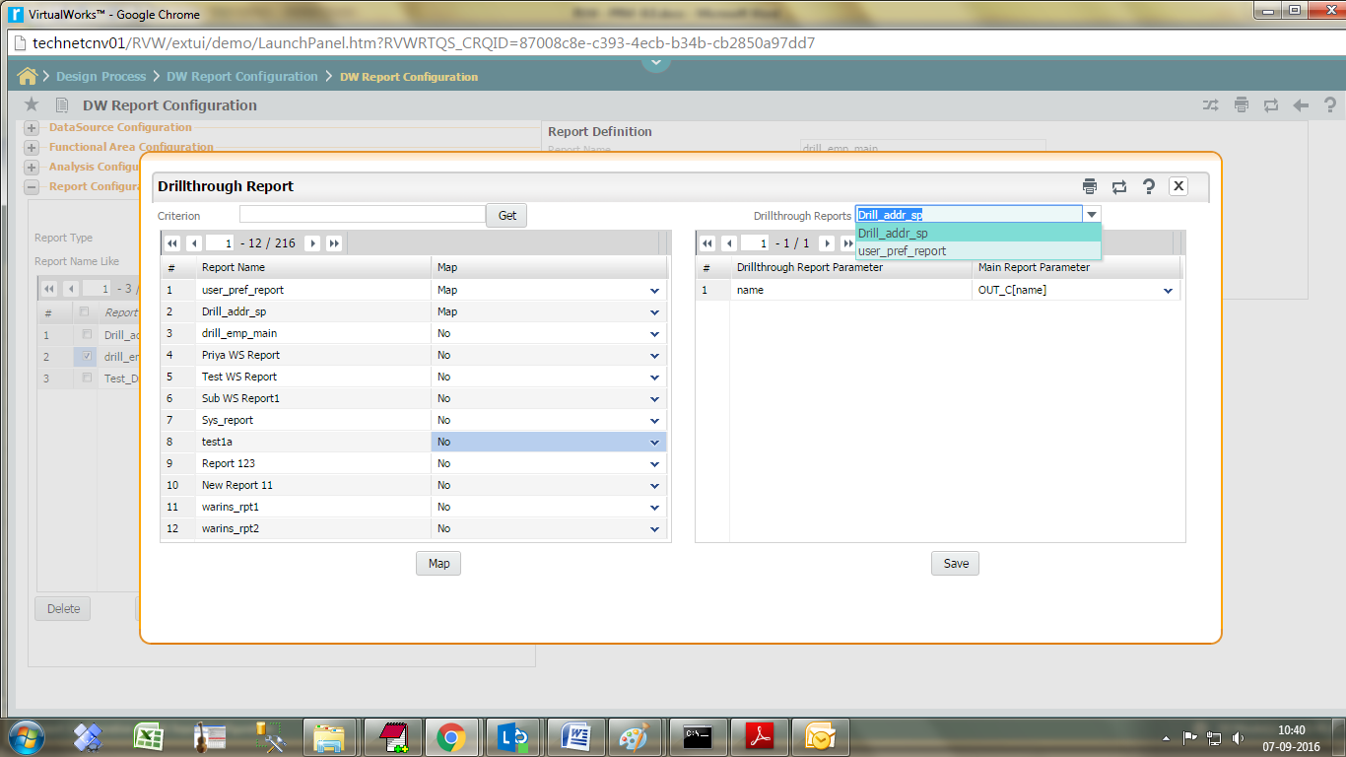

Left pane grid displays the following fields,

**Report** N**ame** the name of the drill through report.

**MAP** click of drop-down list display Map, Default Map and No option.

Drill through report multiple map is allowed.

Click on **Map** button, right pane drill through report combo load all mapped report name. Choose one by one and map the parameter details using below grid.

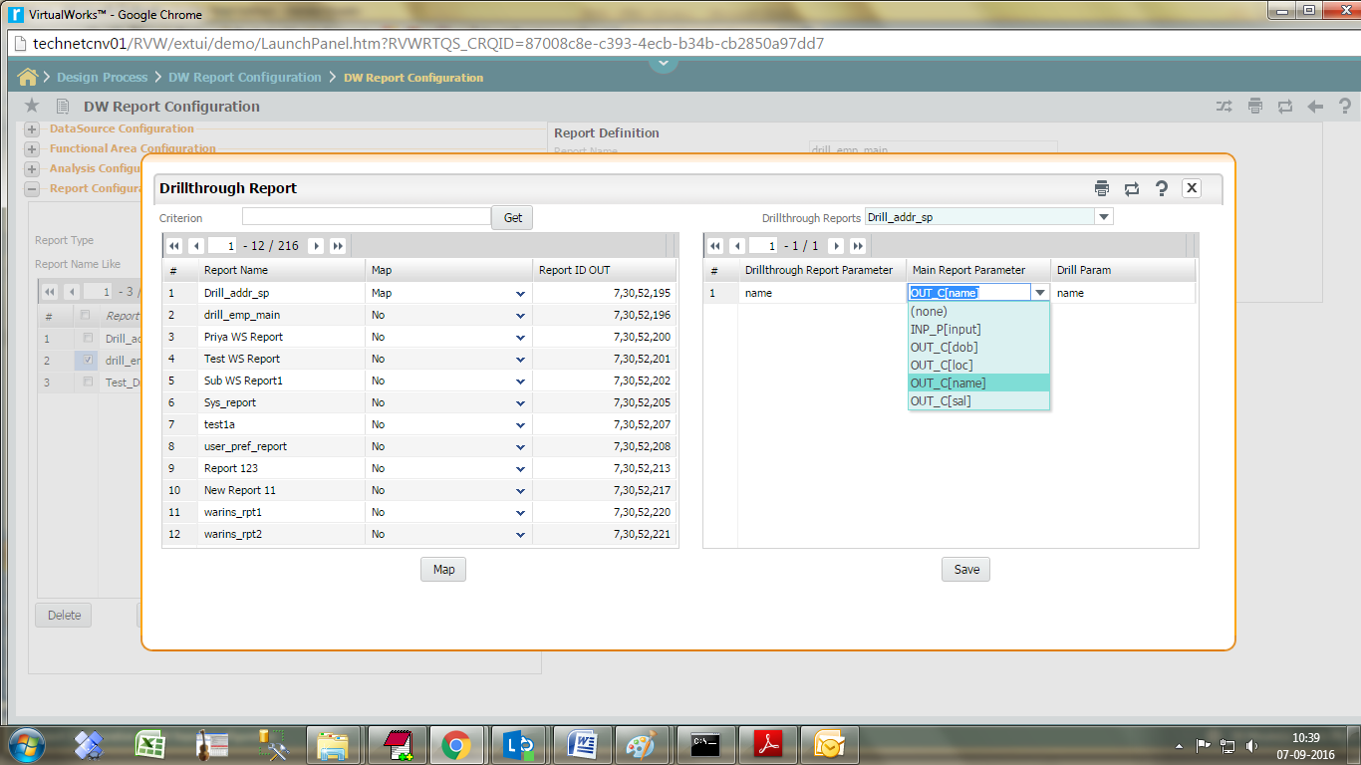

Select Main report column type as “Output column” (or) “Output parameter” (or) “Input parameter” and select Main report parameter (Business term for main report) and Click on save button.

Click the save button to save the changes.

Drill through report can be enabled on any BT used in the **report** **design**. To enable select ‘Enable Hyperlink’ as ‘Reference’

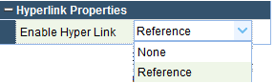

#### Generate Parameters:

Defining Input Parameters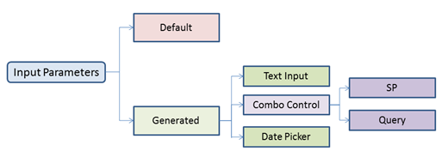

Input parameters can be specified for a report, using the Generate Parameter link in report editing screen. Click on the ‘Generate Parameters’ link it will launch the below screen.



**Apply Generate Parameters** default value is **No**. if choose the option ‘**Yes**‘ will auto generate the parameter screen from the configuration information given in screen.

Click the **save** button to save the changes.

Choose the option **YES**, it will launch the below screen.

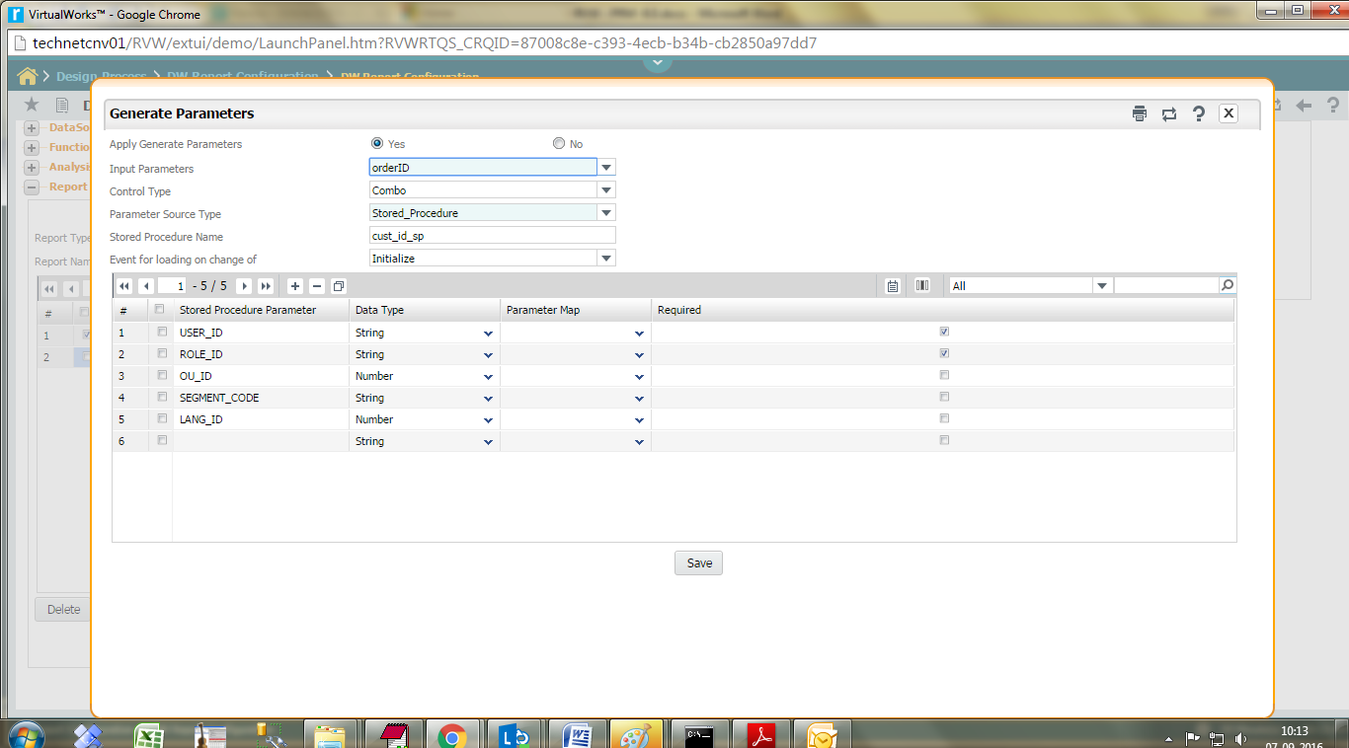

**Input Parameters** list report SP in-param details

**Control type** system generate 3 types of controls namely combo/date control/textinput.

**Parameter source type** it can be either stored procedure or query. This type does not require for Text Input control.

**Stored procedure name** type the stored procedure name.

**Event for loading on change of** choose Initialize by default, if dependent combo, choose the BT.

An Input parameter of type combo can have a Query or Stored Procedure attached to load the data values on load.

To attach the stored procedure, write the SP in below format.

CREATE PROCEDURE custID_SP

@name nvarchar(30), -- dependent combo value passed here

@user_id nvarchar(30),

@role_id nvarchar(30),

@ou_id nvarchar(30),

@lang_id nvarchar(30),

@error_code integer OUTPUT,

@error_id integer OUTPUT,

@error_desc nvarchar(30)OUTPUT

AS

BEGIN

SET NOCOUNT ON

SELECT employeeid 'DISPLAY_VALUE',

employeeid 'DEFAULT_VALUE',

employeeid 'HIDDEN_VALUE'

FROM cust_order(NOLOCK)

SET NOCOUNT OFF

END

To attach a Query, select the Query option

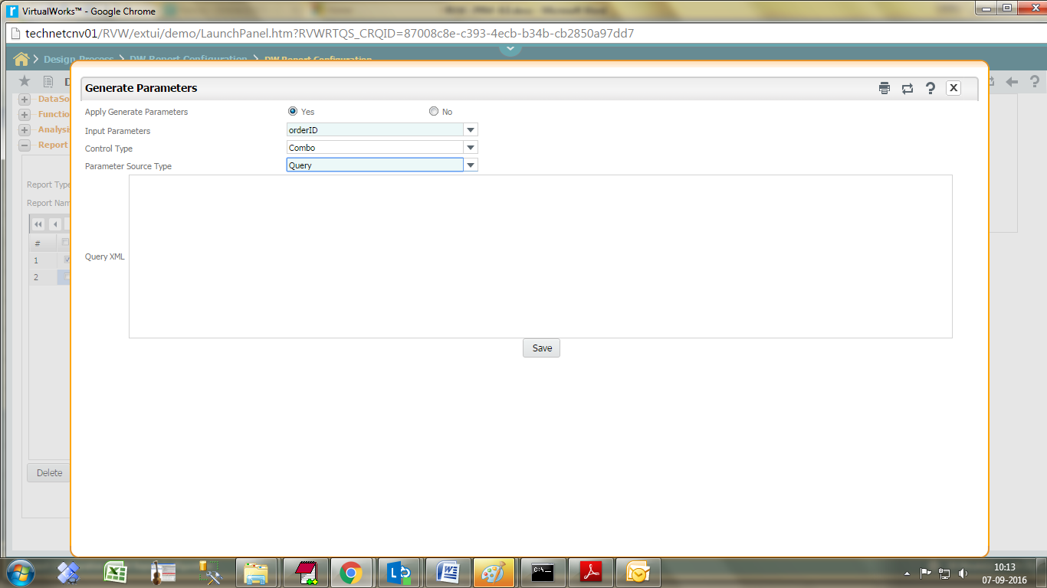

Query XML format is given below:

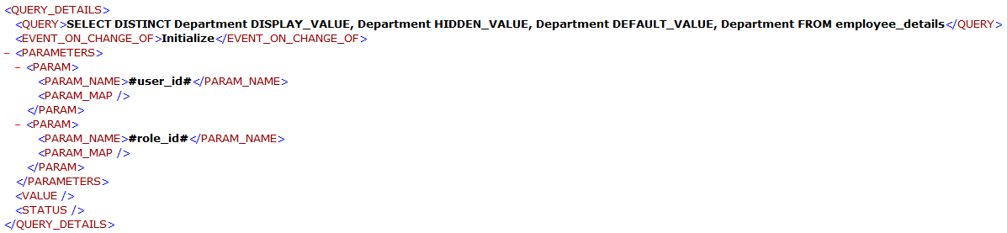

## Designing enterprise reports

The reports designer component of Enterprise reports enables you to define in detail both the content and look and feel of enterprise reports. It consists of a main screen, which lists the main sections of the report. Icons at the top of the screen can be dragged and dropped to each section and the details of the section can be defined.

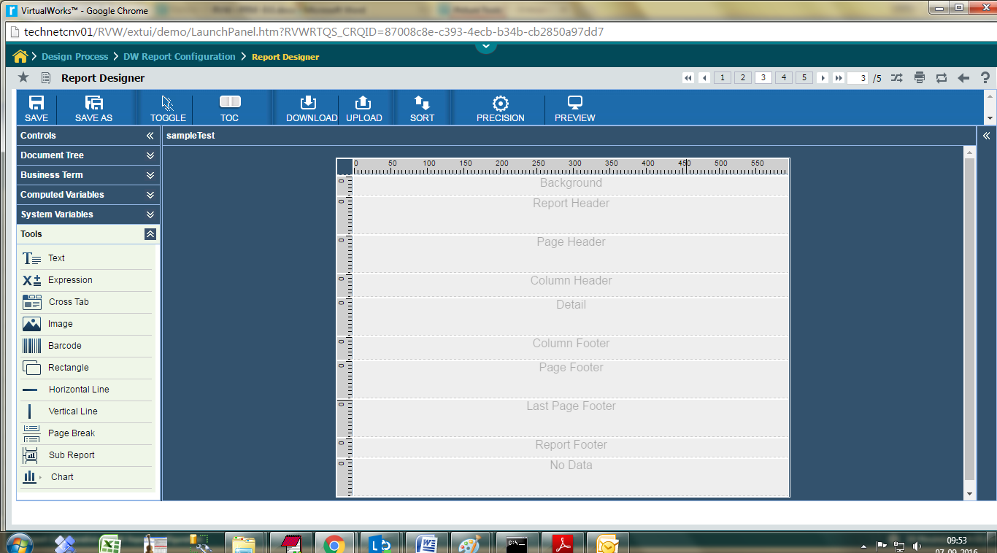

The user can design contents and appearance for the following sections of the report:

|  |  |
| --- | --- |
| **Section** | **Description** |
| Background | The background section is displayed on every page and cannot overflow to the next page. Elements placed on this section are evaluated at page initialization time and are displayed in the background. All other page objects are displayed on top of the background objects. This section is useful for creating page watermark. |
| Page Header | This section appears at the beginning of each page in the generated document. |
| Column Header | This section appears at the beginning of each column in the generated document. If the report has only one column defined, then column header and footer sections are ignored. |
| Group Header | This section is introduced by a report group (chapter Groups). Each time the grouping expression changes its value, the group header section is printed above the detail section. In case, if more than one group is defined, the group header is printed in the order of group definition. |
| Detail | This section is repeated for each line of data supplied by the report's data source. The detail section can be made of multiple bands. |
| Group Footer | This section is introduced by a report group (chapter Groups). The group footer section is printed below the detail section before the value of the grouping expression changes. The group footer is always printed for the last line of data in data source. In case, if more than one group is defined, the group footer is printed in the reverse order of group definition. |
| Column Footer | This section appears at the bottom of each column. If the report's column count is 1, then column header and footer sections are ignored. |
| Page Footer | This section appears at the bottom of each page. |
| Last Page Footer | This section replaces the regular page footer on the last page of the report. In case the summary section is also present, then this might not be the very last page of the document. This section is sometimes useful when summary information has to be displayed at the bottom of the last page. |
| No Data | This section is printed when the When No Data Print report property is set to No Data Section. If the noData section is defined in the report template, and if the data source is empty, then the noData section will be the only one taken into account at fill time, and its content will produce the report output. |

Note: You should save the enterprise report after completing the design to preview the output of the report.

The system displays the Enterprise Reports Definition page.

**Click the Design button.**

The system displays the Report Designer page.



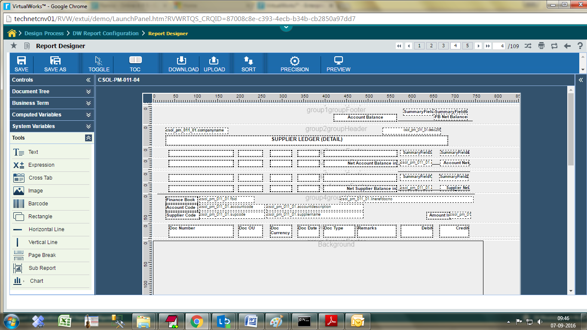

#### Guide Lines for Effective Report Design

When generating reports, the DW reports engine uses the absolute position of each report element to layout the content of each page. Absolute positioning the report elements allows full control over the content of the output documents.

The PDF format supports absolute positioning of the text and graphic elements on a document page and this is why it is widely used on various platforms. However, other document formats such as HTML or XLS, do not support absolute positioning of the text and graphic elements. The content of such documents is arranged in a grid or table structure.

This is why DW reports‟ built-in exporters that produce HTML, XLS or CSV documents use a special algorithm in order to arrange the elements present on a certain document page in some sort of a grid. When the report designs are very complex or agglomerated, passing from absolute positioning to grid or table layout produces very complex tables with many unused rows and columns, to make it for the empty space between elements or their special alignment.

There are a few, very simple guidelines that should be followed by those who want to obtain optimized HTML, XLS or CSV documents.



1. Minimizing the number of rows and columns in the grid oriented formats (minimizing the number of "cuts")

To do that, you have to make sure you align your report elements as often as you can, both on the horizontal and the vertical axis and that you eliminate the space between elements.

2. Avoiding overlapping report elements

Make sure report element will not overlap when the report will be generated. This is because if you have two elements that share some region, it will be impossible for them to share the same cell in the resulting grid structure. Unexpected results might be obtained if elements overlap.

Ex:

In the below screenshot, elements in Header and Detail do not overlap;

#### 

Header: Code – Top, Left: 0, Width: 50, Height: 30, Name – Top: 0, Left: 50, Width: 100, Height: 30

* The width of a control would be the left position of the next control.
* Height of all controls in one section should be same to avoid irregular output when generated

3. Give up using page headers and page footers

Especially when you want to obtain documents in which the page breaks are not relevant (CSV for example), make sure that you suppress the page header and page footer sections in your report design. You could also minimize the top and bottom margins for your report, so that when exported to HTML, XLS or CSV, your documents will be made of a single chunk, without page separators.

4. Main Reports and sub reports should be same width in page settings

5. Sub reports has to be aligned and also it should be uniformly formatted

6. Controls positioning in a band should be of equal height within the band

7. In Main Report, Page settings the left margin should be greater than zero.

8. Unwanted spaces in detail, report header and group headers should be removed.

9. Unwanted spaces between each band to be removed

#### Report Expressions

Report expressions are a powerful feature of DW, which allows us to display calculated data on a report. Calculated data is the data that is not a static data and is not specifically passed as a report parameter or data source field. Report expressions are built from combining report parameters, fields, and static data. By default, the Java language is used for writing report expressions.

Sample expression is given below:

|  |  |
| --- | --- |
| **Pattern** | **DW Reports Syntax** |
| Conditions - if-then / if-then-else | ($F{Col} == 1) ? "red" : ( ($F{Col} == 2) ? "green" : ( ($F{Col} == 3) ? "blue" : "white" ) ) |
| ($F{VendorCode}.equals("1")) ? "red" : ( ($F{VendorCode}.equals("2")) ? "green" : ( ($F{VendorCode}.equals("3")) ? "blue" : "white" ) ) |
| $F{isu_isu_rep_main_mseg.remarks2000}.equals("")?true:false |
| $F{sh_rep_main_hseg.designparamcode04}.equals("Y")? $F{sh_rep_main_hseg.partno} + "**" : $F{sh_rep_main_hseg.partno} |
| $F{sh_rep_main_hseg.date}== null ? "Not available":($F{sh_rep_main_hseg.sinceinspctnmlt} ="0" ?"("+$F{sh_rep_main_hseg.date}+")":$F{sh_rep_main_hseg.date} ) |
| $F{sh_rep_main_hseg.sinceinspctnmlt} 0 ? 0 : $F{sh_rep_main_hseg.sinceinspctnmlt} |
| $F{sh_rep_main_hseg.lotno}.equals("##")? "" :$F{sh_rep_main_hseg.lotno} |
| $F{sh_rep_main_hseg.designparamcode04}.equals("Y")?1:0 |
| "Others: Customer Order #:"+ $F{issrep_rcshp_mainmlt_met.customerorderno}+ "/ Customer PO #: "+ $F{issrep_rcshp_mainmlt_met.customerpono} |
| $F{issrep_rcshp_mainmlt_met.freightcharge} =0 ?true:false |
| Nested if conditions | ($V{legFlag1} 0 && $V{LegFlag2} 0 && $V{LegFlag3} 0 ) ? "** - Hazmat, Mfr .Part # - Manufacturer Part #, UOM - Unit Of Measurement, * - Shelf Life Extendable, Rem. Days - Remaining Days, () - Shelf Life Expired" : ( $V{legFlag1} 0 && $V{LegFlag2} 0 ? "** - Hazmat, Mfr .Part # - Manufacturer Part #, UOM - Unit Of Measurement, * - Shelf Life Extendable, Rem. Days - Remaining Days" : ( $V{legFlag1} 0 && $V{LegFlag3} 0 ? "** - Hazmat, Mfr .Part # - Manufacturer Part #, UOM - Unit Of Measurement, Rem. Days - Remaining Days, () - Shelf Life Expired" : ( $V{LegFlag2} 0 && $V{LegFlag3} 0 ? "Mfr .Part # - Manufacturer Part #, UOM - Unit Of Measurement, * - Shelf Life Extendable, Rem. Days - Remaining Days, () - Shelf Life Expired" : ( $V{legFlag1} 0 ? "** - Hazmat, Mfr .Part # - Manufacturer Part #, UOM - Unit Of Measurement, Rem. Days - Remaining Days" : ( $V{LegFlag2} 0 ? "Mfr .Part # - Manufacturer Part #, UOM - Unit Of Measurement, * - Shelf Life Extendable, Rem. Days - Remaining Days" : ( $V{LegFlag3} 0 ? "Mfr .Part # - Manufacturer Part #, UOM - Unit Of Measurement, Rem. Days - Remaining Days, () - Shelf Life Expired" : "Mfr .Part # - Manufacturer Part #, UOM - Unit Of Measurement, Rem. Days - Remaining Days" ) ) ) ) ) ) |
| $F{sh_rep_main_hseg.designparamcode03}.equals("Y") ?$F{sh_rep_main_hseg.qty}.toString().substring(0,($F{sh_rep_main_hseg.qty}.toString().length()-2))+"*" :$F{sh_rep_main_hseg.qty}.toString().substring(0,($F{sh_rep_main_hseg.qty}.toString().length()-2)) |
| String /Sub-string operations | $F{isu_isu_rep_main_sseg.needdate}.substring( 0,2 ) |
| $F{baspo_pr_pm_05_hdr.podate}.substring( 0,10 ) |
| $F{baspo_pr_pm_05_hdr.address}+( $F{baspo_pr_pm_05_hdr.authaddress} ) |
| $F{RmRptCustatent_txt.transaction}.toUpperCase() |
| Variables | $V{Tot}.equals("Total Variable Costs") ?($V{TotSales}-$V{TotFixedCost}):"0.0" |
| Number Operations | Math.round($F{CSOL_RM_010_01_ttx.PaymentAmt}) |
| **Custom Functions** | |
| **Function Name** | **DW Reports Syntax** |
| Space | "Ramco"+ new com.ramco.dw.customUtils.customField().space("12") +"Systems" |
| isDate | new com.ramco.dw.customUtils.customField().isDate($F{rptx_pck_sht_details.date}) |
| chr | new com.ramco.dw.customUtils.customField().chr("65") |
| Previous | new com.ramco.dw.customUtils.customField().Previous($F{reservation.configuration1},1,$V{REPORT_COUNT}) |
| ProperCase | new com.ramco.dw.customUtils.customField().ProperCase($F{reservation.configuration1},1,$V{REPORT_COUNT}) |
| toNumber | new com.ramco.dw.customUtils.customField().toNumber($F{reservation.balance}) |
| On Last Record | $P{SYS_RECORD_COUNT} |
| cdbl | $F{rptx_pck_sht_details.alloqty}.replaceAll("[^0-9.]", "") |
| totext | $F{rptx_pck_sht_details.alloqty}.toString() |
| Currency in words | new com.ramco.dw.reuse.MoneyToWord().convertNumber(String.valueOf($F{enrpt_details_pack.totalamount}).toString()), "MILLION" , "Rupee", "Rupees", "paisa", "paise") |
| inword | new com.ramco.dw.reuse.MoneyToWord().convertNumber(String.valueOf($F{Totalamountbef}), "MILLION" , "Rupee", "Rupees", "paisa", "paise") |
| ReplicateString | new com.ramco.dw.customUtils.customField().ReplicateString(" String Field ", Occurrences ) Example: Input: new com.ramco.dw.customUtils.customField().ReplicateString("str",4) Output: strstrstrstrstr |
| prefixText | new com.ramco.dw.customUtils.customField().prefixText( Field_Name .toString(), Prefix_Character ,0) Example: For the input 500.56 assigned to variable csol_pm_032_01.amount,  new com.ramco.dw.customUtils.customField().prefixText($F{csol_pm_032_01.amount}.toString(),'*',0) Output is: ******500.56 |
| **Handling Null conditions** | |
| **Function Name** | **Modified Syntax** |
| Number Fields | $V{RCharges} + ($F{qtnvw.basicvalue}.equals(null)?0.00:$F{qtnvw.basicvalue}) + Math.round($V{RTax}) - ($V{RDiscount}.equals(null)?0.00:$V{RDiscount}) |
| MoneyToWord | new com.ramco.dw.reuse.MoneyToWord().convertNumber(String.valueOf(($V{RCharges} + ($F{qtnvw.basicvalue}.equals(null)?0.00:$F{qtnvw.basicvalue}) + $V{RTax}) - ($V{RDiscount}.equals(null)?0.00:$V{RDiscount})).toString()), "LAKH" , "Rupee", "", "paisa", "paise") |

#### Report Designer Panes

#### Top Pane

Save

 This icon saves the report in current design.

Save As

 This icon saves the report with different name.

Toggle

 The report designer offers two modes of operation Select mode and Draw mode. The Select mode allows selection of entities while the draw mode enables actual definition of the details of the selected entities. The system automatically displays the Design mode when icons are dragged and dropped into the report designer. The system toggles the current mode of the Report Designer page to select mode or draw mode.

Table Of Contents

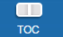This icon lets the user to attach table of content to the report. Clicking on this icon will provide a dialog box as shown below:

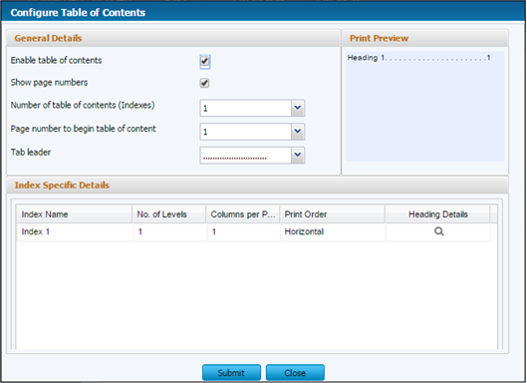

Click on icon under heading details. A dialog box shown as below will appear:

Select the section name where you want to create index and the field name .Click OK.

The table of content will be displayed while previewing the report output.

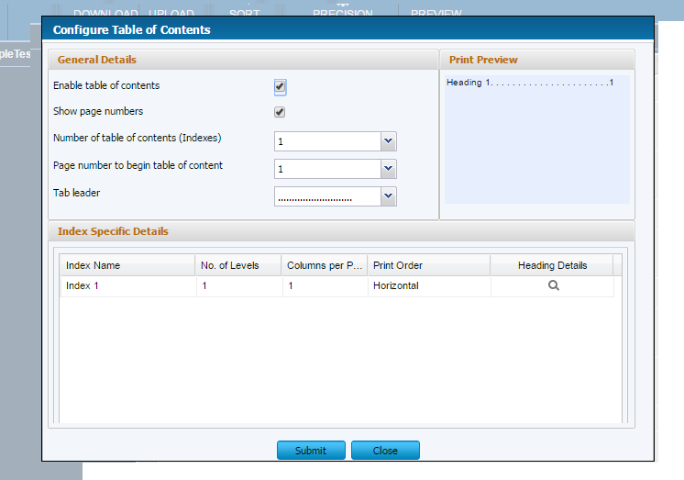

Upload

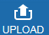 Using this icon, user can update report design xml.

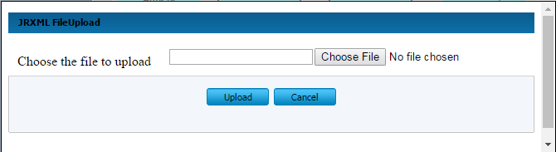

**Sort**

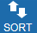 Helps to sort the data inputs that are fetched from the data source from the BT’S in ascending or descending order.

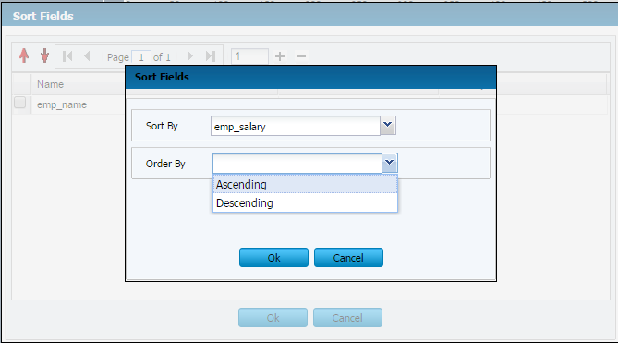

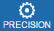 Using this icon, User can map the precision metadata to the correcting BT’s.

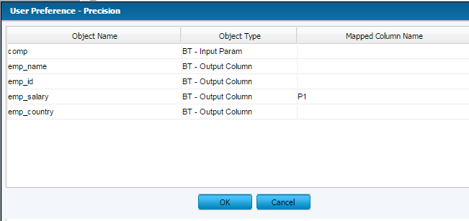

**Attachment**

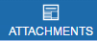This icon lets the user to attach addition document merge with generated report. Clicking on this icon will provide a dialog box as shown below:

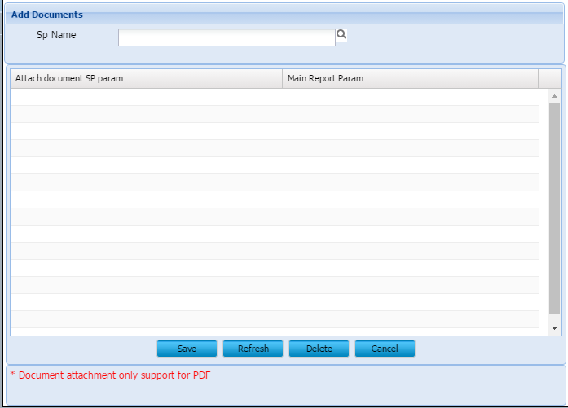

Click on icon - a dialog box as shown below will appear:

Click get button

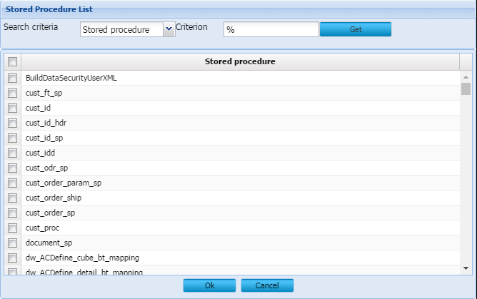

1. Select one Stored procedure name

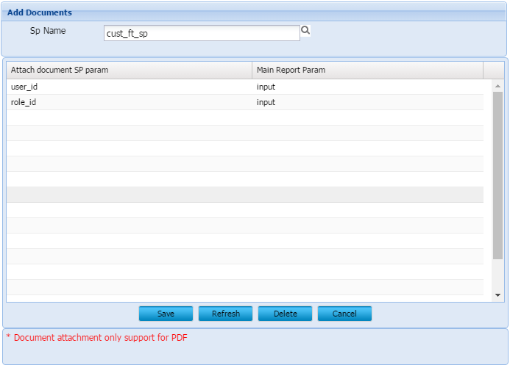

1. Select main report parameter. And click on save button.

**Delete:** Delete button used to delete additional document SP mapping.

**Refresh:** after modify the mapped sp click on the refresh button the changes will be affected. And click on save button

**Stored procedure structure:**

1. One or more input parameter is mandatory.
2. 3 output parameter is mandatory as shown below with specified data types and order. The 3 output parameter should be the last 3 parameters for the SP.s

**Sample SP:**

CREATE procedure XXXXXX (

@input_param nvarchar(20),

@a_n_errorid numeric(10) output,

@a_i_apperrortype integer output,

@a_s_error_desc nvarchar(2000) output)

as

begin

select * from AAAAA

end

 Helps to preview the report in various formats by giving the required input parameters

### Left pane- Document Tree

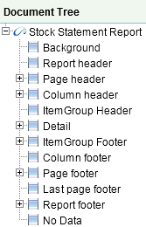

This shows the list of sections available in a report and the controls participating in each section

The section properties can be modified by clicking on the section and changing the property (right pane)

### Groups

Right click Document Tree 🡪 Add Groups

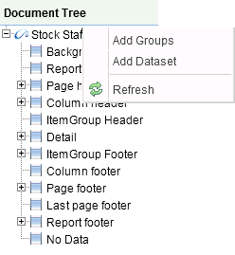

Group Definition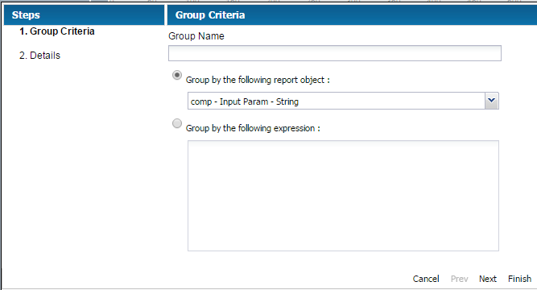

Groups in DW help organize data on report in a logical manner. A report group represent a sequence of consecutive records in the data source that have something in common, like the value of a certain report field. A report group is defined by the group element. A report can have any number of groups. Once declared, groups can be referred to throughout the report.

A report group has three elements:

Group expression: This indicates the data that must change to start a new data group.

Group header section: Helps place label at the beginning of grouped data.

Group footer section: Helps place label at the end of grouped data.

During the iteration through the data source at report-filling time if the value of the group expression changes, a group rupture occurs and the corresponding group Footer and group Header sections are inserted in the resulting document.

Report group mechanism does not perform any sorting on the data supplied by the data source. Data grouping works as expected only when the records in the data source are already ordered according to the group expressions used in the report.

Group Attributes

The group element contains attributes that allow us to control how grouped data is laid out. 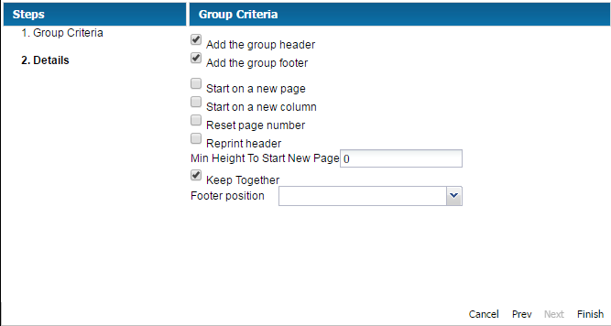

The attributes are summarized in table below:

|  |  |
| --- | --- |
| **Attribute** | **Description** |
| Name | This is mandatory. It references the group in report expressions by name. It follows the same naming conventions we that we mentioned for the report parameters, fields, and report variables. It can be used in other JRXML attributes when you want to refer a particular report group. |
| Start New Column | When set to true, each data group will begin on a new column. Default value is false |
| Start New Page | When set to 'true, each data group will begin on a new page. Default value is false |
| Reset Page Number | When set to true, the report page number will be reset every time a new group starts. Default value is false |
| Reprint Header | When set to true, the group header will be reprinted on every page. Default value is false |
| Min Height To Start New Page | Defines minimum amount of vertical space needed at the bottom of the column in order to place the group header on the current column. The amount is specified in report units. |
| Keep Together | When set to true, prevents the group from splitting on its first break attempt |

DataSet Definition

Right click Document Tree 🡪 Add Dataset



By default, all pixel perfect reports support data from single data set, i.e. data from one Analysis. This is a feature where in, a pixel perfect report can contain data from more than one analysis. The pre-requisite is that, the different data source from which data should be used in a report, should have the same ‘Analysis’ name

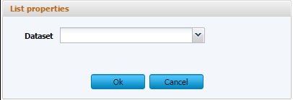

#### Delete Dataset

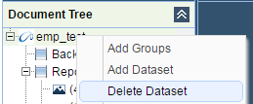

Business Terms

They are the user friendly English words understandable by the end user used in report design

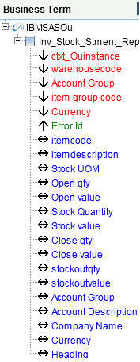

Displays in the hierarchy: Functional Area Name 🡪 Object Name of Analysis 🡪 Input /Output parameters, Output columns of the Analysis

Computed Variables

Computed variables, are those which help store the result of a computation in a filed, which would be used in the report design

To add a variable, right click 🡪 Add Variable

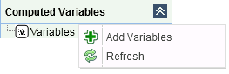

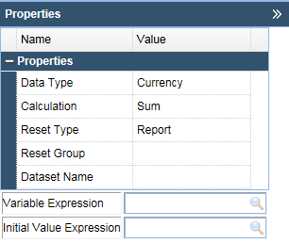

Variable Declaration

Report variables are special objects built on top of a report expression. Report variables simplify the following tasks:

* Report expressions which are heavily used throughout the report template. These expressions can be declared only once by using the report variables.
* Report variables can perform various calculations based on the corresponding expressions values like: count, sum, average, lowest, highest, variance, etc

If variables are defined in a report design, then these can be referenced by new variables in the expressions. Hence the order in which the variables are declared in a report design is important.

Calculation

This attribute determines what calculation to perform on the variable when filling the report. The following subsections describe all the possible values for the calculation attribute of the variable element.

***Average***: The variable value is the average of every non-null value of the variable expression. Valid for numeric variables only.

***Count***: The variable value is the count of non-null instances of the variable expression.

***First****:* The variable value is the value of the first instance of the variable expression. Subsequent values are ignored.

***Highest***: The variable value is the highest value for the variable expression.

***Lowest***: The variable value is the lowest value for the variable expression in the report.

***Nothing***: No calculations are performed on the variable.

***Standard Deviation***: The variable value is the standard deviation of all non-null values matching the report expression. Valid for numeric variables only.

***Sum***: The variable value is the sum of all non-null values returned by the report expression.

***System***: The variable value is a custom calculation.(calculating the value for that variable yourself, using the scriptlets functionality of DW )

***Variance***: The variable value is the variance of all non-null values returned by evaluation of a report variable's expression.

### Increment Type

This determines when to recalculate the value of the variable. This attribute uses values, as below:

***Column***: The variable value is recalculated at the end of each column

***Group***: The variable value is recalculated when the group specified by increment Group changes.

***None***: The variable value is recalculated with every record.

***Page***: The variable value is recalculated at the end of every page.

***Report***: The variable value is recalculated once, at the end of the report.

### Increment Group

This determines the name of the group at which the variable value is recalculated, when incrementType is Group. This takes name of any group declared in the JRXML report template.

**Reset Type**

This determines when the value of a variable is reset. This attribute uses values, as below:

***Column***: The variable value is reset at the beginning of each column.

***Group***: The variable value is reset when the group specified by increment Group changes.

***None***: The variable value is never reset.

***Page***: The variable value is reset at the beginning of every page.

***Report***: The variable value is reset only once, at the beginning of the report.

### ResetGroup

This determines the name of the group at which the variable value is reset, when resetType is Group. The values for this attribute would be the name of any group declared in the JRXML report template.

System Variables

There are some built-in system variables, ready to use in expressions, as follows:

|  |  |
| --- | --- |
| **Variable Name** | **Description** |
| PAGE_NUMBER | This variable's value is its current page number. It can be used to display both the current page number and the total number of pages using a special feature of DW text field elements, the evaluation Time attribute. |
| COLUMN_NUMBER | This variable contains the current column number |
| REPORT_COUNT | This report variable contains the total number of records processed. |
| PAGE_COUNT | This variable contains the number of records that were processed when generating the current page. |
| COLUMN_COUNT | This variable contains the number of records that were processed when generating the current column. |
| Report ID | The internal Report ID referred by the DW Application to identify a report |

### Tools

The following are the tools available to create reports;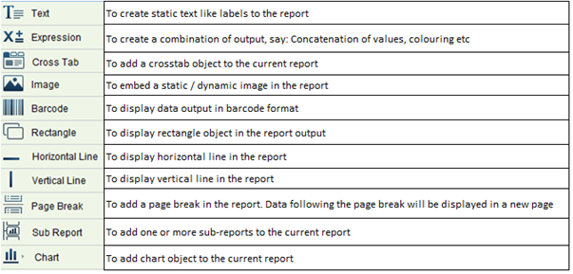

Sub Reports

Sub-reports are an important feature for a report-generating tool. They allow the creation of more complex reports and simplify the design work.

Sub-reports are very useful when creating master-detail type of reports, or when the structure of a single report is not sufficient to describe the complexity of the desired output document.

A sub-report is in fact a normal report incorporated into another report. One can overlap subreports or create subreports containing subreports themselves, up to any nesting level. Any report template can be used as a subreport when incorporated into another report, without anything inside it having to change.

Subreports are like normal report templates.

A sub-report element is used when introducing subreports into master reports. Here is the list of sub-elements in the subreport element.

* Return Value: This is used to assign the value of one of the subreport's variables to one of the master report's variables.
* Print When Expression: Condition based on which the sub-report should be invoked for painting

To create a sub-report drag and drop the Sub-report from Tools pane to Report canvas and select the sub-report by clicking the icon. Select the sub report name. Map the parameters associated with sub report and main report in the Parameter Mapping screen. Click OK. Now the selected sub report will appear in the designer pane.

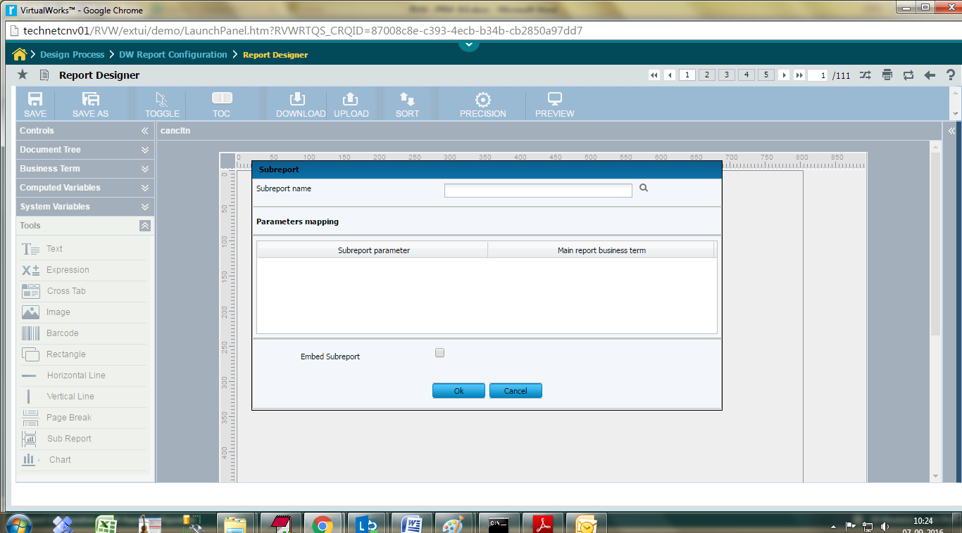

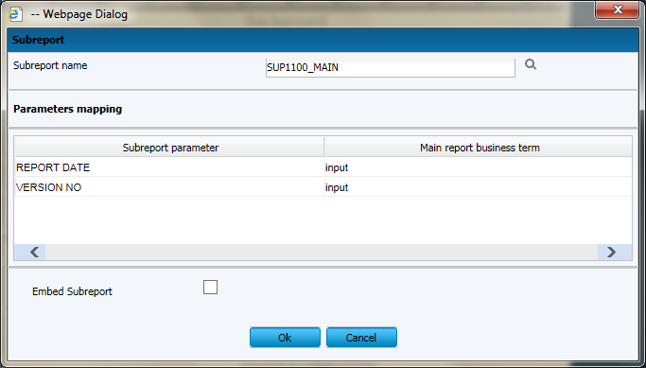

### 

Charts

DW currently supports the following types of charts: Hierarchy, Composition charts like; Pie, Pie 3D, Stacked Bar, Stacked Bar 3D, Stacked Area, Comparison charts like; Line Chart, Area Chart, Bar, Bar 3D and Multi-Axis

**Properties**

Charts are normal report elements, so they share some of their properties with all the other report elements.

**Sub-Elements**

The sub-elements of a chart are:

* **Box**: This element is used to surround charts by a border that's customizable on each side.
* **Chart Title**: This element is used to place the title of the chart. The position attribute decides the title position of the chart in the report. This element has attributes - Position (Values could be Top, Bottom, Left, Right. Default value is Top), color. Chart Title has font and title Expression as sub elements.
* **Chart Subtitle:** This element is used to place the subtitle of the chart. This element has attribute - color. Chart subtitle has font and subtitle Expression as sub elements.
* **Chart Legend:** The element can control the font-related properties as well as the text color and the background color of the chart legend using this element. This element has attributes – text Color, background Color
* **Anchor Name Expression**: This element creates the target for the anchor.
* **Hyperlink Reference Expression**: This element contains a report expression indicating the name of the external resource (usually a URL).
* **Hyperlink Anchor Expression**: Hyperlink points to an anchor in an external resource.
* **Hyperlink Page Expression**: Hyperlink points to a page in the current report.
* **Hyperlink Tooltip Expression**: This element controls the ToolTip of hyperlink. The type of the expression should be java.lang.String.
* **Hyperlink Parameter**: This element when present generates a final hyperlink depending on the parameter values.

Attributes

Attributes in the chart element available for all chart types are:

* **Show Legend**: This attribute is used to determine if a chart legend will be displayed on the report. Values could be true, false. Default value is true
* **Evaluation Time**: Determines when the chart's expression will be evaluated. Values could be Now, Report, Page, Column, Group, Band. Default value is Now.
* **Evaluation Group**: This attribute determines the name of the group to be used to evaluate the chart's expressions. The value for this attribute must match the name of the group we would like to use as the chart's evaluation group.
* **Hyperlink Type**: This attribute can hold any text value. Default value is None. This means neither the text fields nor the images represent hyperlinks, even if the special hyperlink expressions are present.
* **Hyperlink Target**: This attribute help customize the behavior of the specified link when it is clicked in the viewer. Values could be Self, Blank. Default value is Self
* **Bookmark Level**: This attribute when set to a positive integer, generate bookmarks in reports exported to PDF. Default value is 0.
* **Customizer Class**: This is the name of a class (optional) that can be used to customize the chart. The value for this element must be a String containing the name of a customizer class.

### Datasets

* One of the common properties across all chart types is dataset element. Chart datasets help mapping report data and retrieving chart data at runtime. Each chart type contains different sub-elements to define a chart's expressions that define the data used to generate the chart. All of these sub-elements contain a dataset element that defines when the chart's expressions are evaluated and reset.
* Several types of chart datasets are available in DW because each type of chart works with certain datasets: Pie, Category, XY and XYZ. All chart datasets initialize and increment in the same way, and differ only in the type of data or data series they map.

### Dataset Properties

Table below summarizes the attributes of the element dataset.

|  |  |  |
| --- | --- | --- |
| **Attribute** | **Description** | **Values** |
| Reset Type | This attribute determines when the value of the chart expression is to be reset. | None, Report, Page, Column, Group. Default value is Report |
| Reset Group | This attribute determines the name of the group at which the chart expression value is reset. | The value for this attribute must match the name of any group declared in the JRXML report template. |
| Increment Type | This attribute determines when to recalculate the value of the chart expression. | None, Report, Page, Column, Group. Default value is "None". |
| Increment Group | This attribute determines the name of the group at which the chart expression is recalculated. | The value for this attribute must match the name of a group declared in the JRXML report template. |

Table below summarizes the sub elements of the element dataset

|  |  |
| --- | --- |
| **Sub element** | **Description** |
| Increment When Expression | The way a chart dataset is incremented can be customized by filtering out unwanted data through the use of this sub element. |
| Dataset Run | This contains information required to instantiate a report sub dataset. |

Specific dataset types are explained below:

Pie Dataset

A pie dataset is characterized by the following expressions:

* Key Expression - represent the categories that will make up the slices in the pie chart. This expression can return any java.lang.Comparable object.
* Value Expression - produces the values that correspond to each category/key in the dataset. Values are always java.lang.Number objects.
* Label Expression - if this expression is missing, the chart will display default labels for each slice in the pie chart. Use this expression, which returns java.lang.String values, to customize the item labels for the pie chart.
* Section Hyperlink - sets hyperlinks associated with pie sections.

Category Dataset

A category dataset is characterized by the categorySeries element, which contains:

* Series Expression - indicates the name of the series. This expression can return any java.lang.Comparable object.
* Category Expression - returns the name of the category for each value inside the series specified by the series expression. Categories are java.lang.Comparable objects.
* Value Expression - produces the values that correspond to each category in the dataset. Values are always java.lang.Number objects.
* Label Expression - if this expression is missing, the chart will display default labels for each item in the chart. Use this expression, which returns java.lang.String values, to customize the item labels for the chart.
* Item Hyperlink - sets hyperlinks associated with chart items

Types of Charts

DW Reports offers built-in support for several chart types. They are listed as below:

* **Pie Chart**: A combination of a Pie dataset and a Pie plot.
* **Pie 3D Chart**: Groups a Pie dataset and a Pie 3D plot.
* **Bar Chart**: A basic combination of a Category dataset and a Bar plot.
* **Bar 3DChart**: Wraps a Category dataset and a Bar 3D plot.
* **Stacked Bar Chart**: Uses data from a Category dataset and renders its content using a Bar plot.
* **Stacked Bar 3DChart**: Uses data from a Category dataset and renders its content using a Bar 3D plot.
* **Line Chart**: Groups a Category dataset and a Line plot.
* **Area Chart**: Items from a Category dataset are rendered using an Area plot.
* **Stacked Area Chart**: Items from a Category dataset are rendered using an Area plot.
* **MultiAxis Chart**: Contains multiple range axes, all sharing a common domain axis.

Chart definition:

Select a chart type

- Organization

- Composition

- Comparison. Click Next button

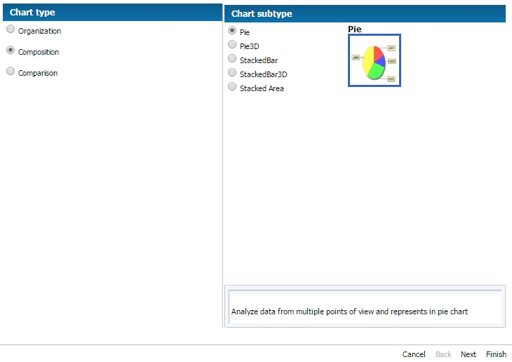

Provide Series Expression:

**Key / Category Expression**: The value to be displayed on X-Axis (Mandatory)

**Value Expression**: The value to be displayed on Y-Axis (Mandatory)

**Label expression**: To specify labels for each data point in the chart (Optional)

**Series Expression**: To display data point of the field.

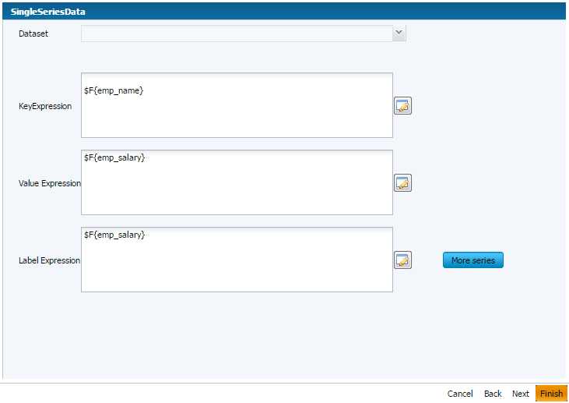

**Reset type:** Choose the band at which chart data is to refresh. Used with Report/Page/Group/Column.

**Increment Type:** The band at which chart data will be incremented. Used with Report/Page/Group/Column.

**Filter Expression**: Any filter which is to be applied.

**Tooltip Expression**: The selected field will show tooltip.

Click Finish button to save the chart configuration

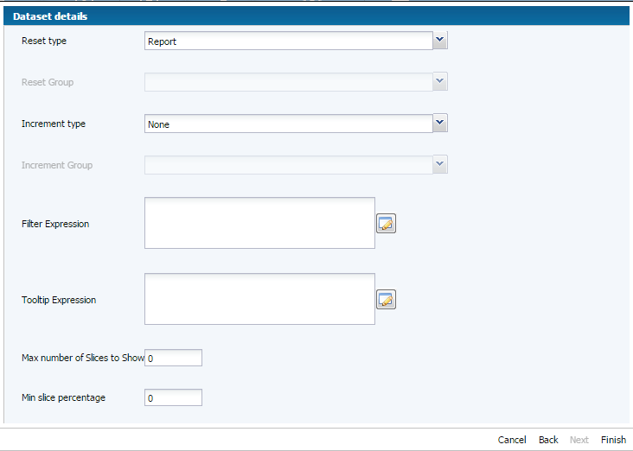

Below image shows a Pie Chart designed in Enterprise Report.

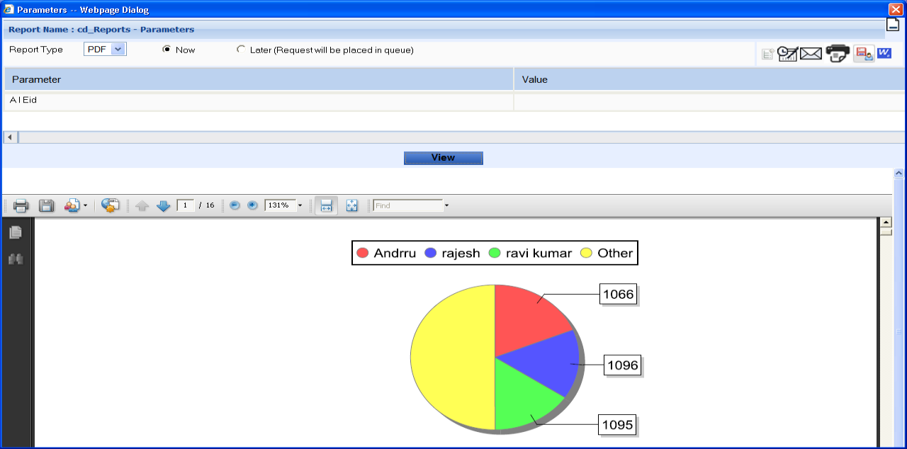

Crosstab Reports

Crosstab (cross-tabulation) reports are reports containing tables that arrange data across rows and columns in a tabular form. Crosstab object is used for inserting a crosstab report within the main report. Crosstabs can be used with any level of data (nominal, ordinal, interval, or ratio), and usually display the summarized data, contained in report variables, in the form of a dynamic table. Variables are used to display aggregate data such as sums, counts, average values.

### CrossTab Properties

Following is the list of attributes of a Crosstab element:

* **Repeat Column Headers**: Indicates whether the column headers should be reprinted after a page break. The default value is true.
* **Repeat Row Headers:** Indicates whether the row headers should be reprinted after a crosstab column break. The default value is true.
* **Column Break Offset**: When a column break occurs, indicates the amount of vertical space, measured in pixels, before the subsequent crosstab piece to be placed below the previous one on the same page. The default value is 10.
* **Run Direction**: Indicates whether the crosstab data should be filled from left to right (LTR) or from right to left (RTL). The default value is LTR.
* **Ignore Width**: Indicates whether the crosstab will stretch beyond the initial crosstab width limit and don't generate column breaks. Else it will stop rendering columns within the crosstab width limit and continue with the remaining columns only after all rows have started rendering. The default value is false.

Sub Elements

A crosstab element has following sub elements:

* Report Element: This element defines the position, width, and height of the crosstab within its enclosing. Attributes for this element include all standard report Element attributes.
* Crosstab Parameter: This element is used to access report variables and parameters from within the crosstab. Attributes for this element include:
  + Name: This defines the parameter name.
  + Class: This indicates the parameter class.
* Parameters Map Expression: This element is used to pass a report variable or parameter, as a set of parameters for the crosstab. This element contains no attributes.
* Crosstab Dataset: This element defines the dataset to use to populate the crosstab (see next section for a detailed explanation). Attributes for this element include:
  + Data Pre Sorted: This indicates whether the data in the dataset is pre-sorted. Default value is false.
* Crosstab Header Cell This element defines the content of the region found at the upper-left corner of the crosstab where column headers and row headers meet. The size of this cell is calculated automatically based on the defined row and column widths and heights.
* Row Group: This element defines a group used to split the data into rows. Attributes for this element include:
  + Name: This defines the name of the row group.
  + Width: This defines the width of the row group.
  + Header Position: This defines the position of the header contents (Top, Middle, Bottom and Stretch).
  + Total Position: This defines the position of the entire column (Start, End, None).

This element contains the following sub elements:

* + bucket
  + Crosstab Row Header
  + Crosstab Total Row Header
* Column Group: This element defines a group used to split the data into columns. Attributes for this element include:
  + Name: This defines the column group name.
  + Height: This defines the height of the column group header.
  + Header Position: This defines the position of the header contents (Right, Left, Center, and Stretch).
  + Total Position: This defines the position of the entire column (Start, End, None).

This element contains the following sub elements:

* + bucket
  + Crosstab Column Header
  + Crosstab Total Column Header
* Measure: This element defines the calculation to be performed across rows and columns. Attributes for this element include:
  + Name: This defines the measure name.
  + Class: This indicates the measure class.
  + Calculation: This indicates the calculation to be performed between crosstab cell values. Its values could be any of these - Nothing, Count, Distinct Count, Sum, Average, Lowest, Highest, Standard Deviation, Variance, First. Default value is nothing.
* Crosstab Cell: This element defines how data in non-header cells will be laid out. Attributes for this element include:
  + Column Total Group: This indicates the group to use to calculate the column total.
  + Height: This defines the height of the cell.
  + Row Total Group: This indicates the group to use to calculate the row total.
  + Width: This defines the width of the cell.
* When No Data Cell: This element defines what to display on an empty crosstab cell. This element contains no attributes.

The crosstab calculation engine aggregates data by iterating through the associated dataset records. In order to aggregate data, one needs to group them first. In a crosstab, rows and columns are based on specific group items, called buckets. A bucket definition should contain:

* Bucket Expression: The expression to be evaluated in order to obtain data group items.
* Comparator Expression: Needed in the case the natural ordering of the values is not the best choice.
* Order By Expression: Indicates the value used to sort data.

Row and column groups (defined above) in a crosstab rely on buckets.

Built-In Crosstab Total Variables

Below is a list of current value of measure and totals of different levels corresponding to the cell can be accessed through variables named according to the following scheme:

* The current value of a measure calculation is stored in a variable having the same name as the measure.
* Measure _ Column Group _ALL: This yields the total for all the entries in the column group from the same row..
* Measure _ Row Group _ALL: This yields the total for all the entries in the row group from the same column.
* Measure _ Row Group _ Column Group _ALL: This yields the combined total corresponding to all the entries in both row and column groups.

###### Creating Crosstab Reports

Drag and drop a crosstab object into the Report Footer section of the report

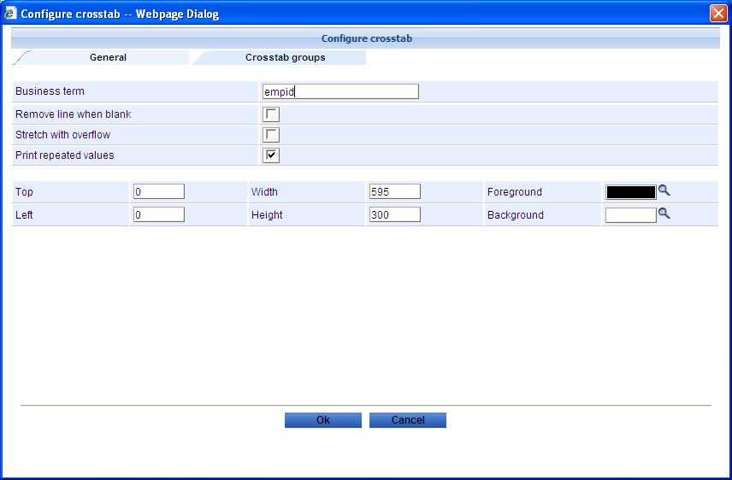

Map the BT’s into respective Row/Column/Measure group

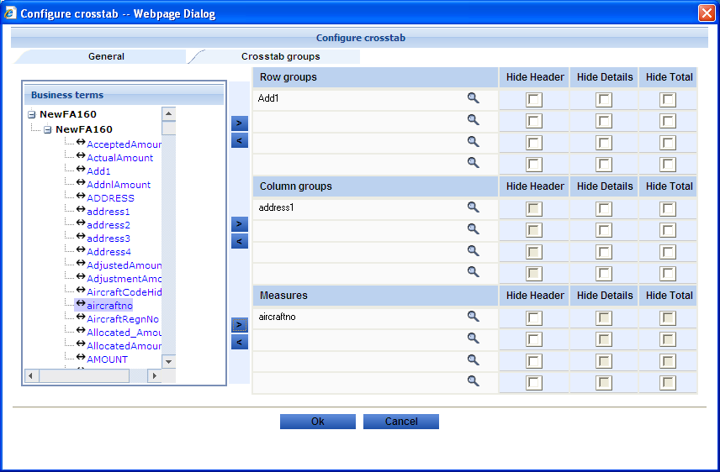

Double Click the Cross Tab to open the Cross Tab Designer Dialog Box. Cross Tab Properties can be changed here.

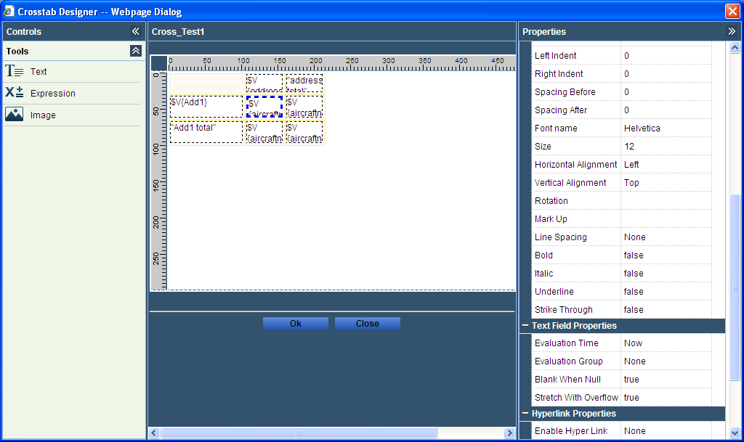

Below Image shows the output of cross tab.

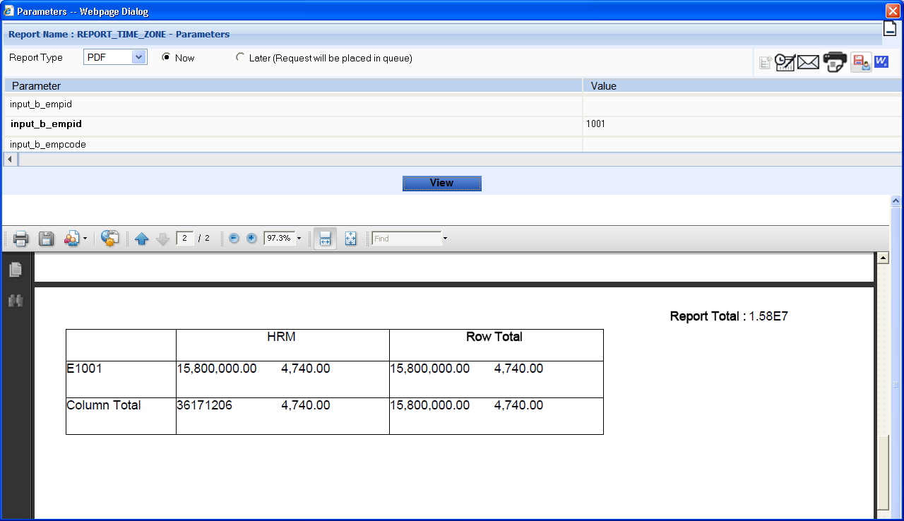

### 

### Right Pane

Section, Elements and Attribute Relation

The following diagram shows the elements and attributes relationship in a section in a report.

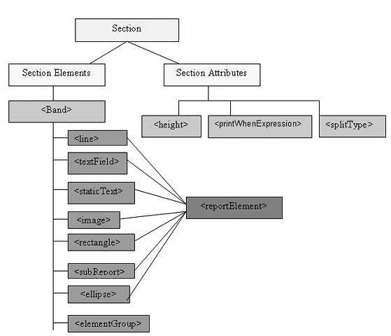

Section Elements

All the above mentioned report sections are optional. But any report template will have at least one such section. Each of these sections contains a single band element as its only sub-element. A band can contain zero or more following sub-elements:

Each of these elements must contain a single report Element as its first element (except element Group). A report Element determines how data is laid out for that particular element. Unlike variables and parameters, report elements are not required to have a name, because normally you do not need to obtain any individual element inside a report template.

The table below summarizes the attributes of report Element:

|  |  |  |
| --- | --- | --- |
| **Attribute** | **Description** | **Valid Values** |
| x | Specifies the x coordinate of the band element. | An integer value indicating the x coordinates of the element in pixels. This attribute is required. |
| y | Specifies the y coordinate of the band element. | An integer value indicating the y coordinates of the element in pixels. This attribute is required. |
| Width | Specifies the width of the band element. | An integer value indicating the element width in pixels. This attribute is required. |
| Height | Specifies the height of the band element. | An integer value indicating the element height in pixels. This attribute is required. |
| Key | Unique identifier of band element. | A unique string value. |
| Stretch Type | Specifies how the element stretches when the containing band stretches | **NoStretch (default**): The element will not stretch. |
| **RelativeToTallestObject:** The element will stretch to accommodate the tallest object in its group. |
| **RelativeToBand:** The element will stretch to fit the band's height. |
| Position Type | Specifies the element's position when the band stretches. | Float: The element will move depending on the size of the surrounding elements. |
| FixRelativeToTop (default): The element will maintain a fixed position relative to the bands top. |
| FixRelativeToBottom: The element will maintain a fixed position relative to the band's bottom. |
| Print Repeated Values | Specifies if repeated values are printed. | True (default): Repeated values will be printed. |
| False: Repeated values will not be printed. |
| Mode | Specifies the background mode of the element | Opaque, Transparent |
| Remove Line When Blank | Specifies if the element should be removed when it is blank and there are no other elements in the same horizontal space. | true, false |
| Print In First Whole Band | Specifies if the element must be printed in a whole band, that is, a band that is not divided between report pages or columns. | true, false |
| Print When Detail Overflows | Specifies if the element will be printed when the band overflows to a new page or column. | true, false |
| Print When Group Changes | Specifies that the element will be printed when the specified group changes. | A string value. |
| Fore Color | Specifies the foreground color of the element. | Color can be chosen by clicking the fore color help |
| Back color | Specifies the background color of the element. | Color can be chosen by clicking the back color help |

Section Attributes

Following are attributes of a report section:

**Height**

Height of the section specifies the height in pixels for that particular section and is very important in the overall report design.

**Print When Expression**

A Boolean expression that determines whether the section should be printed or not.

**Split Allowed**

A flag indicating whether the section is allowed to split when it does not fit on the current page. If true, the section will be transferred to the next page. Note that in case the section does not fit on the next page then the section will be split regardless of the flag's value. splitType can take following values:

* "Stretch”: Splits stretched content. If the section stretches on the current page(if the available space is less than declared height), the region that is added to the original height is allowed to split onto the next page
* "Prevent”: Prevent split on first attempt. If the section does not fit on the next page, the split occurs normally, as band split prevention is effective only on first split attempt.
* "Immediate”: Split immediately. The band is allowed to split anywhere except above its topmost element.

Report Fonts

A report font is a collection of font settings, declared at the report level. A report font can be reused throughout the entire report template when setting the font properties of text elements.

**Font Attributes**

Table below summarizes the main attributes of the font element:

|  |  |
| --- | --- |
| **Attribute** | **Description** |
| Font Name | The font name, which can be the name of a physical font, a logical one or the name of a font family from the registered DW font extensions. |
| Size | The size of the font measured in points. It defaults to 10. |
| Bold | The flag specifying if a bold font is required. It defaults to false. |
| Italic | The flag specifying if an italic font is required. It defaults to false. |
| Underline | The flag specifying if the underline text decoration is required. It defaults to false. |
| Strike Through | The flag specifying if the strikethrough text decoration is required. It defaults to false. |
| Pdf Font Name | The name of an equivalent PDF font required by the iText library when exporting documents to PDF format. |
| Pdf Encoding | The equivalent PDF character encoding, also required by the iText library. |
| Pdf Embedded | The flag that specifies whether the font should be embedded into the document itself. It defaults to false. If set to true, helps view the PDF document without any problem. |

Font types

In DW fonts can be categorized in the following types:

1. **Logical Fonts**: These fonts are the five font types that have been recognized by the Java platform since version 1.0: Serif, SansSerif, Monospaced, Dialog, and DialogInput. These logical fonts are not actual font libraries that are installed anywhere on the system. They are merely font type names recognized by the Java runtime. These must be mapped to some physical font that is installed on the system.
2. **Physical Fonts**: These fonts are the actual font libraries consisting of, for example, TrueType or PostScript Type 1 fonts. The physical fonts may be Arial, Time, Helvetica, Courier, or any number of other fonts, including international fonts.
3. **Font Extensions**: The DW Report library can make use of fonts registered on-the-fly at runtime, through its built-in support for font extensions. A list of font families can be made available to the DW Report using font extension. These are made out of similarly looking font faces and supporting specific locales.

As described in the table above we need to specify in the attribute fontName the name of a physical font, the name of a logical font, or the name of a font family from the registered DW font extensions.

**Fonts**

DW Report s recognizes the following font names:

* Helvetica
* Helvetica-Bold
* Helvetica-BoldOblique
* Helvetica-Oblique
* Courier
* Courier-Bold
* Courier-BoldOblique
* Courier-Oblique
* Times-Roman
* Times-Bold
* Times-BoldItalic
* Times-Italic
* Arial
* Arial-Bold
* Verdana
* Verdana-Bold
* Arial Black
* Arial Narrow
* Arial Rounded MT Bold
* Book Antiqua
* Book Antiqua Bold
* Bookman Old Style
* Calibri
* Century
* Century Gothic
* Courier New
* Lucida Bright
* Lucida Console
* Lucida Fax
* Lucida Sans
* Lucida Sans Typewriter
* Microsoft Sans Serif
* Tahoma
* Times New Roman
* Angsana New
* Wingdings 2
* Mangal
* Rupee_Foradian
* Micre13B
* Trebuchet MS

Font Sizes

DW Reports support a wide range of Font size from as low as 3 to big as 96.

## Adhoc Report

Ramco Adhoc Reporting is targeted towards empowering with a complete flexibility to create reports on the fly on a business friendly semantic model eliminating the need for the end users to know everything about the complex technical information about how and where the data is stored.

It allows end users to easily generate their own reports by modifying existing ones using the published business terms (BT’s) by simple drag and drop. It also enables end users to dynamically modify and drill through report data for powerful information analysis, can be visualized in multiple formats including charts and collaborated with other users.

## Creation of Adhoc Reports

The following are the ways to create Adhoc reports;

* Creating Adhoc reports using Stored procedures
* Creating Adhoc reports using Views
* Creating Adhoc reports using Queries

### Report Creation in Normal Method

This is the usual method of Adhoc report creation wherein, we need to explicitly visit the screens for Data source, Functional Area, Business terms for Enterprise Report and Analysis Configuration.

## Creating reports using Stored Procedures

**Data source Definition**

It is the process of defining a reference to the database where the required data resides. This database will be the source of information that is presented in the report.

The first step is the data source definition. The data source specifications are declared in this step.

**Menu**: 

**Data Source Configuration:**

The system displays the Data source Configuration page on the left pane as shown below:

This page displays a list of existing data sources in drop down list.



### Creating a data source

**To define a new data source, click the New button.**



Enter the following fields in the right pane:

Data Source Name A unique name assigned to a data source. Mandatory.

Description The description of the data source.

Data Source Type Select the type of data source from the drop-down list box. The system displays “Database”,”Warehouse” and “OLAP".

Server Name The name of the database server .Mandatory

Database User Id A unique ID assigned to a user for the database server. Mandatory

Database Password The password for the user ID for the database server.

Port Number The port number for connecting to the data source. Mandatory

**Click the Get Databases button to get the database details.**

**Database Name** The system displays all databases in the drop-down list box.

Click the **Save** button to save the data source details.

### Edit the data source

Choose **Data Source name** from drop-down list box and Click the **Edit button** to modify the data source detail.



To modify the following fields:

Description The description of the data source.

Server Name The name of the database server .Mandatory

Database User Id A unique ID assigned to a user for the database server. Mandatory

Database Password The password for the user ID for the database server.

Port Number The port number for connecting to the data source. Mandatory

**Click the Get Databases button to get the database details.**

**Database Name** The system displays all databases in the drop-down list box.

Click the **Save** button to save the modified data Source details.

### Deleting the data source

Choose **Data Source name** from drop-down list box and Click the **Delete button** to delete the data source detail.

Data sources can be deleted only if they are not used in any report configuration.



### Data source Functional Area Mapping

Functional area is a logical or business name given to a group of reports based on subject area Viz., Sales, HR, and Finance.

In this step, you will know the functionality of Functional Area and configure the Functional Area Data source.



This page displays a list of functional areas in drop-down list box



The system displays the following fields:

Functional Area Name Created functional Area name listed in drop- down list box.

***Delete*** Click on **delete** button, Functional Area can be deleted only if they are not used in any report configuration.

New Click on New button, user can create new functional area.

Edit Click on Edit button, user can modify the functional area definition.

### Creating a functional area

Click the **New** button system will display below screen.



Enter the following fields:

Functional Area Name A unique name assigned to a functional area. Mandatory.

Description The description of the functional area.

Data source Name to select the data source that you want to map to the functional area.

**Click the Save button to save the functional area details.**

The new functional area details are saved.

### Analysis Configuration

**Click the New button to create a new Analysis.**

The system displays the details of the Analysis Configuration page.



Analysis Name The name of the analysis of the functional area that is mapped to the stored procedure or query or web service.

Analysis Mode The mode of execution can be either a stored procedure or or web service or View or query. Choose the mode as SP.

Functional Area Select functional area name from drop-down list.

SP type Select, the section of the report to which the stored procedure is attached from the drop-down list box. The drop-down list box contains the following options: “Details” and “Header”.

Header/Detail SP analysis can attach one Header and detail Sp. multiple header / detail SP not allowed. Click on lens icon, it will launch the stored procedure list screen. User can select the SP and click the OK button.

***Stored Procedure List*** The system launches the Stored Procedures List page.



Click the save button to save the Analysis configuration details.

### Edit Analysis Configuration

Select functional area and click the search button.

Choose analysis name from grid and click the edit button.



#### Stored Procedures– Business Terms mapping

This page enables the user to select the business terms to be mapped to the stored procedure column name. The user can also create new business terms through the same page. The Input parameter and the Output parameter details will be defaulted automatically. The Output column (select the columns given in the stored procedure) alone needs to be specified here additionally. The Business Term will be automatically defaulted based on the Input parameter and the Output parameter names.

The system launches the SP/XML Columns – Business Terms Mapping page.

Enter the following fields in the multiline:

Column Number Enter the column number in the order of sequence for each column type (i.e. the input parameter / output parameter) and output column would each have its own sequence.. Mandatory

SP Column Name By default all the table column names would be populated in this field .Mandatory

Column Type Select an appropriate option from the drop-down list box to indicate the column type for the SP column name being defined. The system displays “Input Param”, “Out Param” and “Output Column” as options.

Data Type Select an appropriate option from the drop-down list box to indicate the data type for the SP column name being defined. The system displays “String”, “Number”, “Currency” and “Date” as options.

Business Term Click the  icon displayed to select the business term that you want to map to the stored procedure column name. The system launches the Business Terms List page from which you can select the business term that you want to map to the stored procedure column name.

System Parameters This pertains to the column type “Input param”. Assign values to the input param from the available set of system parameters viz. User, Role, OU, Segment, LangID, SessionID.

Display in Parameter Screen This pertains to the column type “Input param” assigned with System parameter. If this is checked, then this field will be displayed in the Report Input Parameter screen in non-editable mode.

Default Value This pertains to the column type “Input param”. As the name suggests, use this to assign default values to input param.

Blank When NULL This pertains to the column type “Input param”. As name suggests, this is used to default input param with Blank if it is has got a NULL value.

Mandatory Check This pertains to the column type “Input param”. If this is checked, the input param should contain some value mandatorily.

**Click the OK button.**

The system saves the selected SP column names and returns to the main page.

Select the ‘Analysis name’ in the drop down of ‘BT mapping’ tab.

The output columns would be categorized into Dimensions and Measures. All non-numeric fields are categorized as dimensions and all the numeric fields as measures. The columns can be renamed as ‘Business terms’ which would be displayed in the left pane of the report.

Click ‘Next’ button to continue.

### Report Configuration

Click the menu Deployment process -> DW Report Configuration -> DW Report Configuration

**Click the New button to define a new advanced report.**

The system displays the **advanced** Report Definition page.

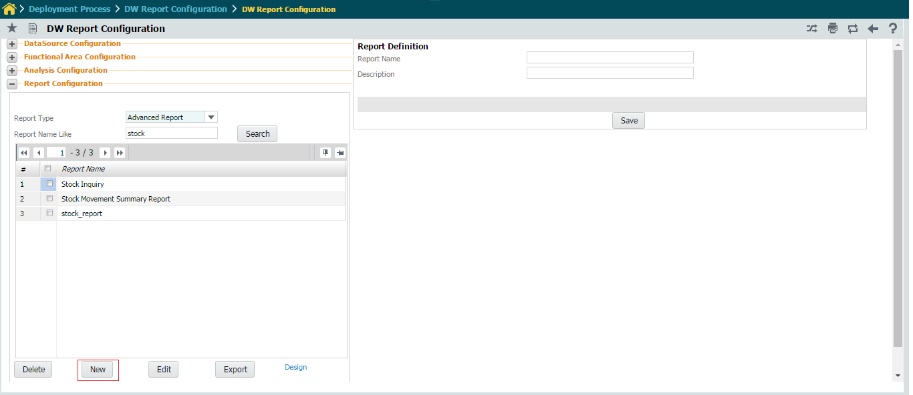

Enter the following fields in right pane.

Report Name The name of the enterprise report. Mandatory.

Report Description The description of the enterprise report.

Click the OK button.

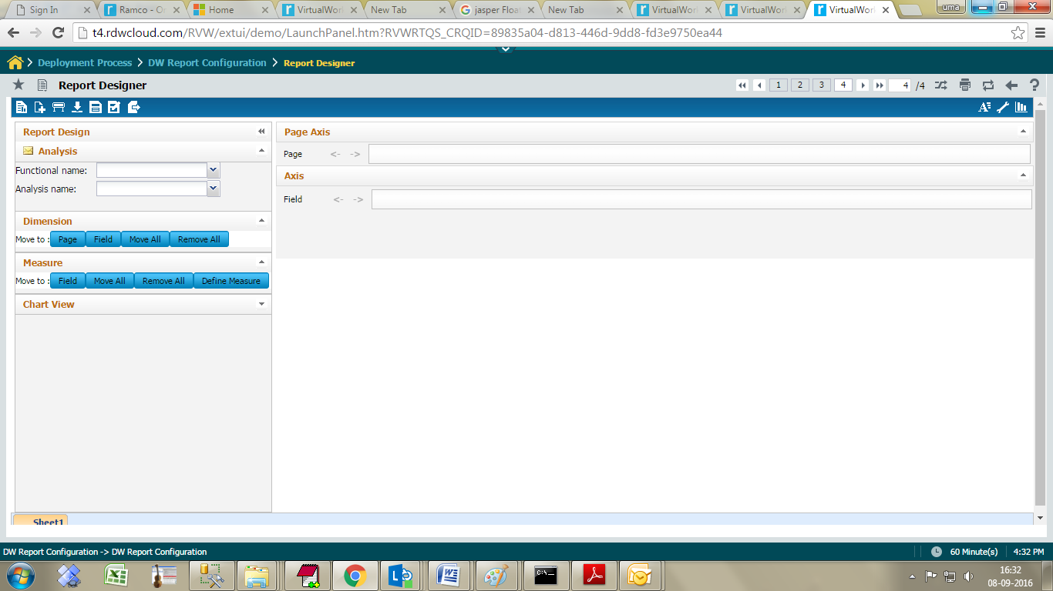

Select the Functional Name, followed by ‘Analysis Name’. The list of dimensions and measures to which the user has security will be displayed.

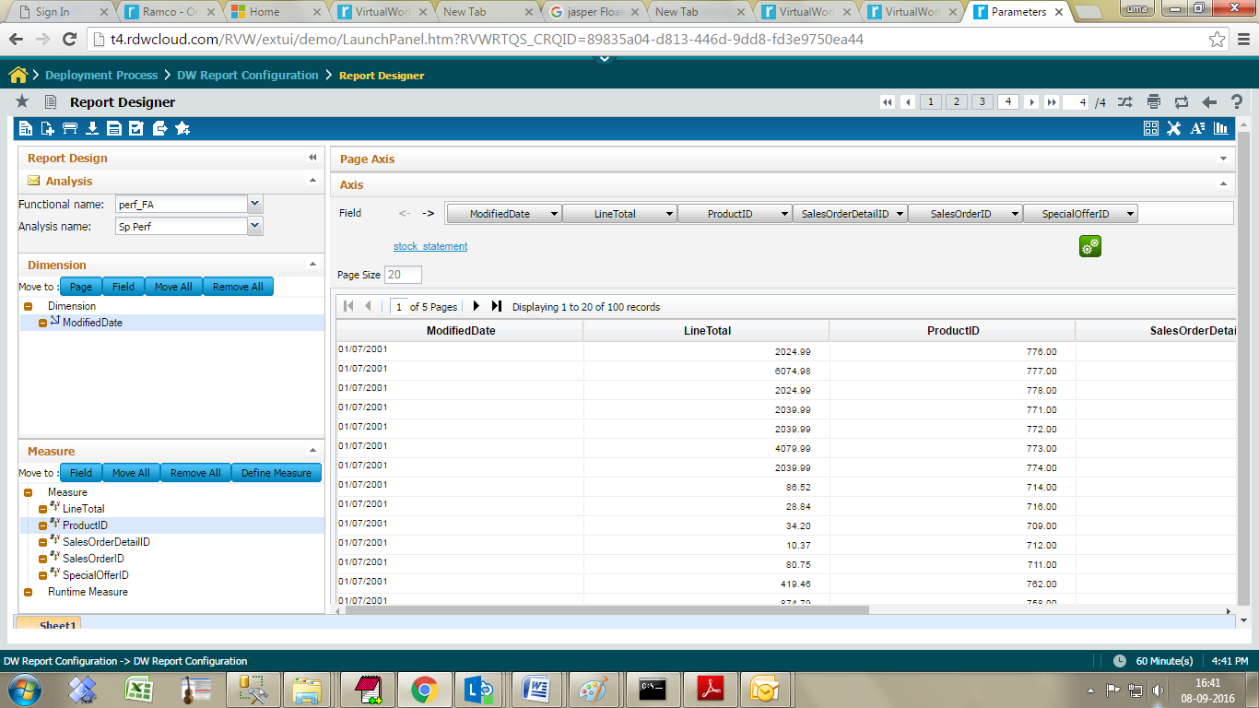

Drag a Dimension / click on dimension followed by ‘Field’ button to place the field in ‘Field’ axis. The dimension placed in ‘Page’ axis will act as Filter to the report.

Drag a ‘Measure’ / click on ‘Field’ button to place a measure in ‘Field’ Axis.

Click the ‘Show data’ icon to launch the report. If the procedure has input parameters, the parameter screen is shown as below. Provide the values for the parameters and click Ok button.

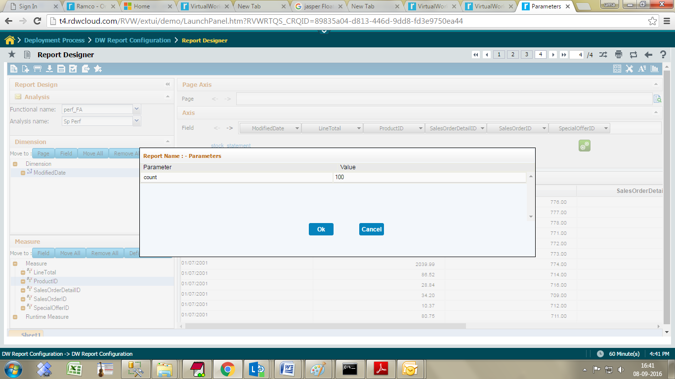

The output is rendered as shown below.

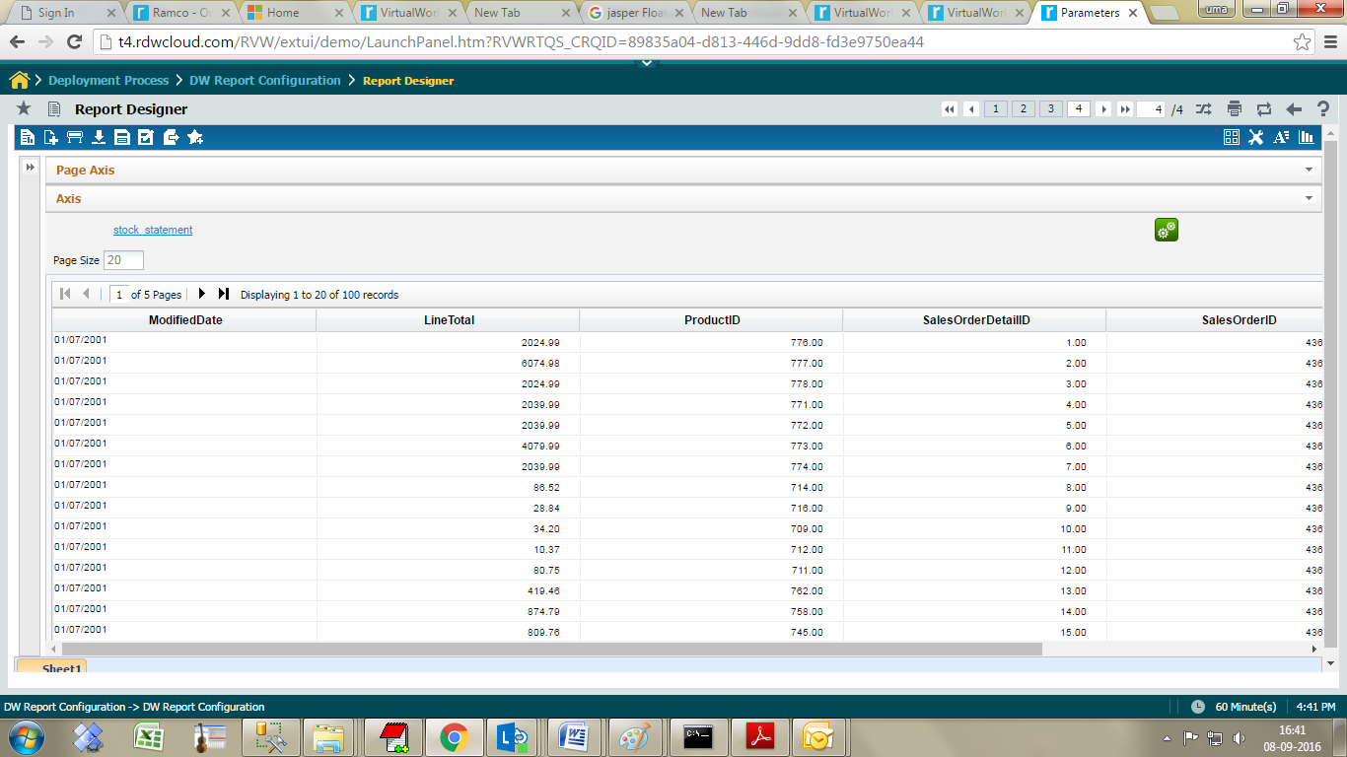

## Creating reports using Views

### Analysis Configuration:

Go to Analysis definition page; create new analysis name and Select Analysis mode as **View**.choose functional area and click the view name icon.

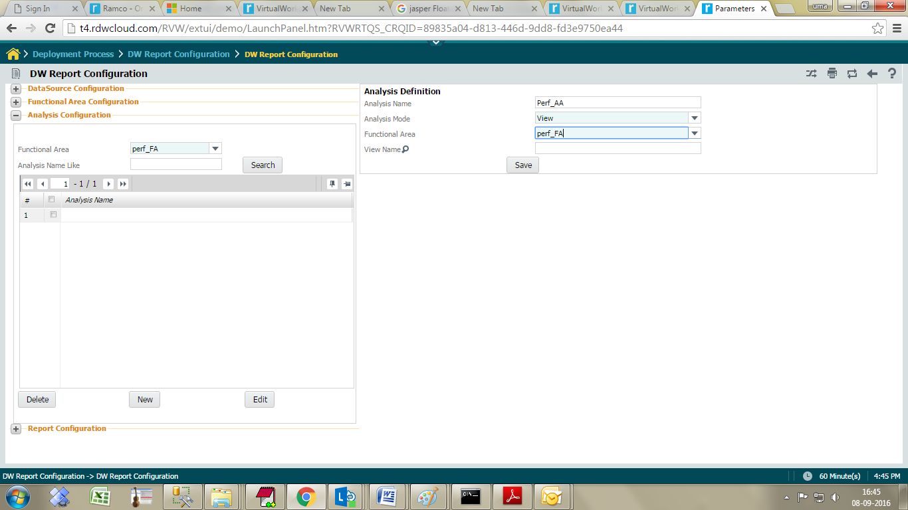

It will launch the view list screen.

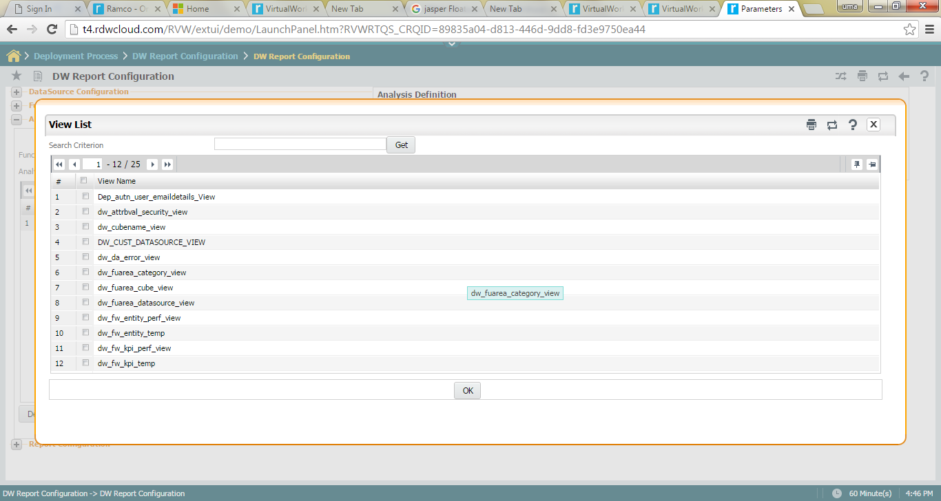

Select the view name from view list. Analysis name and view name should be same.

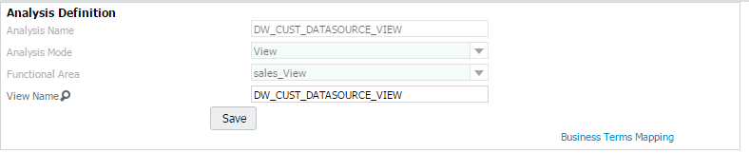

|  |  |  |  |
| --- | --- | --- | --- |
| Click on the Business terms Mapping link, it will display the below screen. |  |  |  |

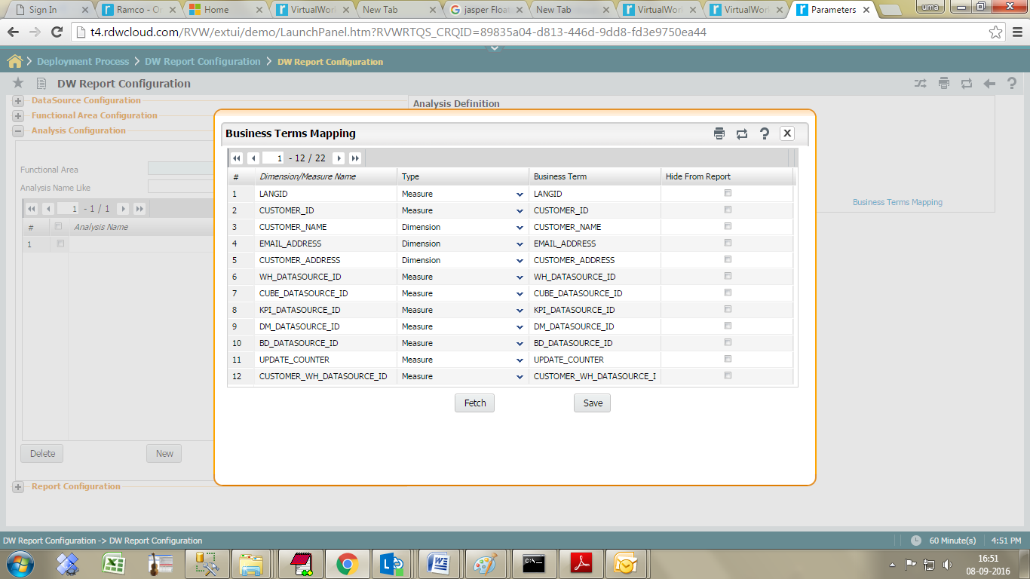

Click Fetch button to list all view Columns.

The output columns would be categorized into Dimensions and Measures. All non-numeric fields are categorized as dimensions and all the numeric fields as measures. The columns can be renamed as ‘Business terms’ which would be displayed in the left pane of the report.

Users can modify the business term.

Some BT is not required for report can able to hide using **Hide from Report** Check box.

Click the **save** button to save all the changes.

Click -> Design button -> to create new report and select the functional area and view name from analysis combo.

Fields are rendering in left pane tree, Drag a Dimension / click on dimension followed by ‘Field’ button to place the field in ‘Field’ axis. The dimension placed in ‘Page’ axis will act as Filter to the report.

Drag a ‘Measure’ / click on ‘Field’ button to place a measure in ‘Field’ axis.

Click on the show button, report get launched.

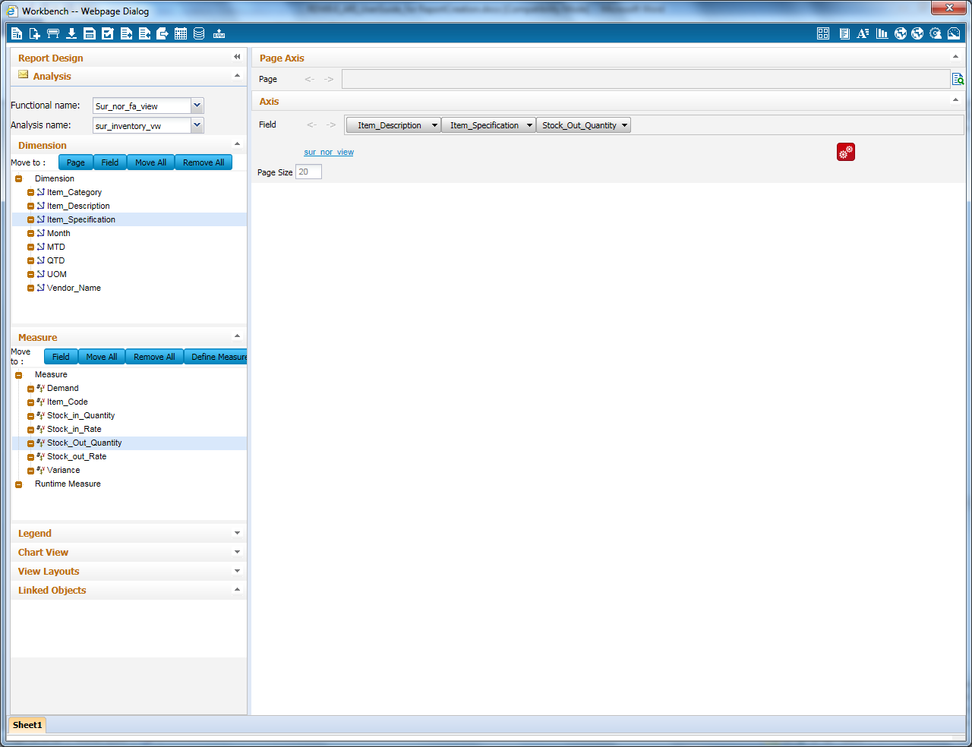

## Creating reports using Queries

In this, three options are available to attach a query while doing the Report Design. They are:

* Click to Upload Query
* Link to Query Builder
* Copy from Existing Query

### Analysis Configuration

Go to Analysis configuration -> click new button.

System display below screen in right pane.

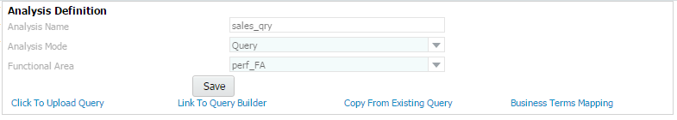

**Analysis Name** Enter analysis name

**Analysis Mode**  Select Query from drop –down list.

**Functional Area**  Select functional area name from drop –down list.

Click **Save** button to create new Analysis for query mode.

**Click to Upload Query**

Click on the link, system will open below screen to load the query window.

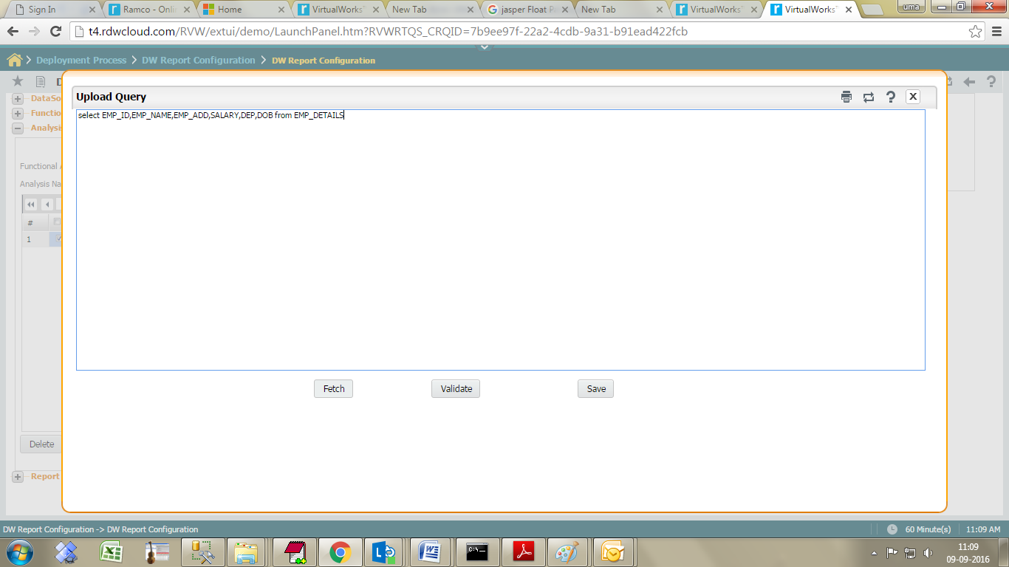

Click on ‘**Fetch’** to fetch uploaded Query.

Click on ‘**Validate’** button to validate the query.

Now click on the ‘**save**’ button to save the query details.

Click the link “**Business Terms mapping”** screen. It will launch the below screen.

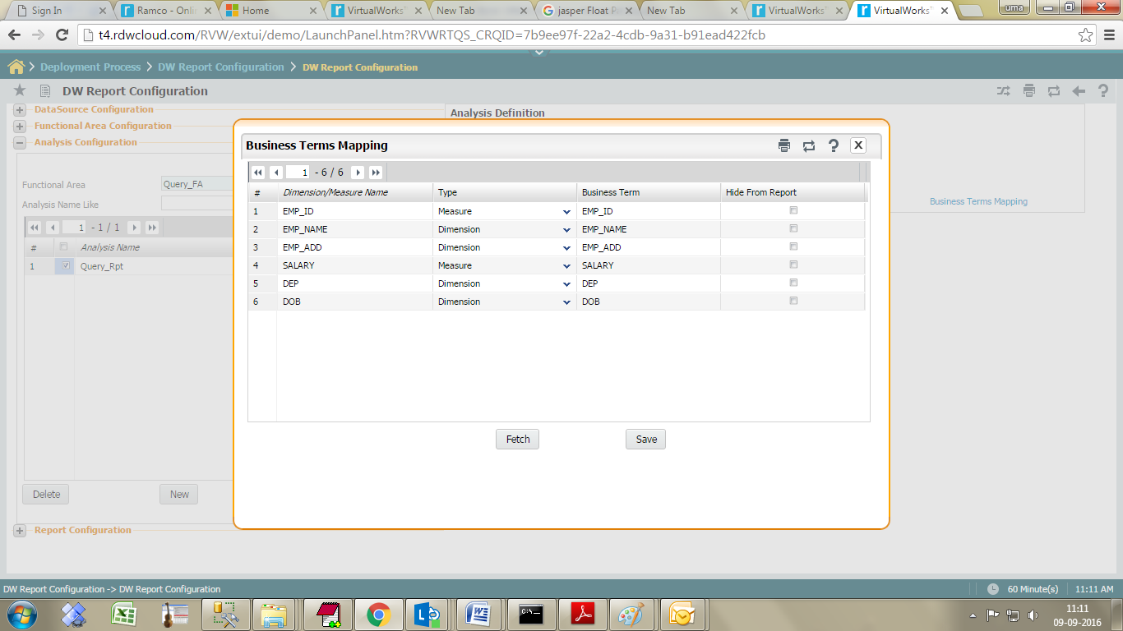

Click the “**Fetch**” button list all dimension and measures in grid. The output columns would be categorized into Dimensions and Measures. All non-numeric fields are categorized as dimensions and all the numeric fields as measures. The columns can be renamed as ‘Business terms’ which would be displayed in the left pane of the report.

Go to **Report Configuration** to create **New** Query based reports.

### Report Configuration:

Click-> New button- > to create new advanced Report using query mode.

Select report name -> click Design button -> system launched new window. Select the functional area and view name from analysis combo.

Fields are rendering in left pane tree, Drag a Dimension / click on dimension followed by ‘Field’ button to place the field in ‘Field’ axis. The dimension placed in ‘Page’ axis will act as Filter to the report.

Drag a ‘Measure’ / click on ‘Field’ button to place a measure in ‘Field’ axis.

Click the ‘Show data’ icon to launch the report.

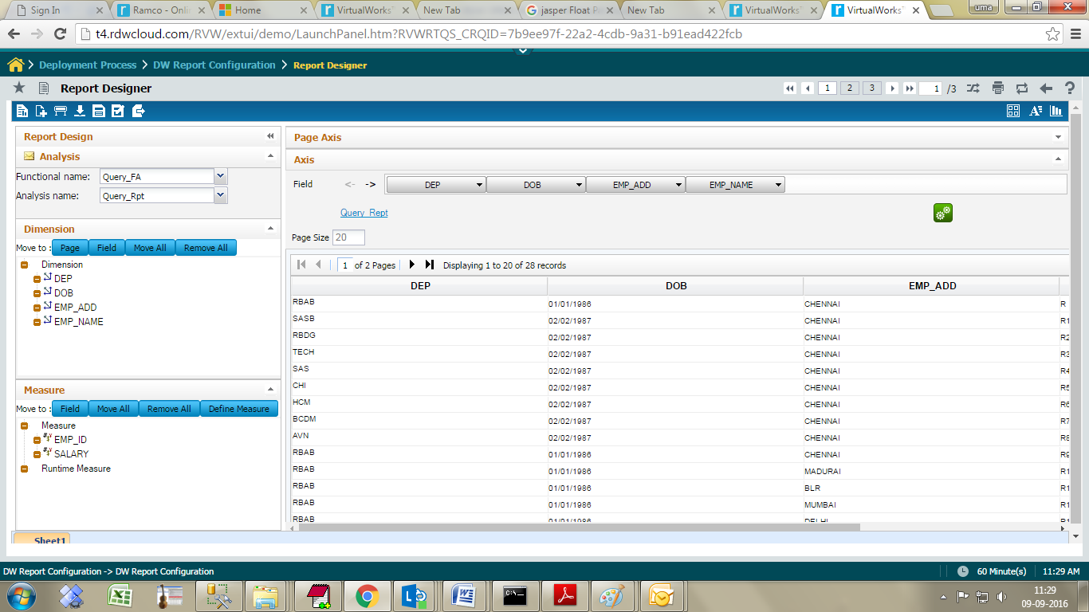

**Option 2 - Link to Query Builder**

Launch Report Design screen under Configure 🡪 Analytical Report 🡪 Report Design. Click on ‘+’ icon to create a new Report.

Click on the link ‘Link to Query Builder’ in the above screen, to launch the below Query Builder screen, for generation of the desired query.

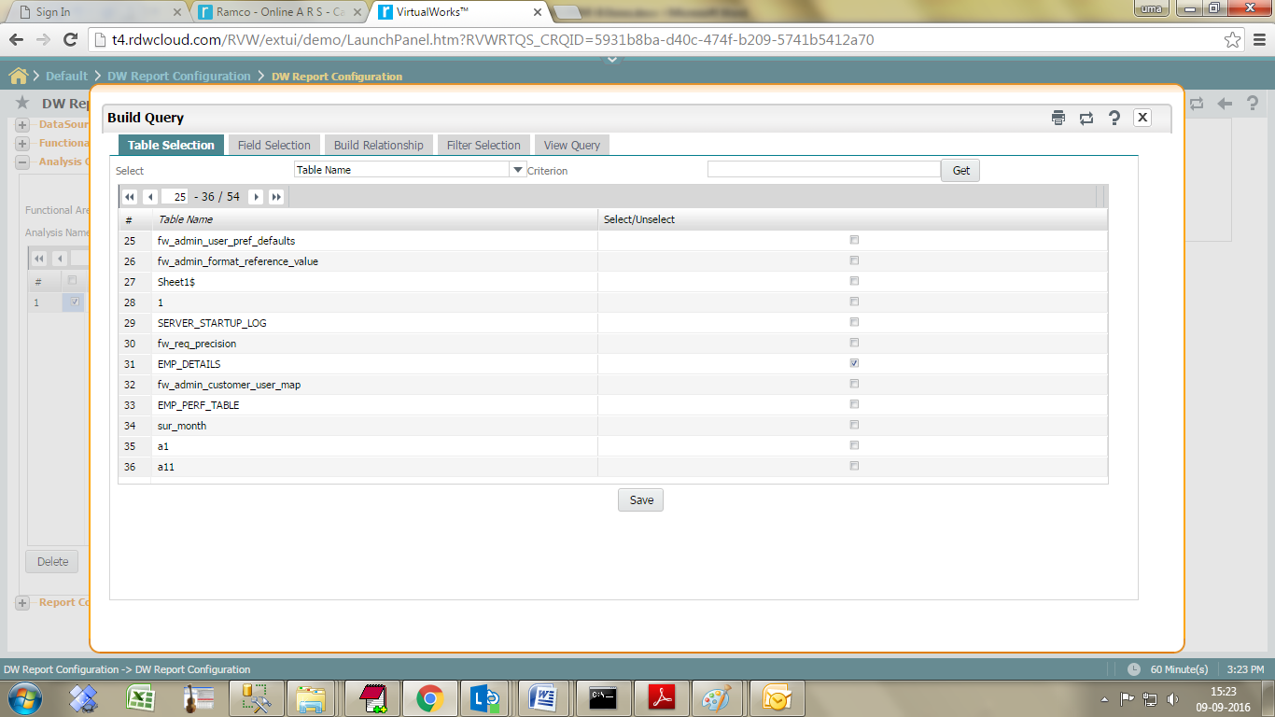

Click the get button list the table.

Select tables from grid and click the save button.

The screen moves to the next tab ‘Field Selection’, where the required columns from the selected tables can be selected.

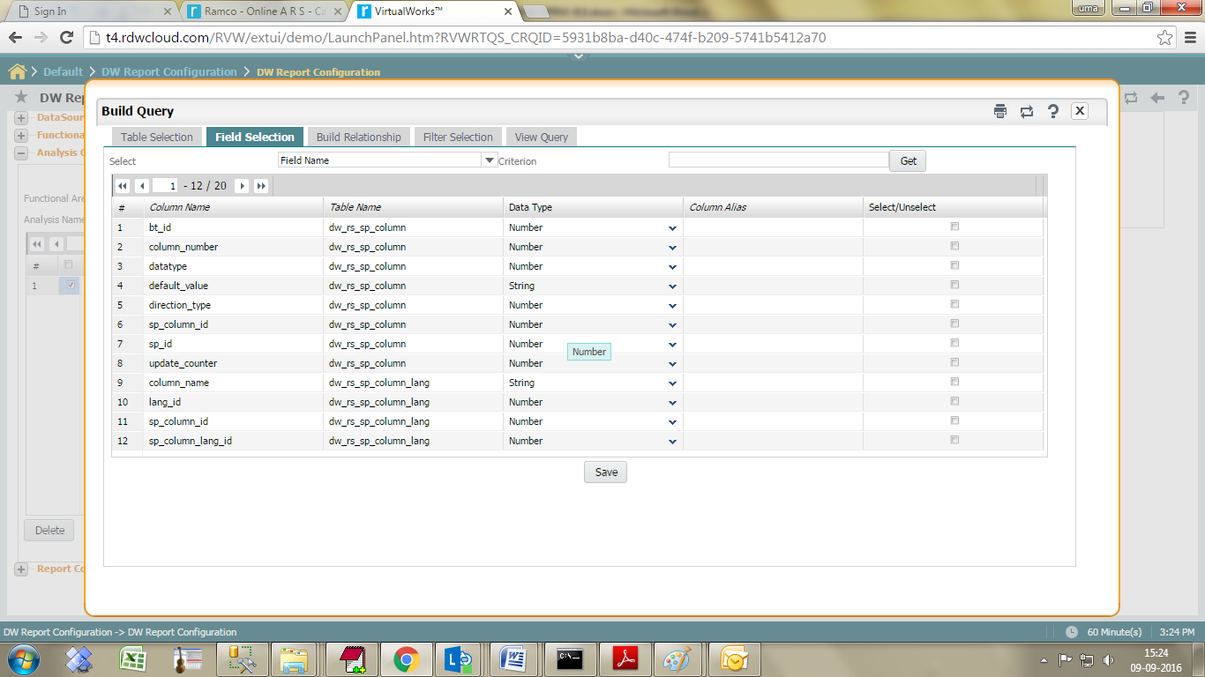

Click the save and move to next tab Build Relationship.

This tab helps to link the tables chosen for the query, as required.

Click on link **“Define Relation”**

Take help on the ‘Base Table Field’ to select a column from base table, for joining appropriately with the other participating tables.

Choose the ‘Join Type’ as required.

Take help on the ‘Related Table Field’ to select a column from participating table for joining with the base table.

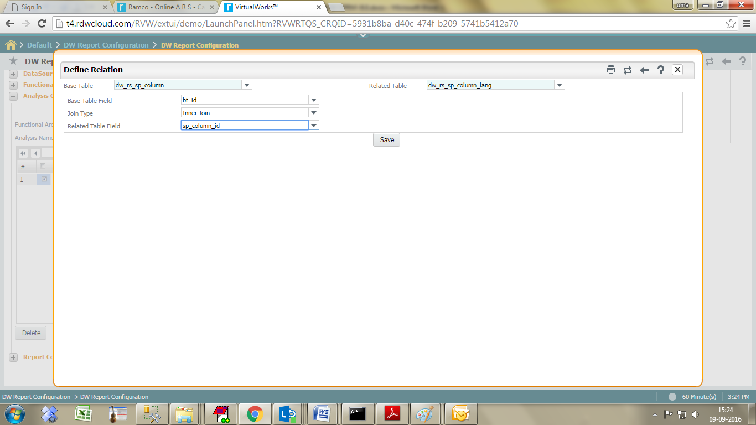

Click save and click back button.

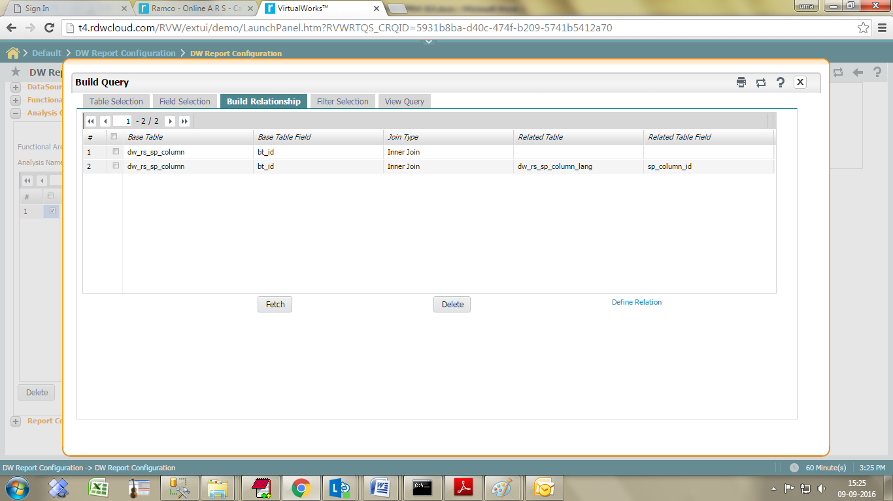

Next click the Filter Selection.

This tab helps in providing filter conditions for the columns chosen in the earlier step. Choose the required columns and provide the filter values accordingly.

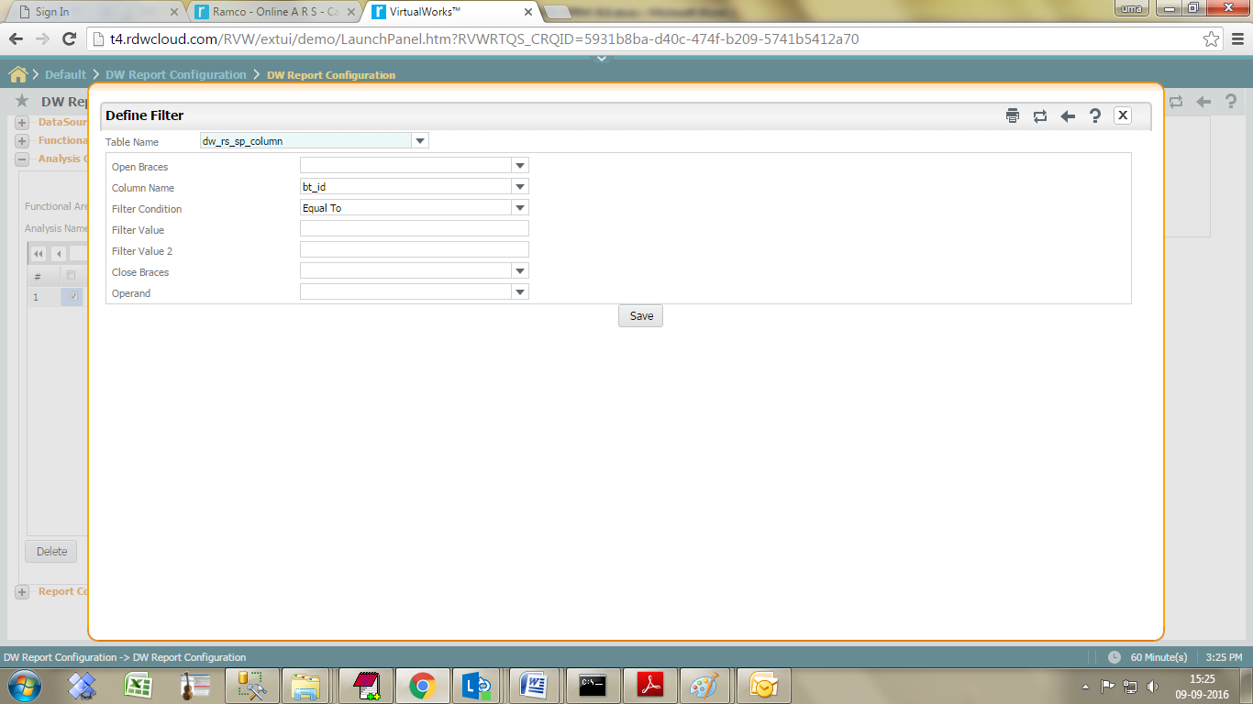

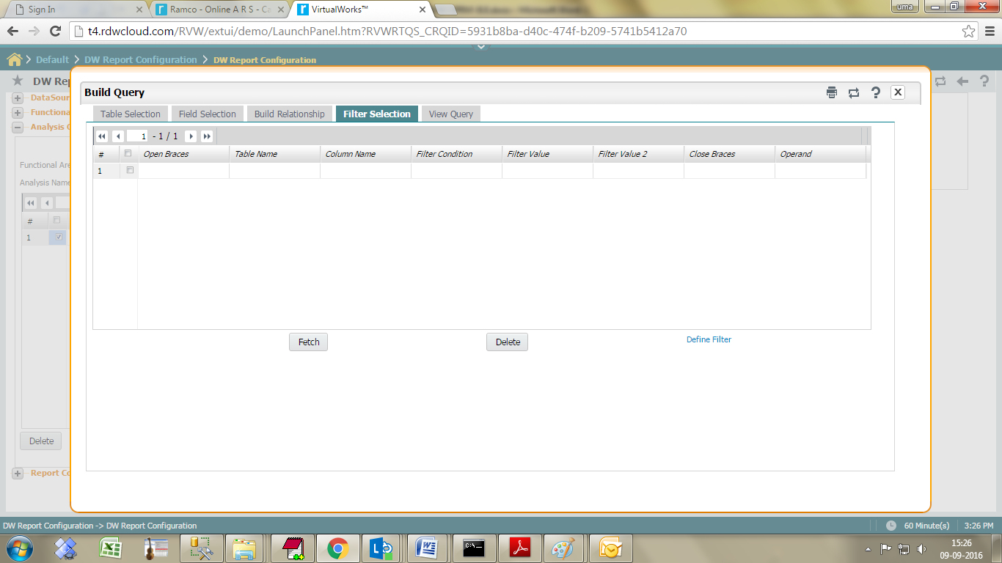

Click on the ‘Next’ tab the focus passes to the View Query tab, where generated query gets displayed.

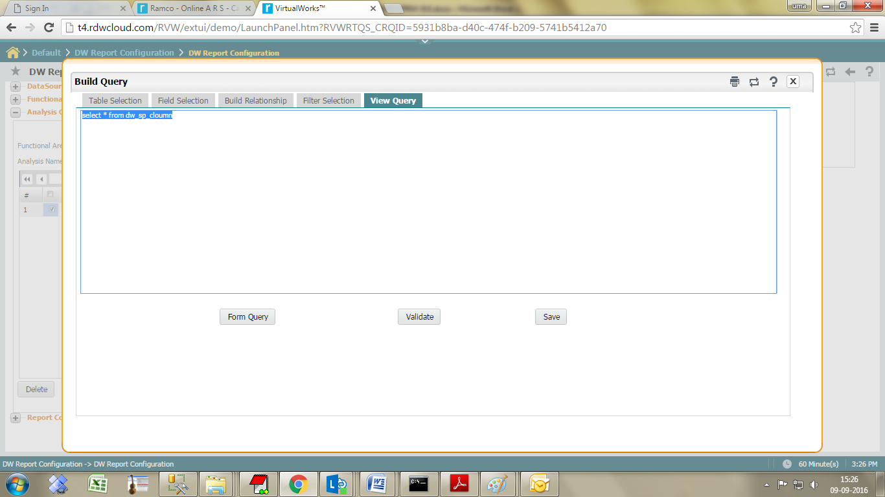

Click save and design new report using this query.

**Option 3 - Copy from Existing Query**

Click on the link ‘Copy from Existing Query’ to launch the below screen.

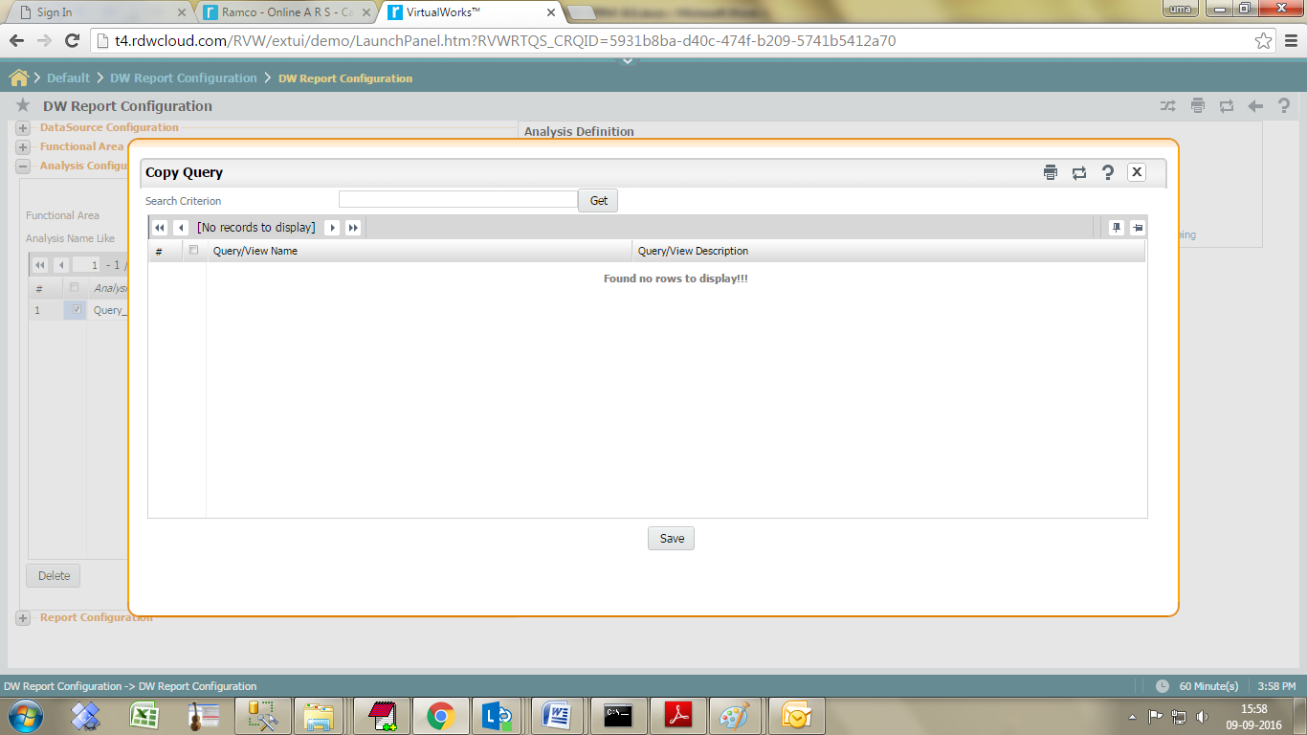

Click the get button it will list all queries in grid. User can select the relevant queries, and click save.

It is possible to retain the selected query content or modify the same by choosing different set of tables/ columns/ joins/ filters, in this process of query generation.

## Configure a Drill down report

Go to Configure 🡪 Analysis Configuration

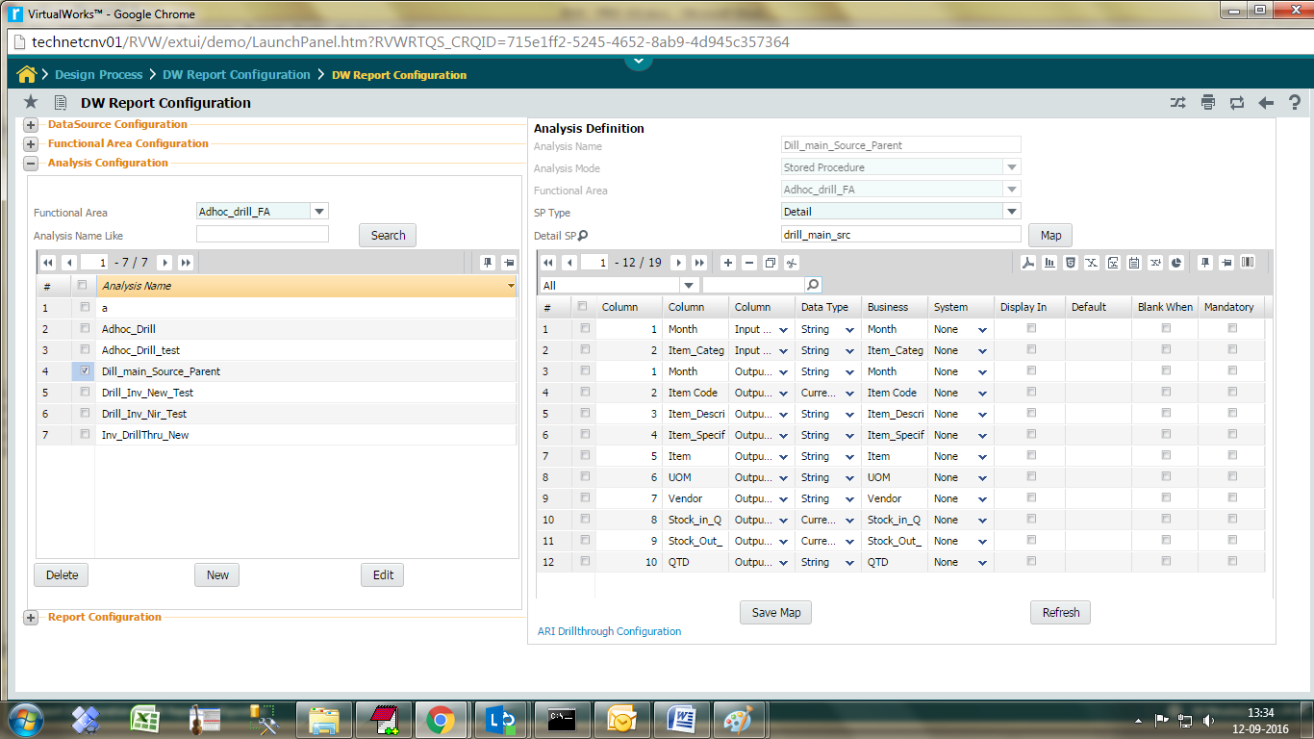

Click the **ARI Drillthrough Configuration** link,

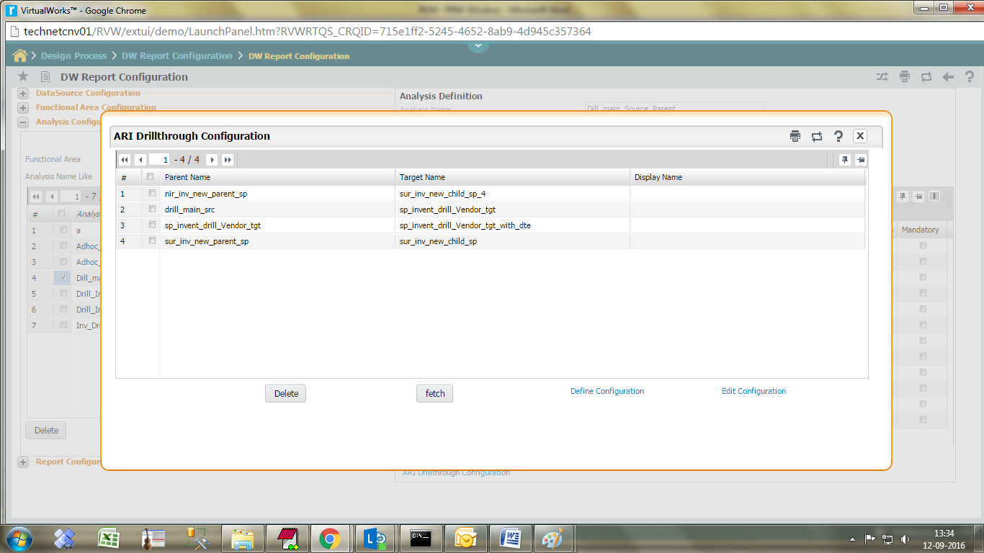

**Define Configuration**

Click on the Define configuration hyperlink, system launches below screen.

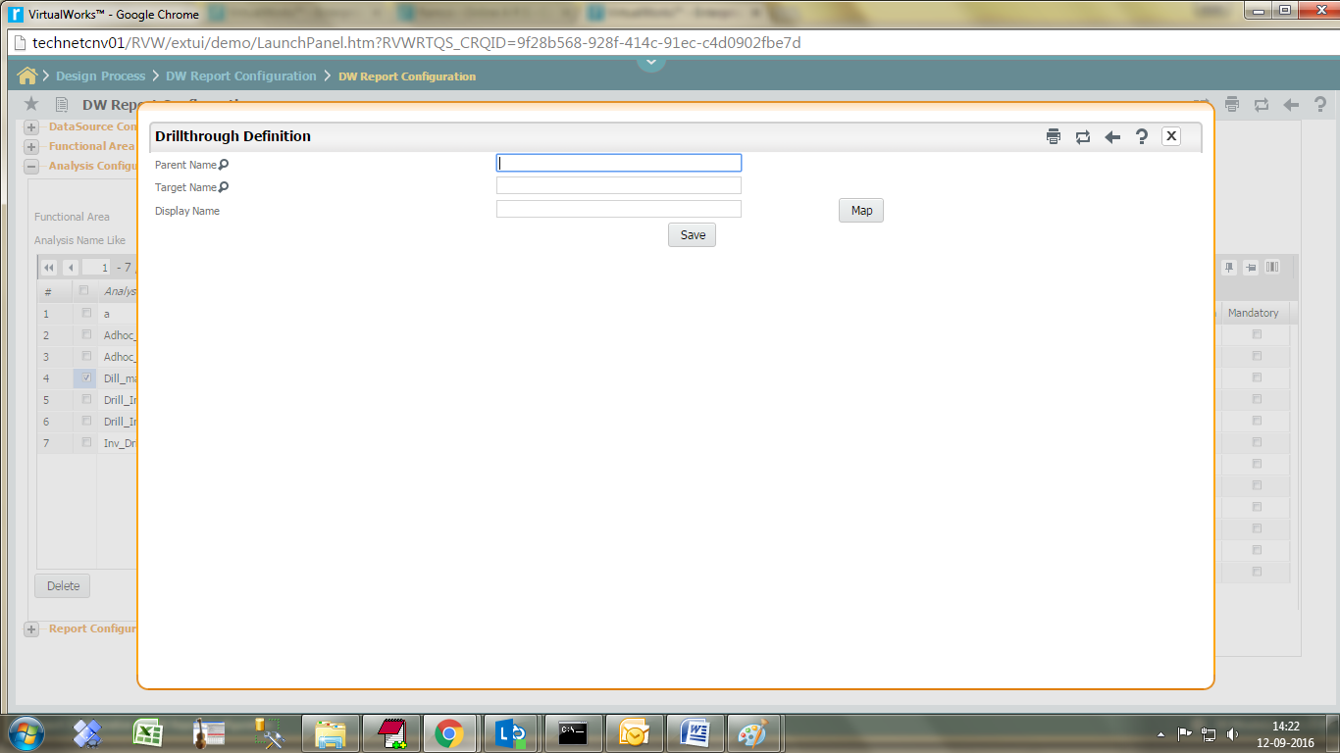

Click parent name lens Icon, it will list the stored procedure name in help screen. Choose parent stored procedure.

Click Target name lens Icon, it will list the stored procedure name in help screen. Choose target stored procedure.

Click **OK** button.

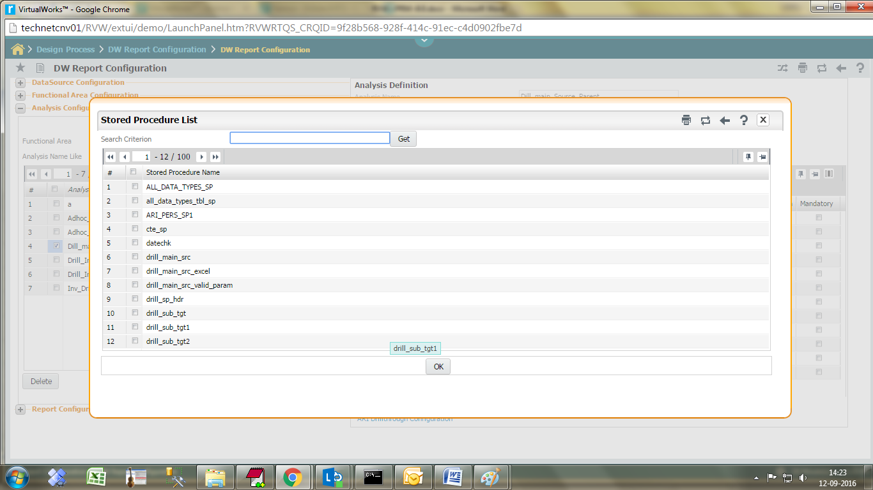

**Column level Drill through:**

It may be noted that for same parent procedure, there can be different target procedures. This facilitates the functionality of Column level drill through. And in turn, the target procedure can be a parent procedure and so on.

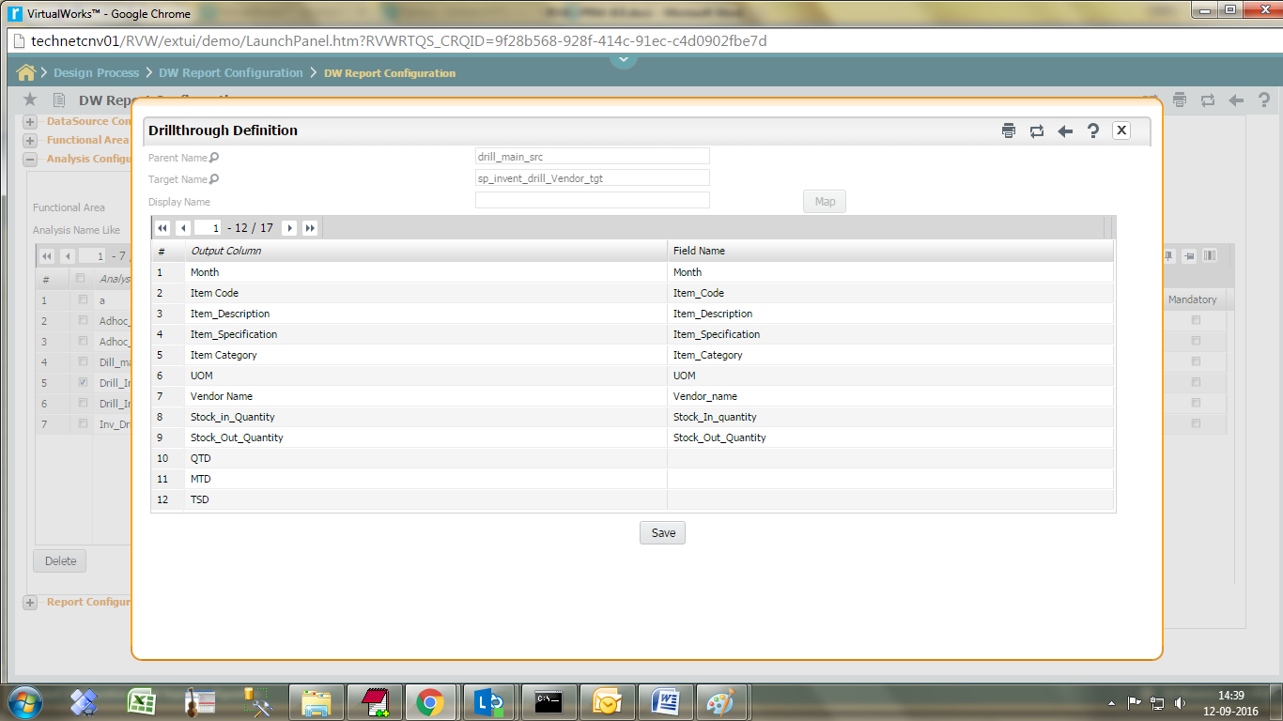

**Parent Name** Select the parent procedure

**Target Name** Select the Target procedure

Enter the target output column which needs to be searched in the target procedure.

Click on **save** button to save configuration details.

Go to Report configuration select -> Report type (**Advanced Report**) > Click N**ew** button.

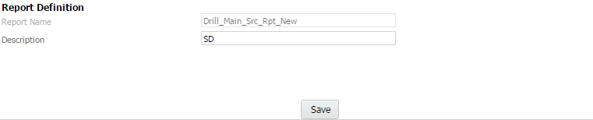

Save the Report name and click the **Design** Button to launch the design screen.

Choose functional area and Analysis name, it shows all dimension and measure in left pane tree. design the report and save.

Click on the Drill through mapping icon.

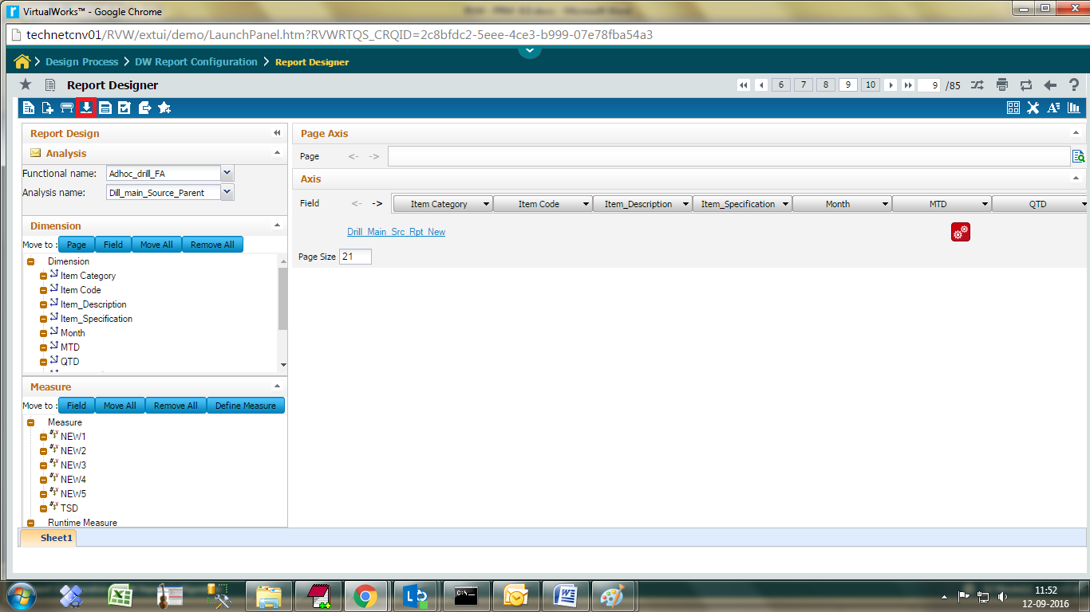

Drill through report configuration can be done for each column using the below screen.

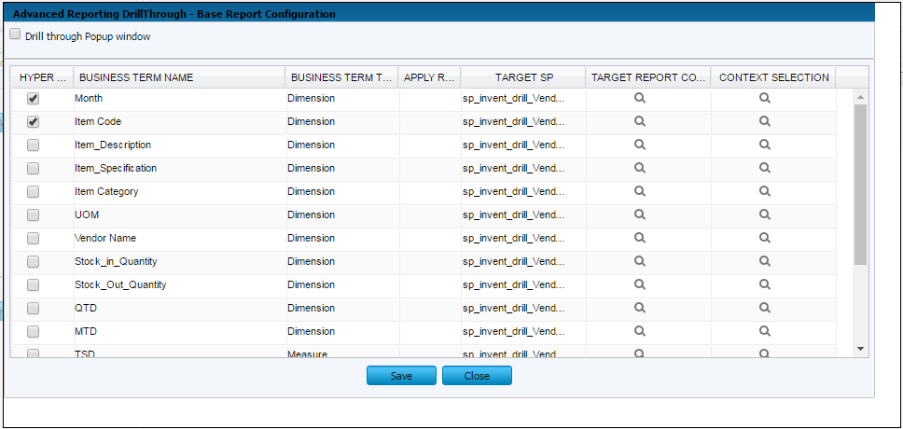

***Hyper Link*** Click on the required hyperlink on which the drill through is needed.

***Target Sp***  This field lists the child procedures mapped to the parent procedure. Choose the required one from the list

***Target Report column selection*** Click this to select the required columns to be displayed in the drill through report.

***Context Selection*** Click this to launch a sub screen wherein facility is provided

to pass the required parameters and set the required hidden fields for drill through procedure.

Context and hidden fields selection screen:

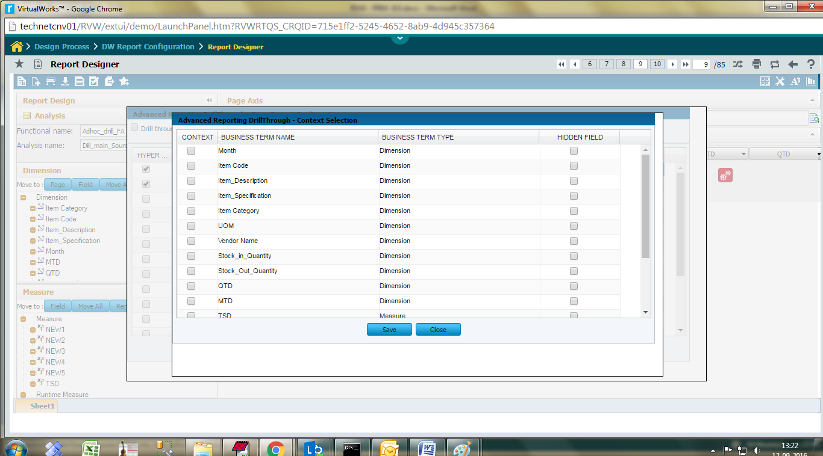

***Context*** Select the required context.

***Hidden field*** Select the required hidden fields.

Click save button to save the details.

Target report Business terms selection:

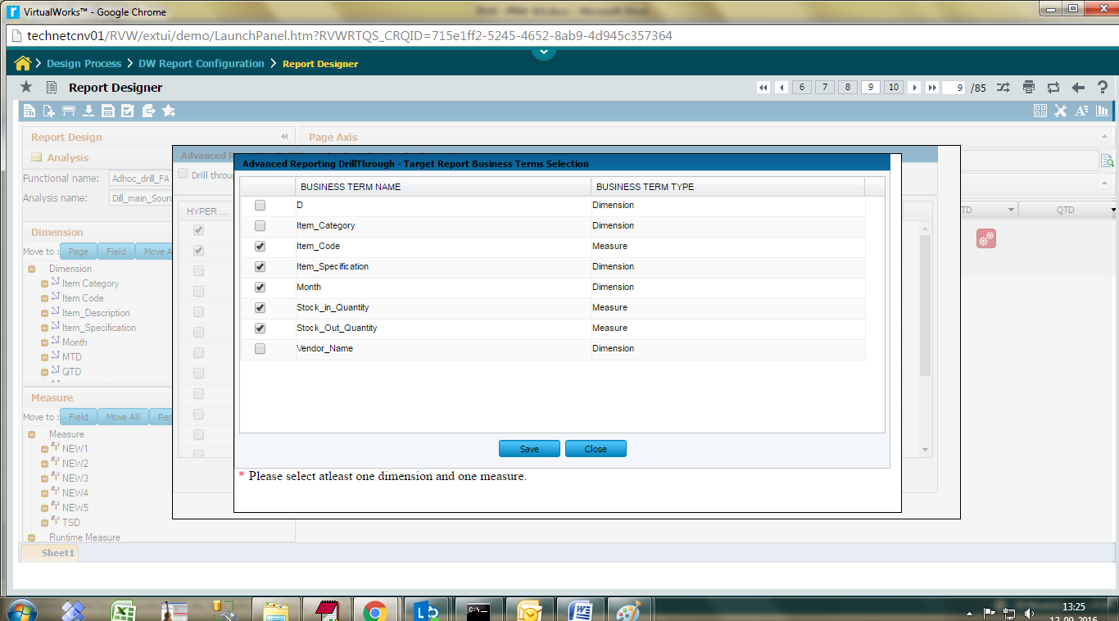

Select the required columns.

Click the save button.

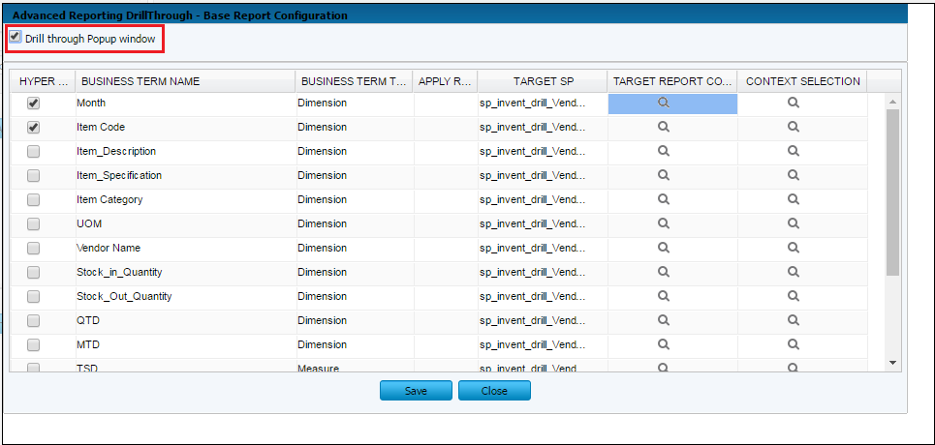

If drill through report launches in pop up window, select the **Drill through popup window** check box.

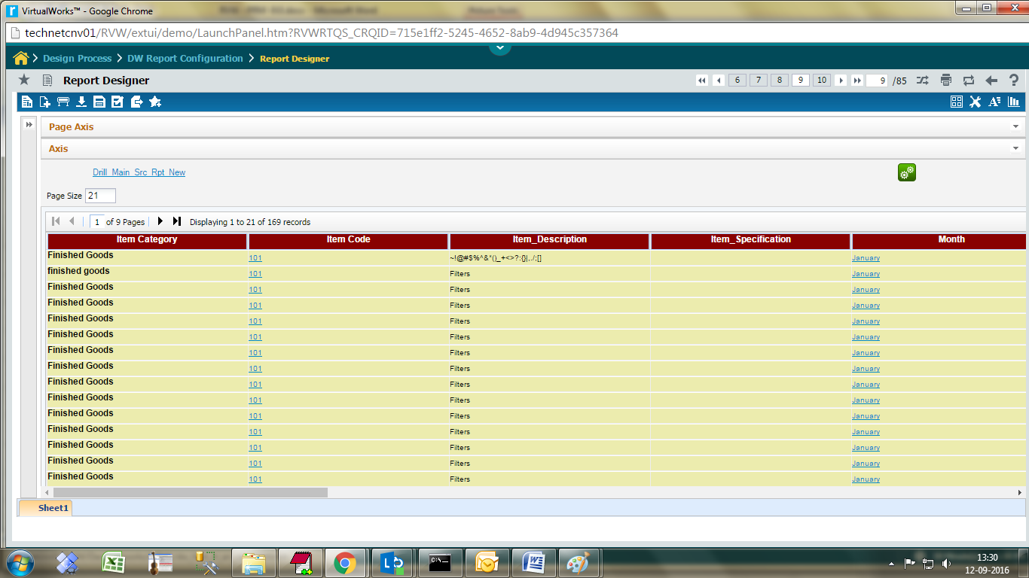

Click the hyperlink for drill through report.

Drill through report is launched as shown below.

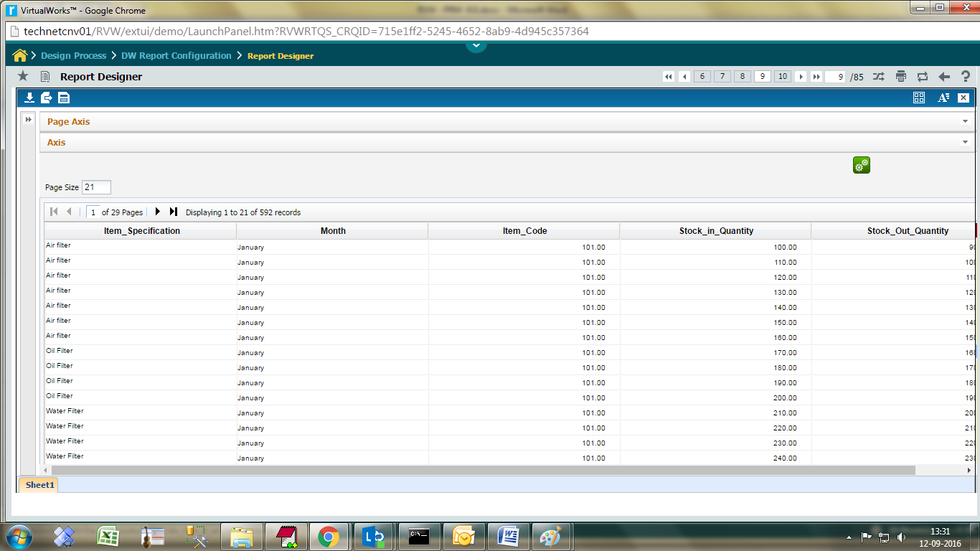

### Expand All / Collapse All:

The Expand All / Collapse All feature can be used in combination with grouping feature. When the data are grouped and if you want to expand all the groups in a single click or if you want to collapse all the groups in a single click then these feature is there for you. A new icon will be available at the top right place when grouping is applied.

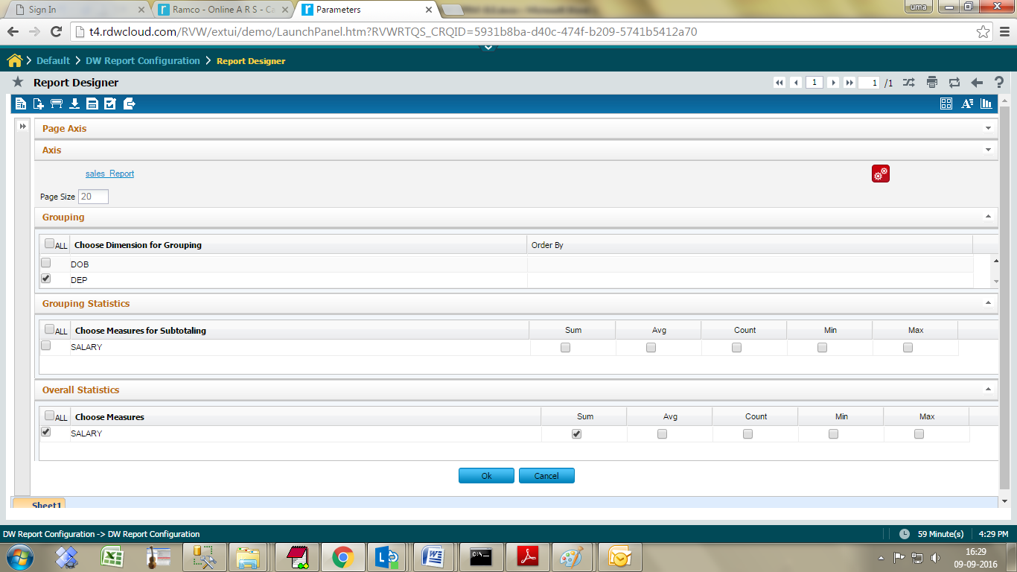

Click the show button report get launched.

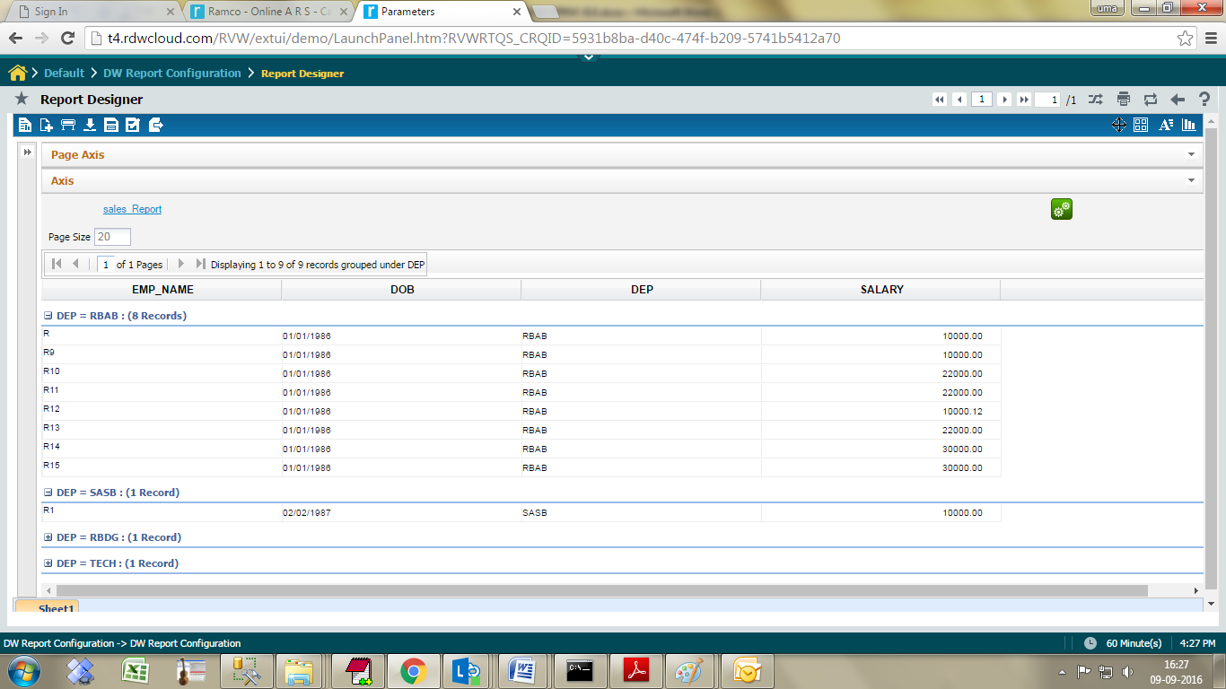

User can expand/collapse all groups.

**Drag and Drop**

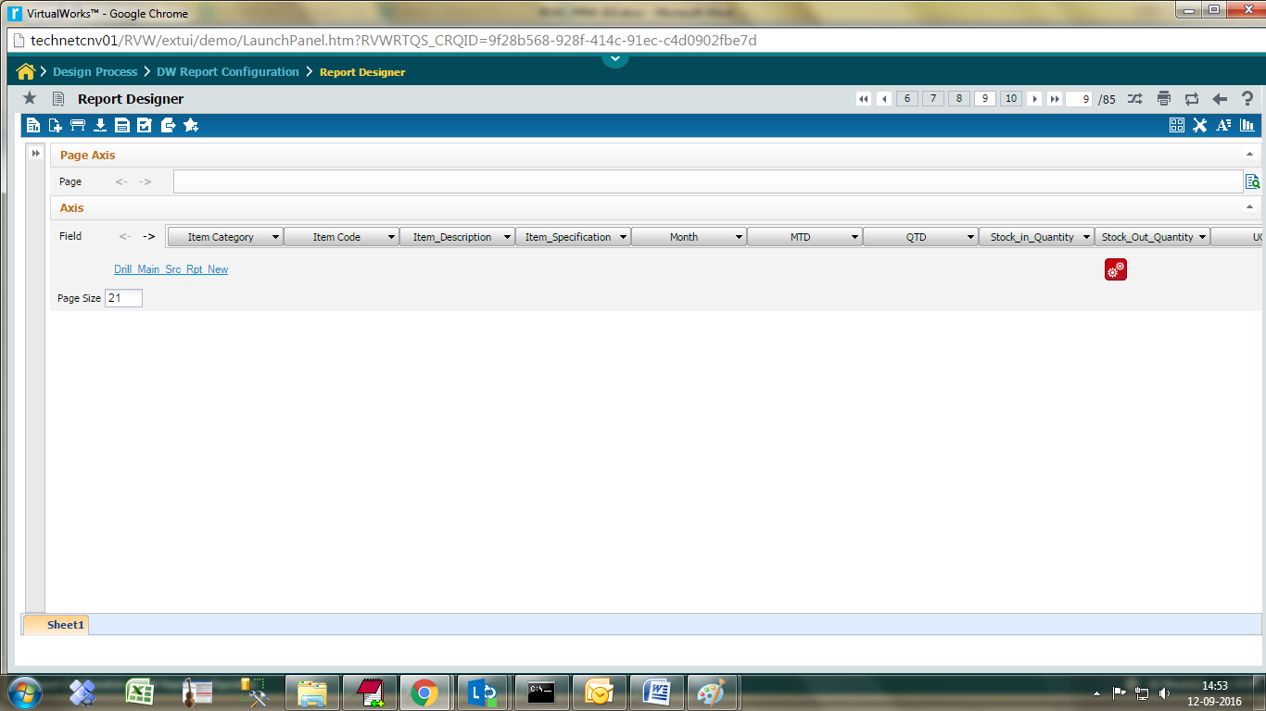

 Click the expand icon to expand the left pane.

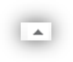 Click the expand icon to expand the axis

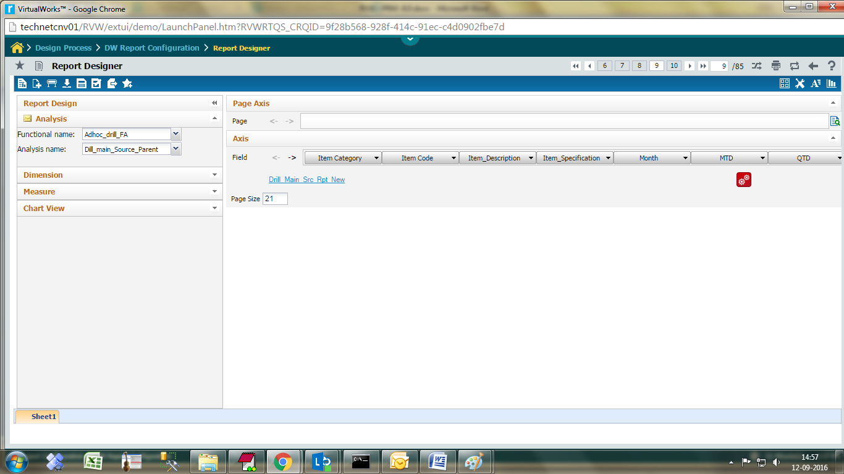

3. Click the expand icon to expand the Dimensions pane

4. Click the expand icon to expand the Measures pane

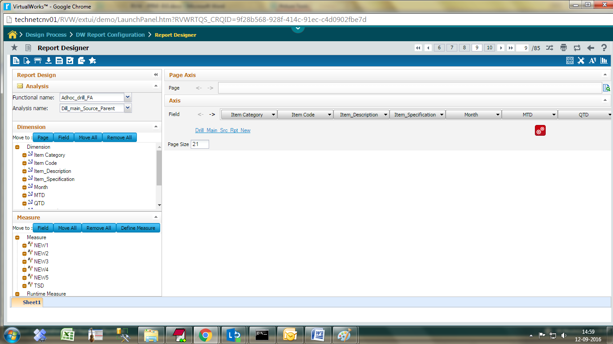

2. Select a measure and click on Field button to move to Field axis

Selected dimensions and measures are in field axis

1. Select a dimension and click on Page (or) Field button to move to corresponding axis

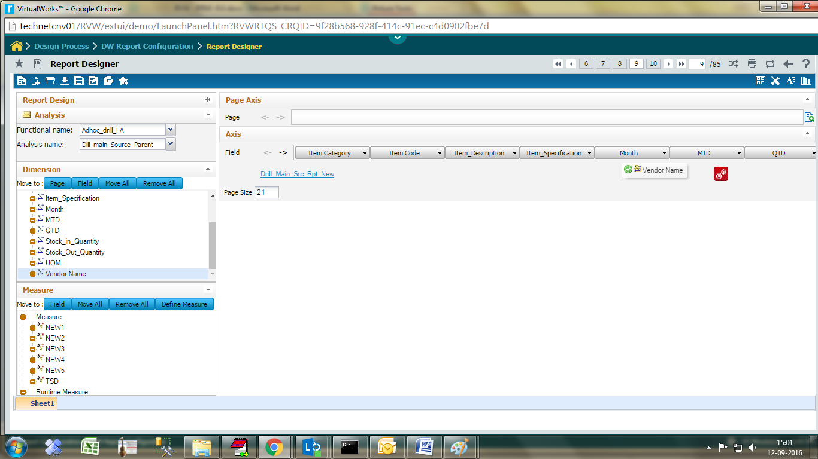

A dimension (or) measure can also be dragged & dropped into the field axis

### Re-arrange columns

The fields present in Page / Field axis can be moved left / right. Only dimensions which are participating in Field axis can be moved to page axis and vice versa.

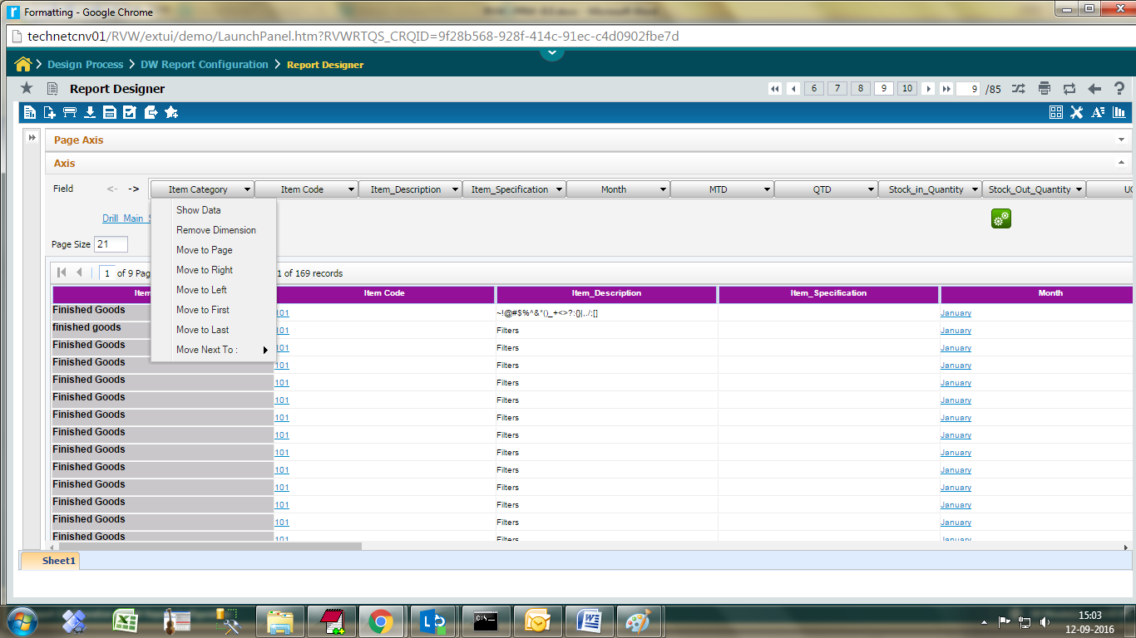

### 

### Apply Filters

**Grouping & Sub-totaling**



Click on Grouping and sub-totaling icon.

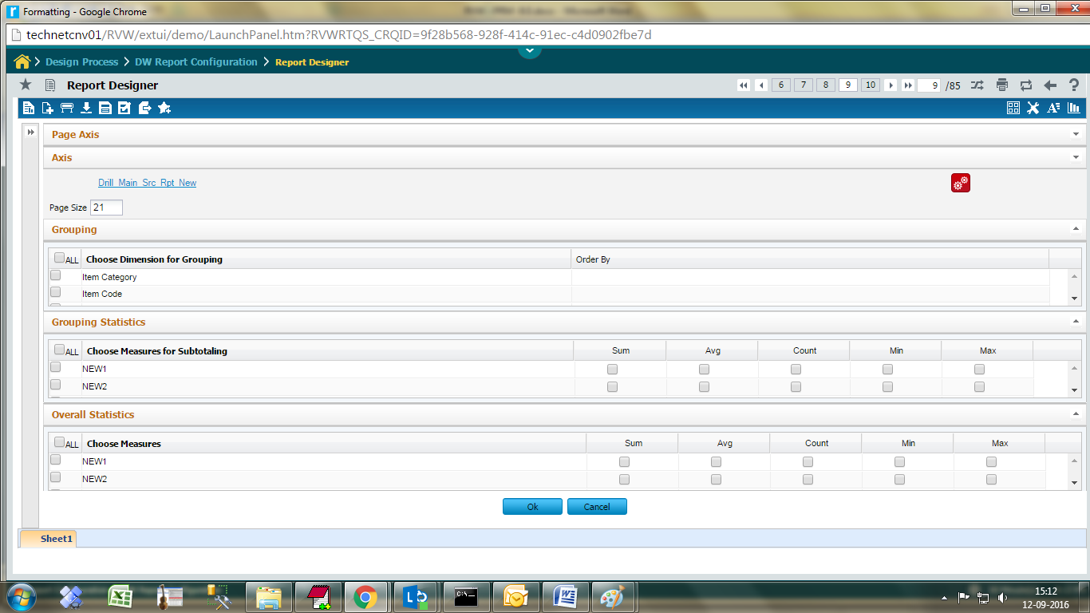

**Grouping**

***Choose Dimension for Grouping***  Click on the necessary dimension to group

***Order By*** Enter the order for the dimension to group

**Grouping Statistics**

***Choose Measure for subtotaling*** choose the appropriate measure for sub total

***Sum, Avg, Count, Min, Max*** selects the aggregation types.

**Overall Statistics**

Select a measure to show its overall statistics.

Click **Ok** button

Run the report

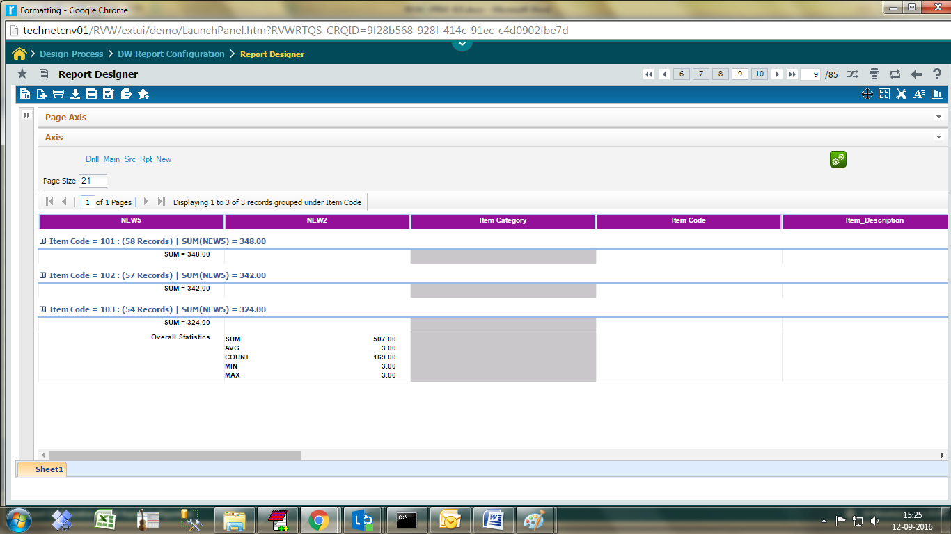

The selected dimensions are appearing in groups.

Each group lists the aggregated values in bottom of group.

At the end overall statistics will be displayed.

**Search Filter/Parameters**

Input parameters can either be parameter based, using pre-defined parameter input screen (or) by giving custom conditions based on the available fields

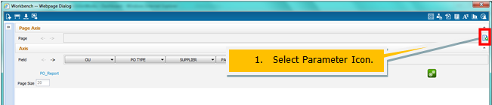

Input parameters screen

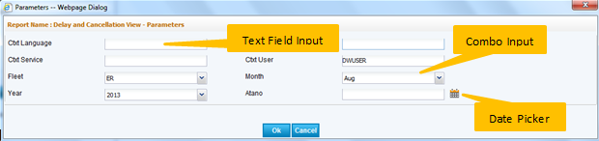

Input type can be Text field input (or) Combo Input (or) Date picker. Select/Enter the value and click OK button

**Custom Condition**

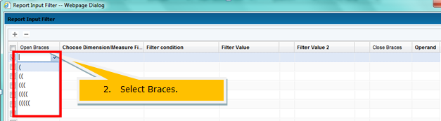

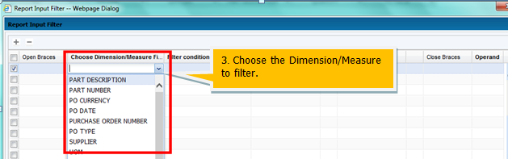

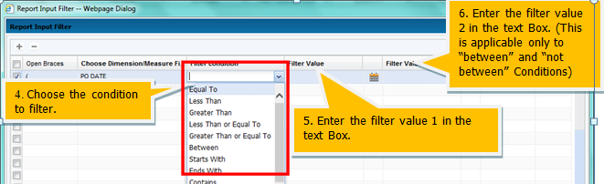

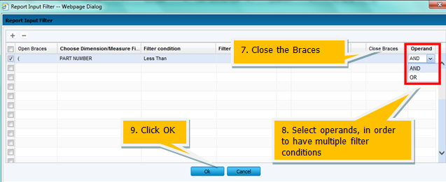

Run the report

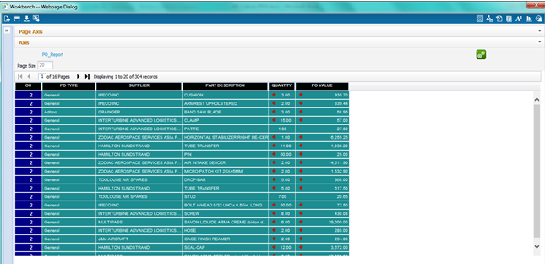

**Show Data**

Another type of filter is the Show data, where this type of filter can be applied only to dimensions which participate in Field or Page axis

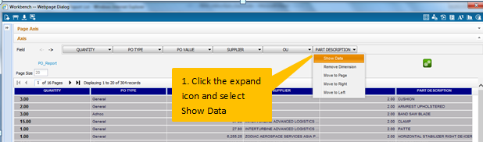

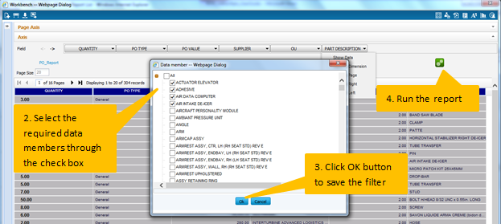

The data based on the filter will be displayed

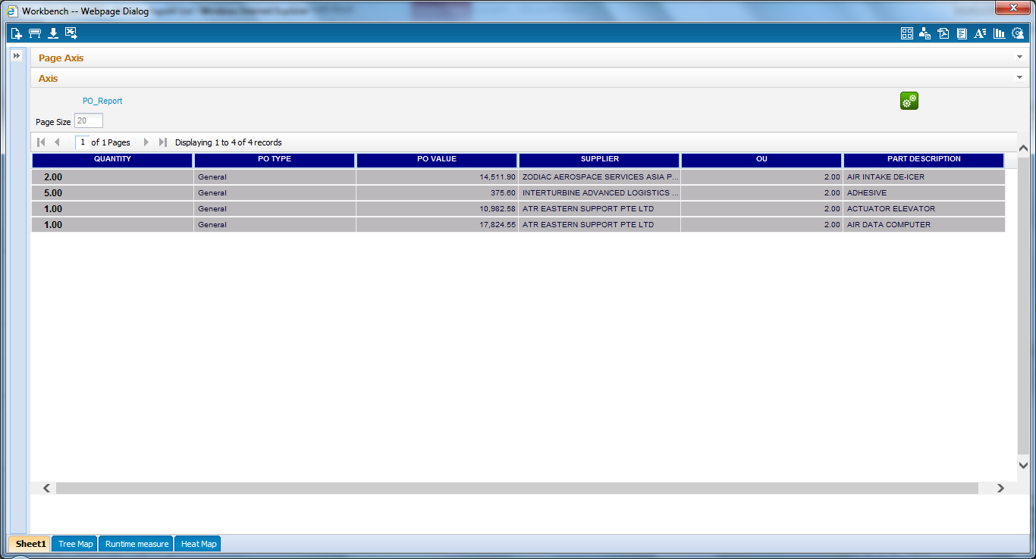

### Create Runtime Measures

Using the already available measures, new computed measures can be created

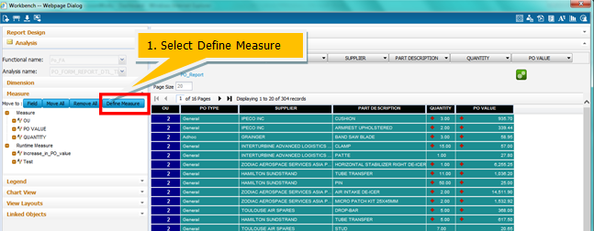

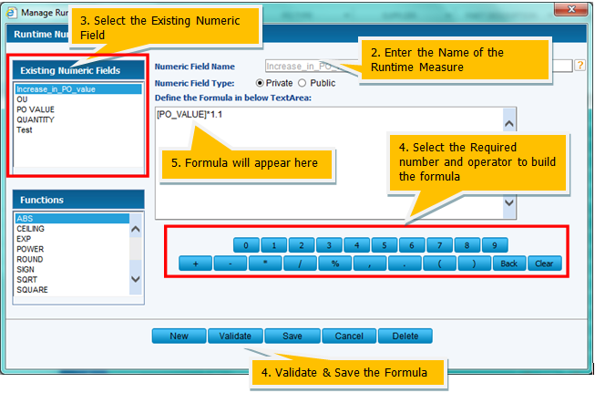

### 

### Apply formatting

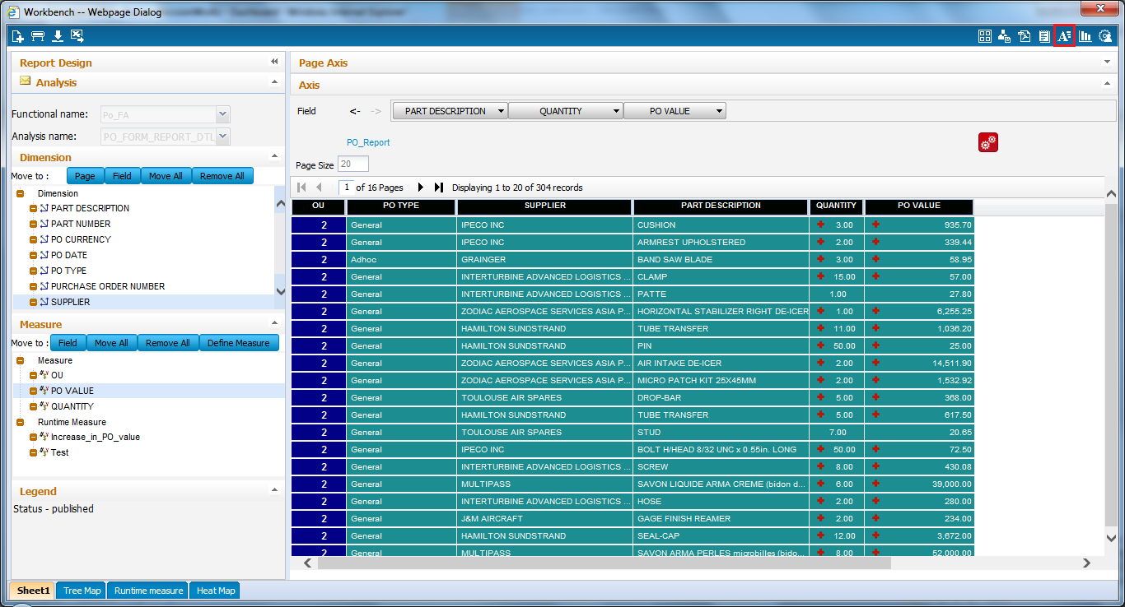

Click the Formatting icon

Template selection

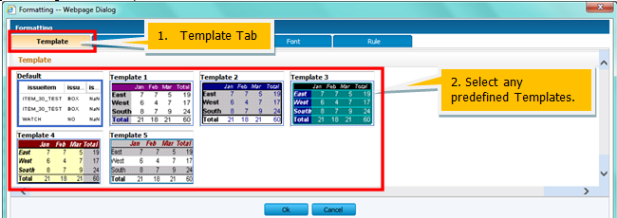

Data to be shown as type can be selected

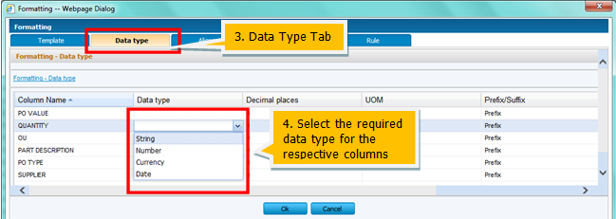

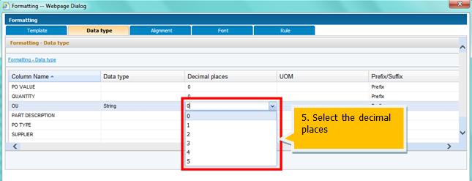

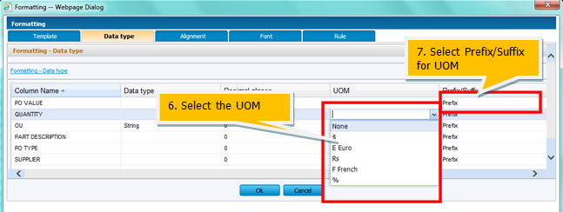

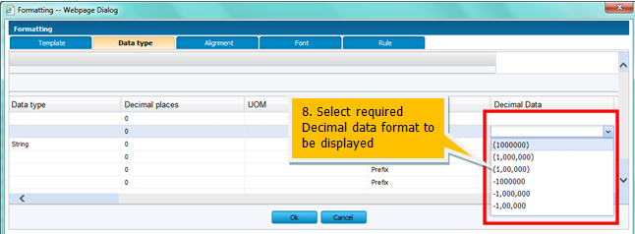

Alignment changes can be specified

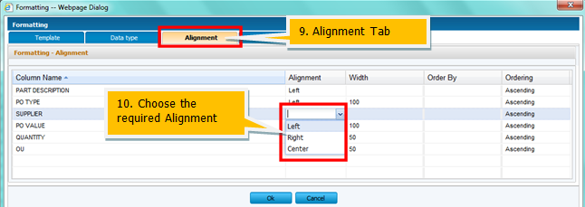

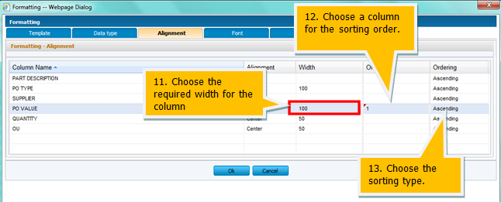

Font can be set to the fields

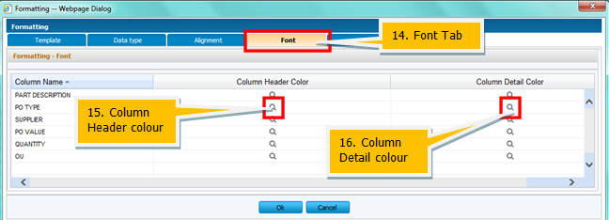

### Apply a conditional filter (rule)

A facility to attach rules to a field is available. This will be used as additional input filter when displaying the data

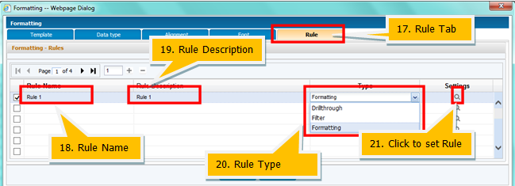

### Charts

Adhoc reports support a variety of charts which can be included in the report

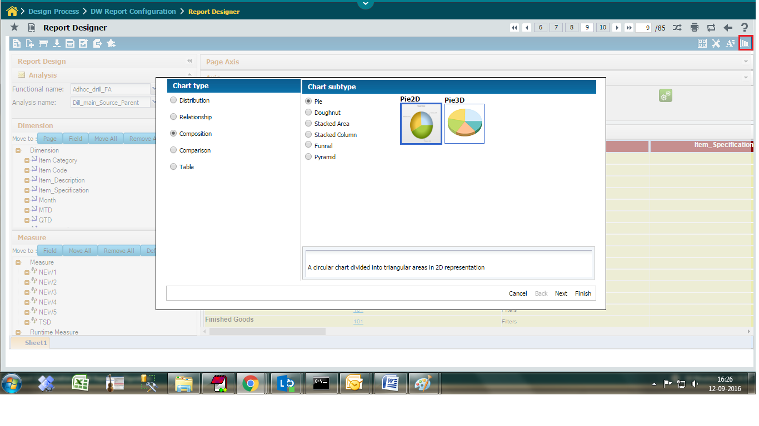

Click the Charts icon

Click **Next** button

Select the required sheet from drop-down list box.

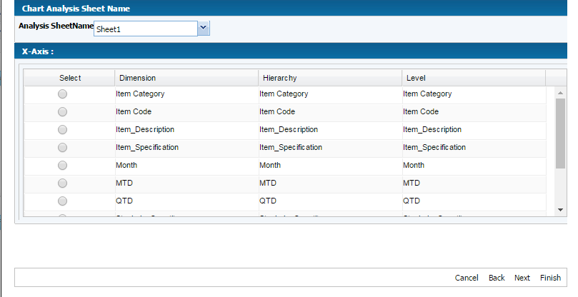

Click the required Dimension for X- Axis.

Click **Next** button

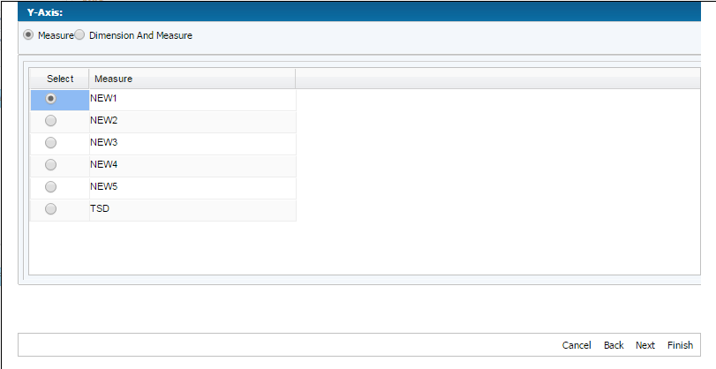

Click the required Measure for Y- Axis.

Click **Next** button

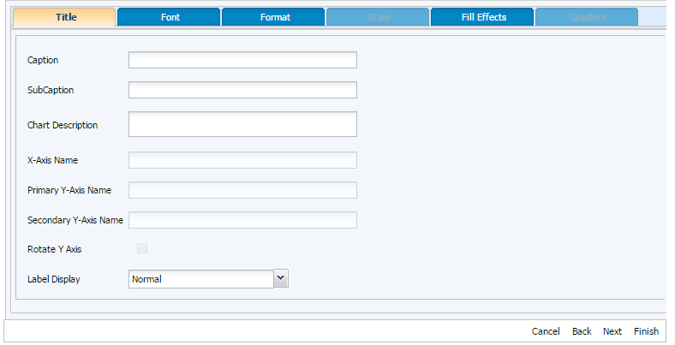

Select the required formatting changes like chart Title, Font, Format, Scale and Fill Effects.

Click **Next** Button.

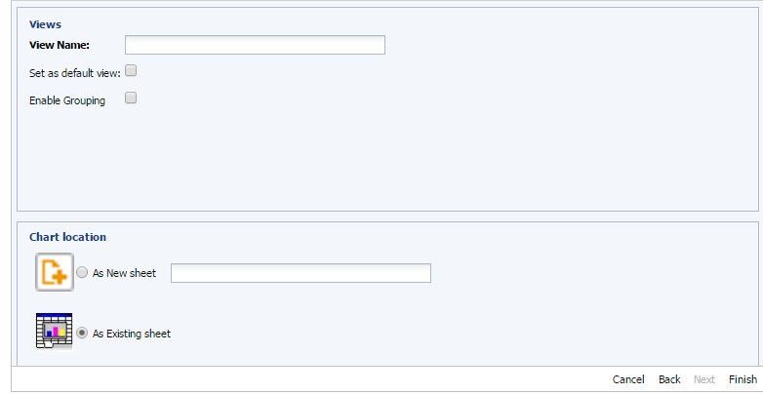

**View Name** Enter View name.

**Enable Grouping** to view the chart with grouping.

Click **Finish** button

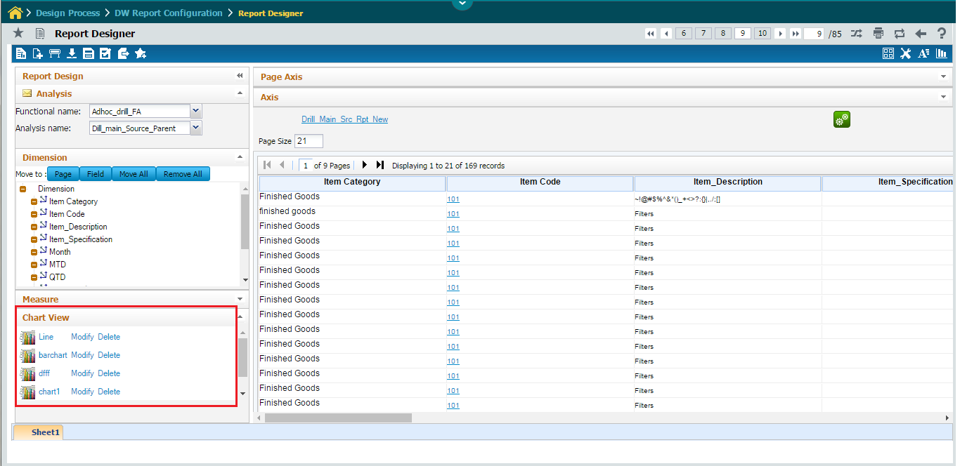

Chart view panel list all created charts in left pane. Click on the Modify link can modify the chart details.

Click on the delete link can delete the chart details.

Click on the view name chart will display in the right pane window.

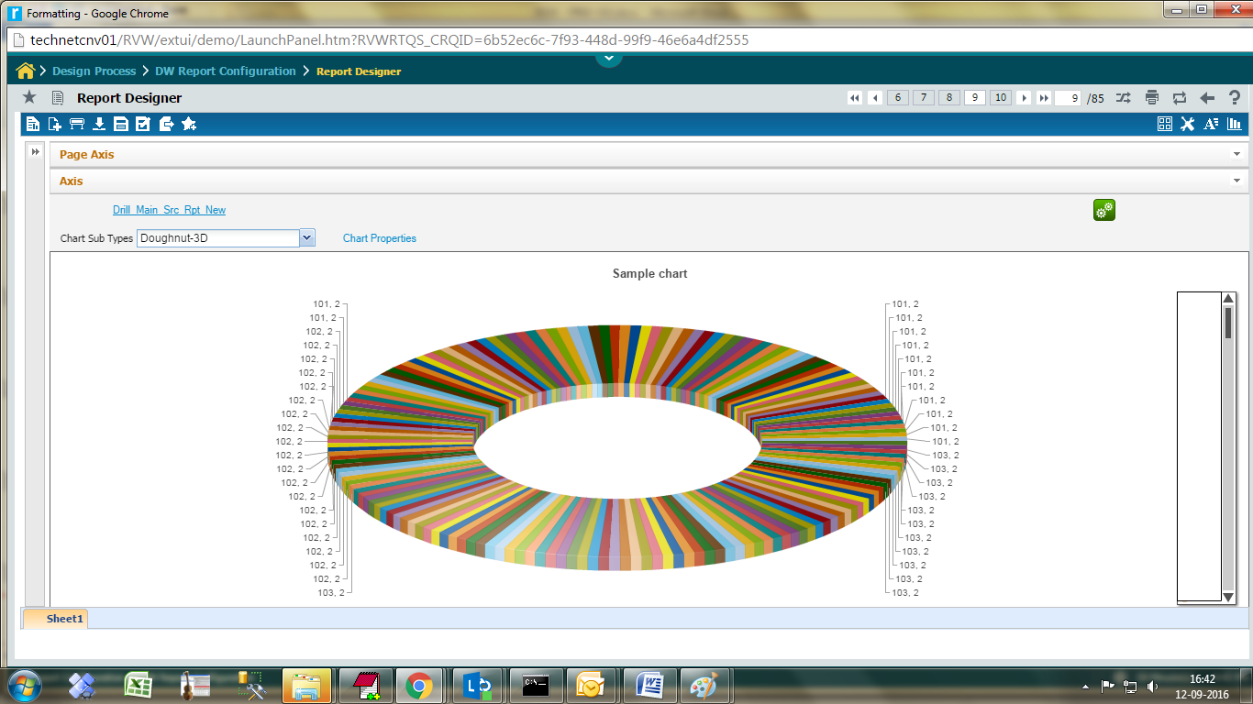

### Add New Sheet(s)

From the existing view, additional sheets can be added, each having different analysis.

Click the  New Sheet Icon.

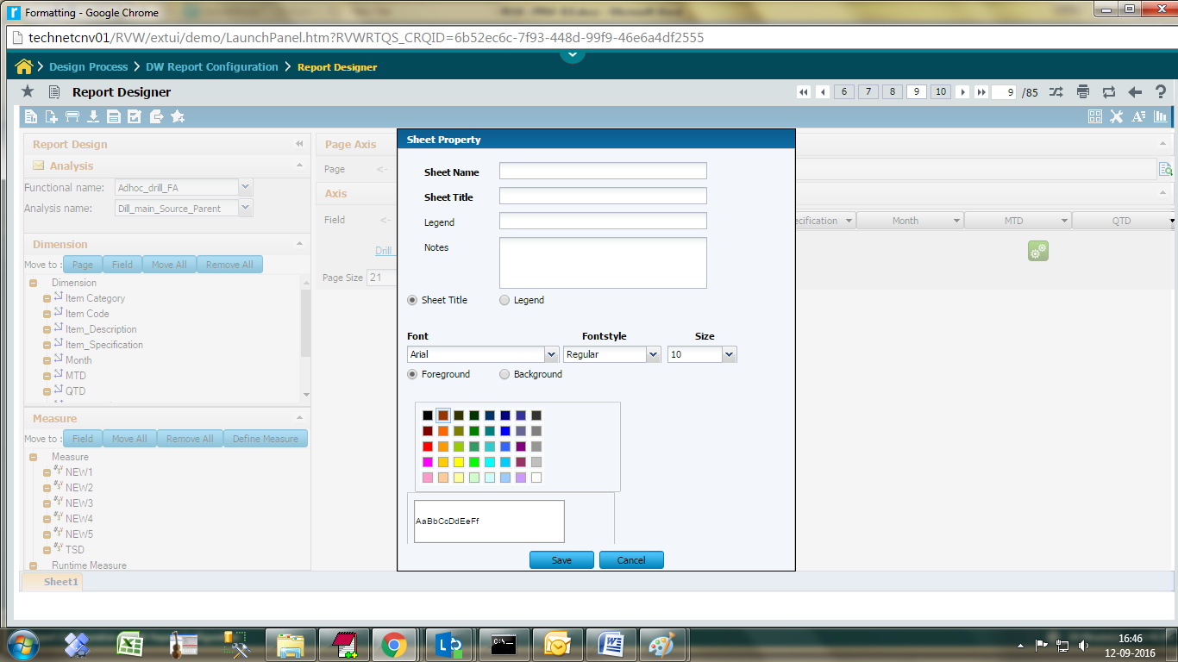

Type the sheet name and title .choose font types and colors and click save button.

The new sheet will be placed to the right

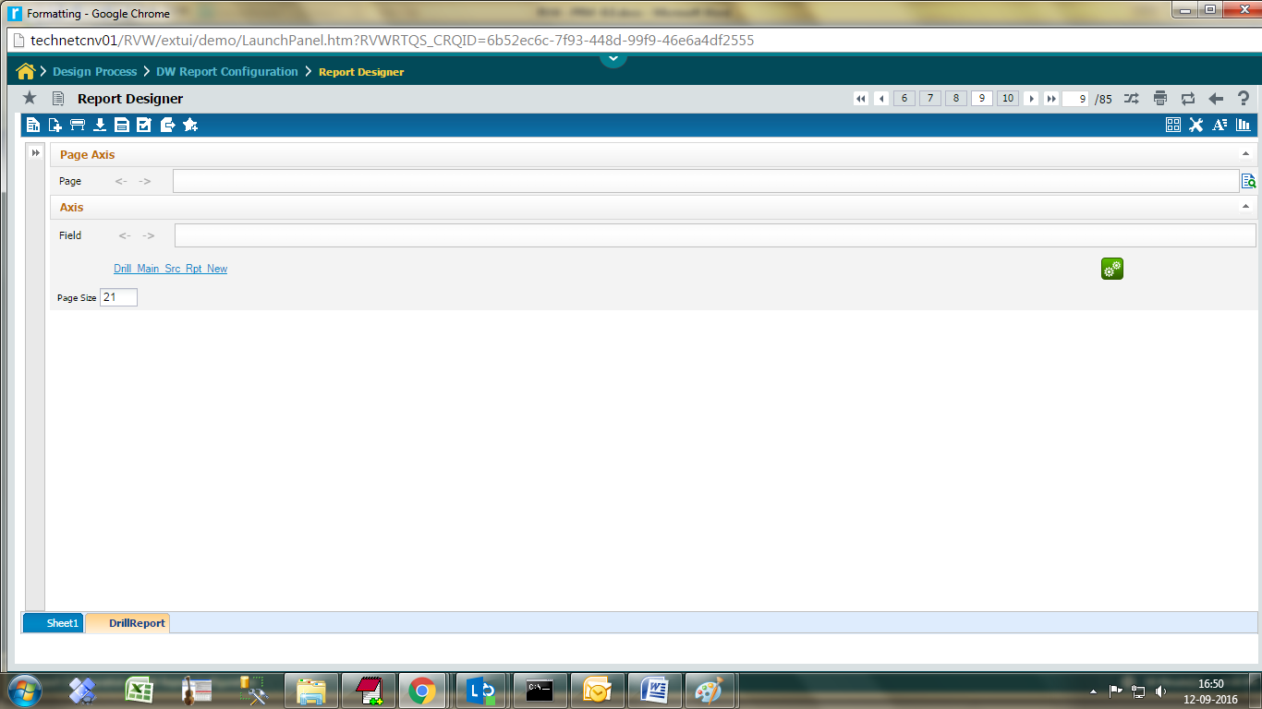

### Export the data

Adhoc reporting can export data as;

1. Excel
2. PDF

Both options provide two ways to export the data

1. What you see is what you get – The report data visible to the user gets exported
2. Full data – The full data for the report gets exported

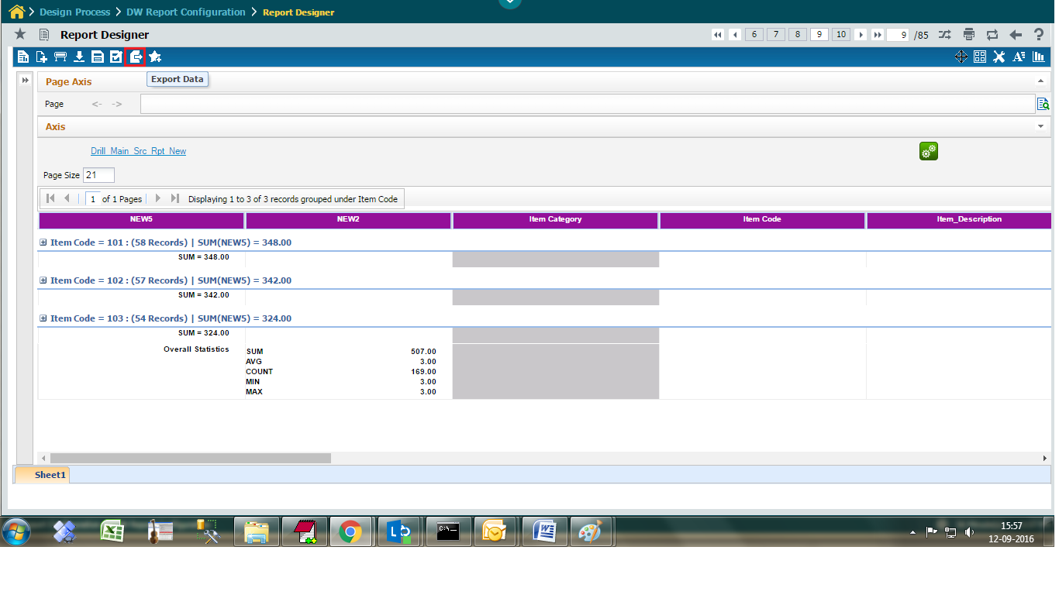

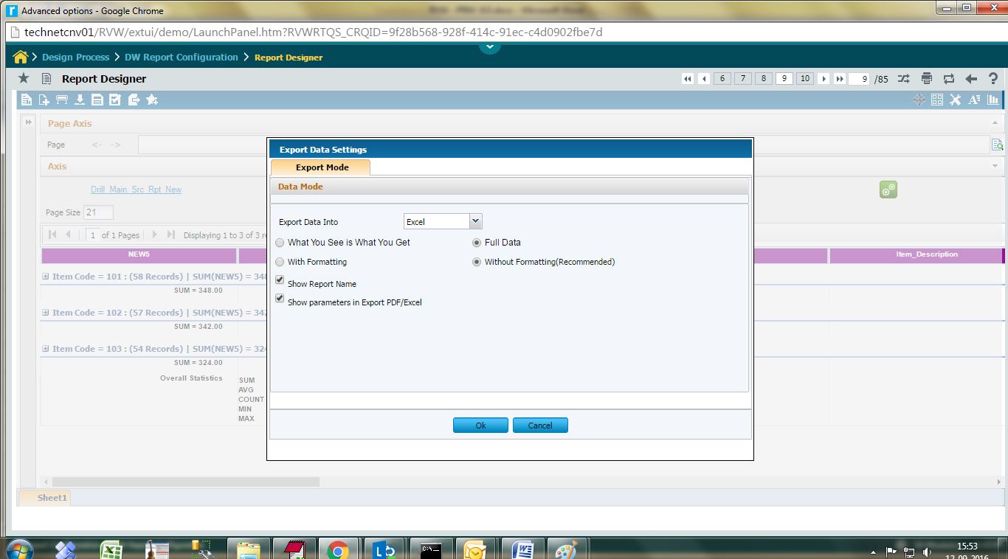

**Excel Output**

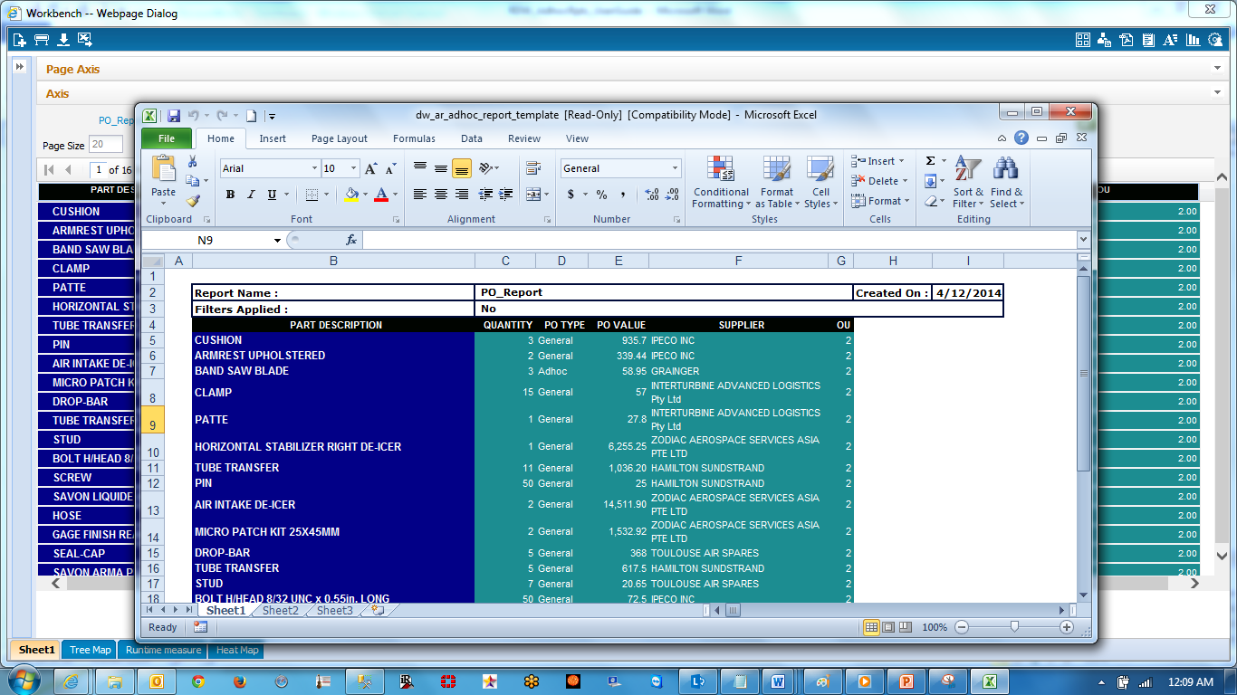

**PDF Output**

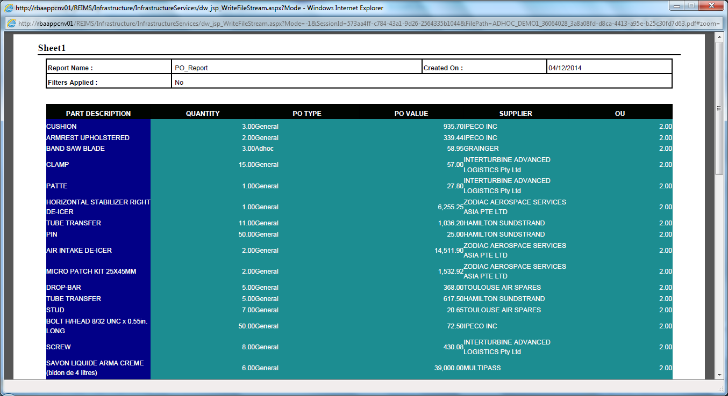

### ARI – Chart Properties feature

This feature is used to set the chart properties without using the chart wizard screen, using the newly introduce link “Chart Properties”. Also the chart sub type can be changed and viewed at ease.

**Step 1:**

Login to the RDW product with valid user id and password.

Go to Configure Menu 🡪 Analytical Report 🡪 Report Design. Select an ARI report. Click on an already created Chart link, as shown in the below figure.

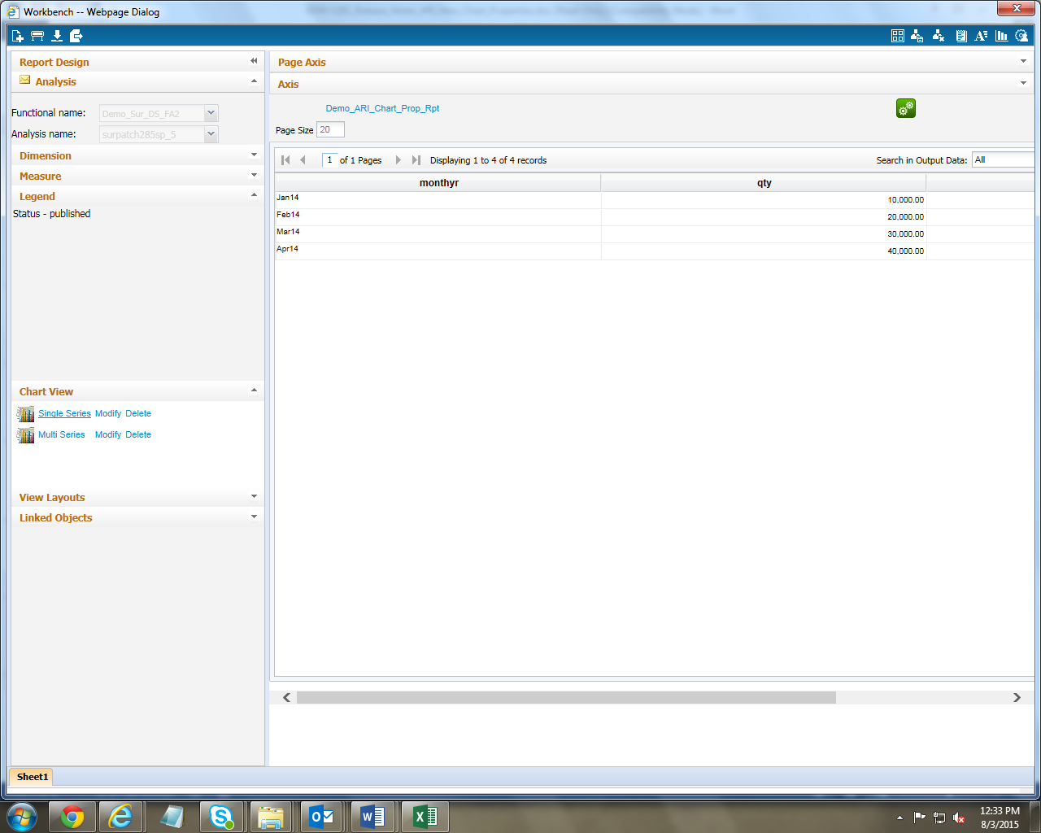

**Step 2:**

A new link “Chart Properties” and a combo to change chart sub type are added as shown in the below fig..

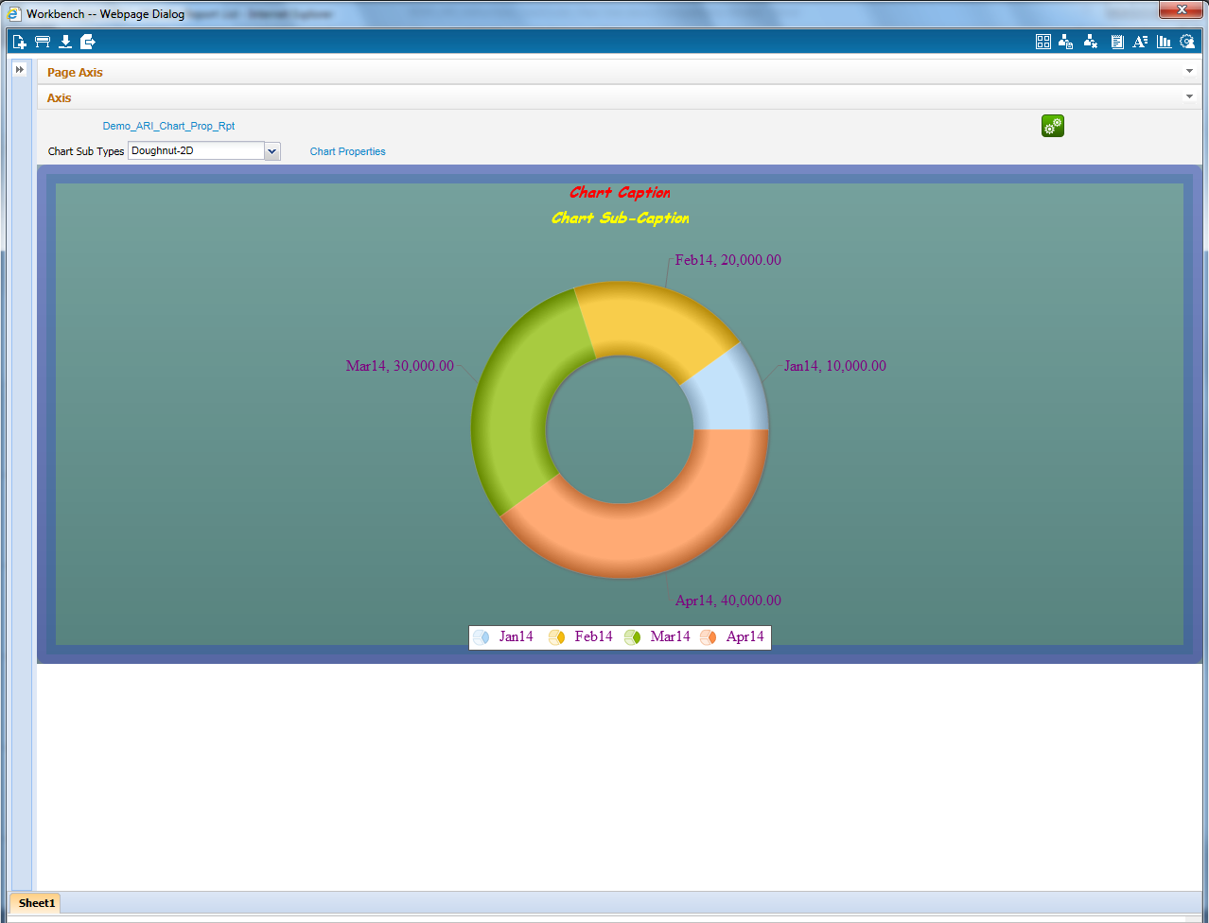

Using the combo box the default chart type can be changed to a new type and viewed. 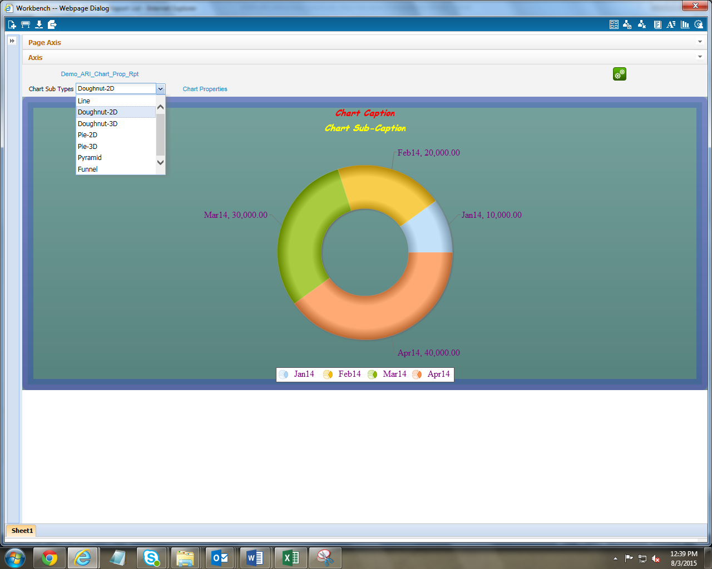

Using the Chart Properties link various chart properties can be set and applied to the chart.

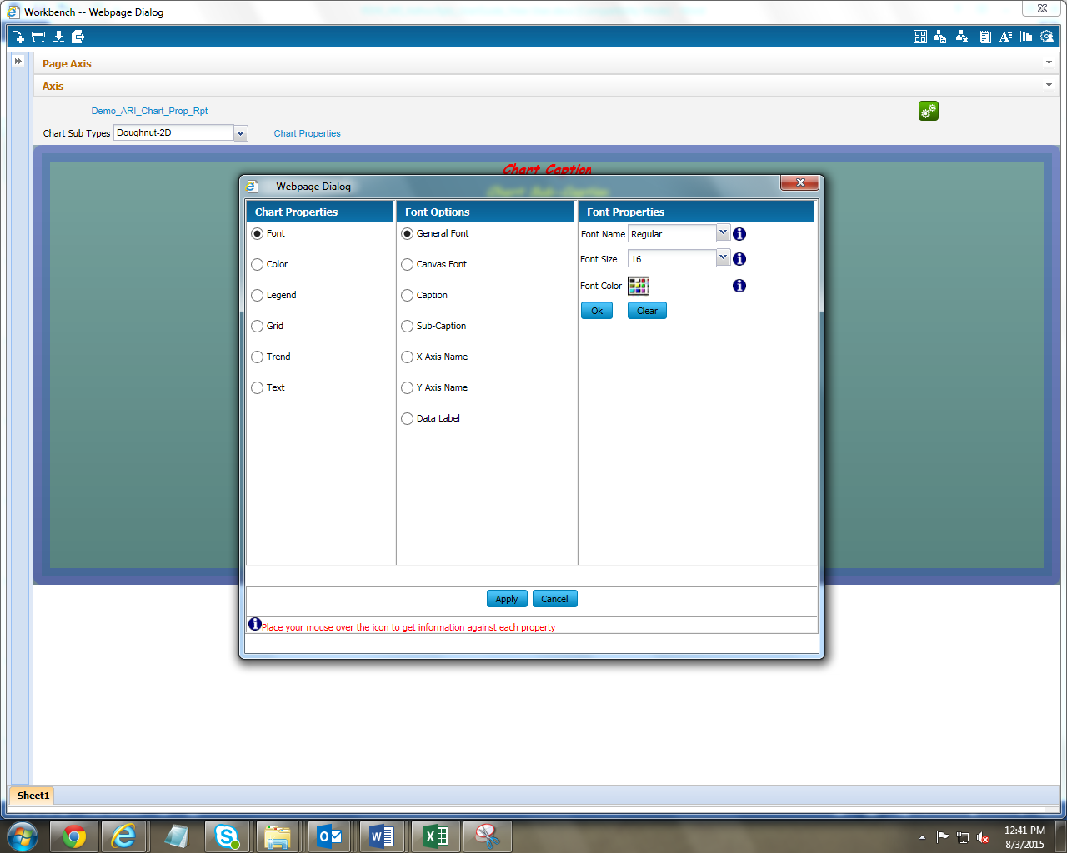

Font – By using the Font option various font properties like font name, font size, font color, style etc. for chart canvas, caption, sub caption, x axis, y axis and data label can be set.

Color – By using the Color option the various color properties like color, alpha, thickness etc. for chart border, line and background can be set.

Legend – By using the Legend option various legend properties like legend shadow, position, icon scale etc. can be set.

Grid – By using the Grid option various grid options like no. of lines, alternate color, line type etc. can be set.

Trend – By using the Trend option the various trend properties like min value, max value, thickness, trend zone, show on top, color etc. can be set.

Text – By using the Text option the various Text properties like show labels, show y axis value, number scale unit, decimals, prefix, suffix etc. can be set.

After setting the individual properties click on the Ok button. To apply overall properties set/selected click on the Apply button. The properties will be reflected in the chart immediately. The same can be saved using personalize option.

**Note:** This new properties link and combo box to change the sub types are applicable to all the chart types except the below types.

* Pivot
* Treemap
* Heatmap
* Table

Also the new properties link is applicable to all the chart types except the below types.

* Bubble
* Radar
* Spline
* Scatter

### Expand All / Collapse All feature

The Expand All / Collapse All feature can be used in combination with grouping feature. When the data are grouped and if you want to expand all the groups in a single click or if you want to collapse all the groups in a single click then these feature is there for you.

A new icon will be available at the top right place when grouping is applied.

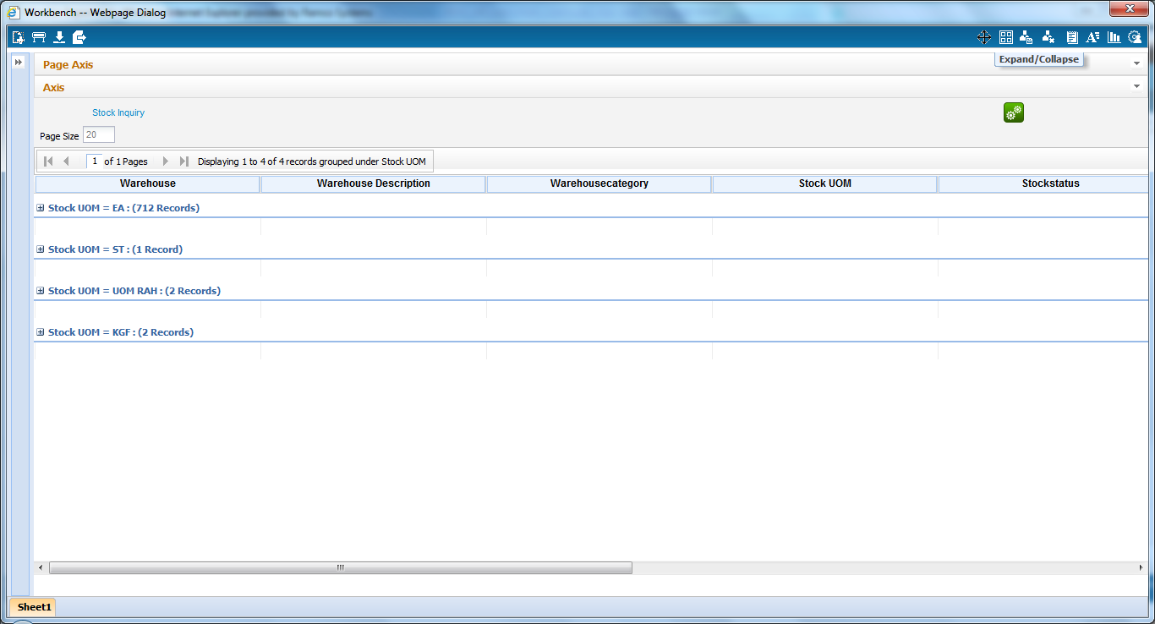

Click on the icon to expand all the groups.

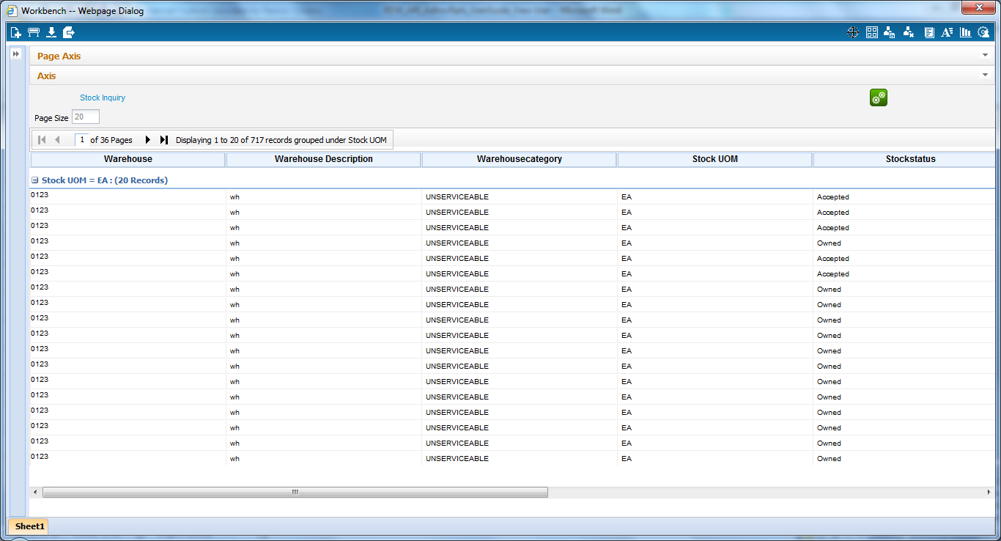

Click on the same icon to collapse all the groups.

### show / hide the description

The report description entered in the report definition screen can be displayed in the workbench and in the export to excel option instead of displaying report name.

To display report description, in report definition screen the “Show Description” flag should be checked which is explained in the UserGuide for Power User document.

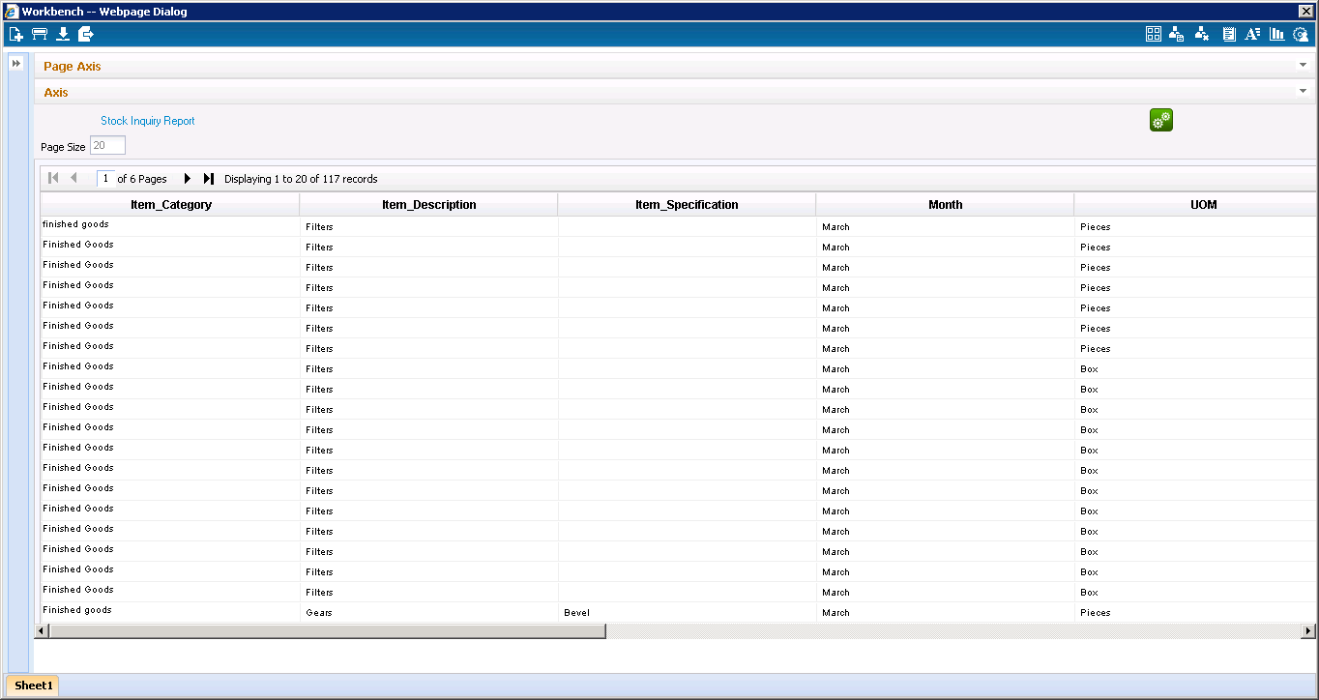

Report description is getting displayed instead of report name

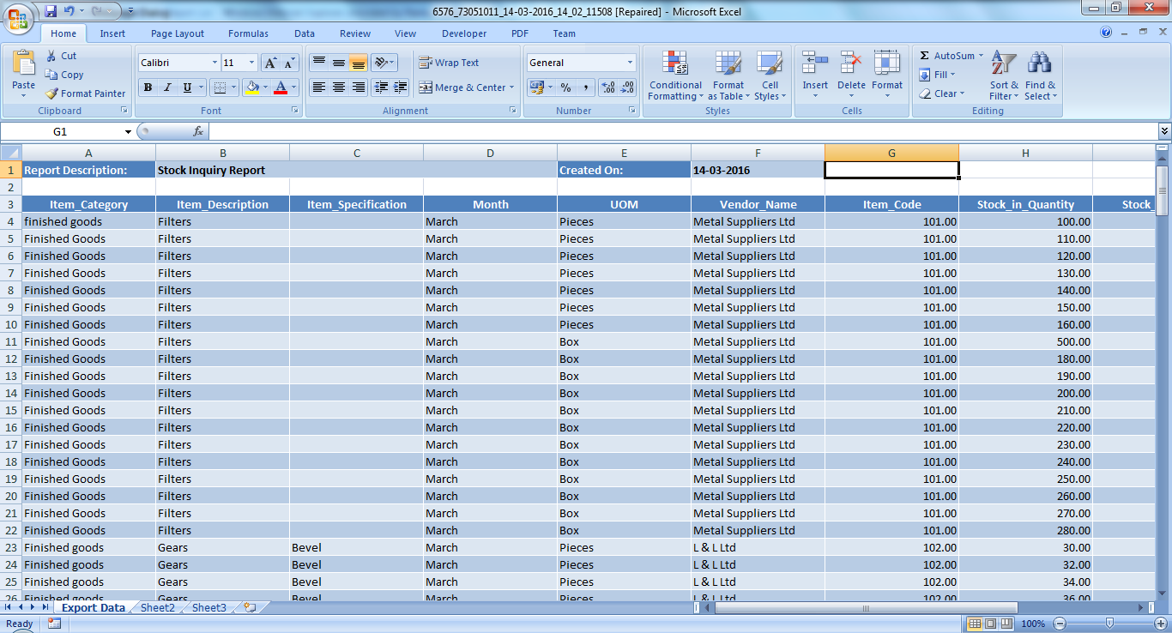

While exporting the data to excel, user defined text with input parameters can be displayed as shown in the below screen shot. This option is only avaialble for SP based report. The configuration steps is explained in the UserGuide for Power User document.

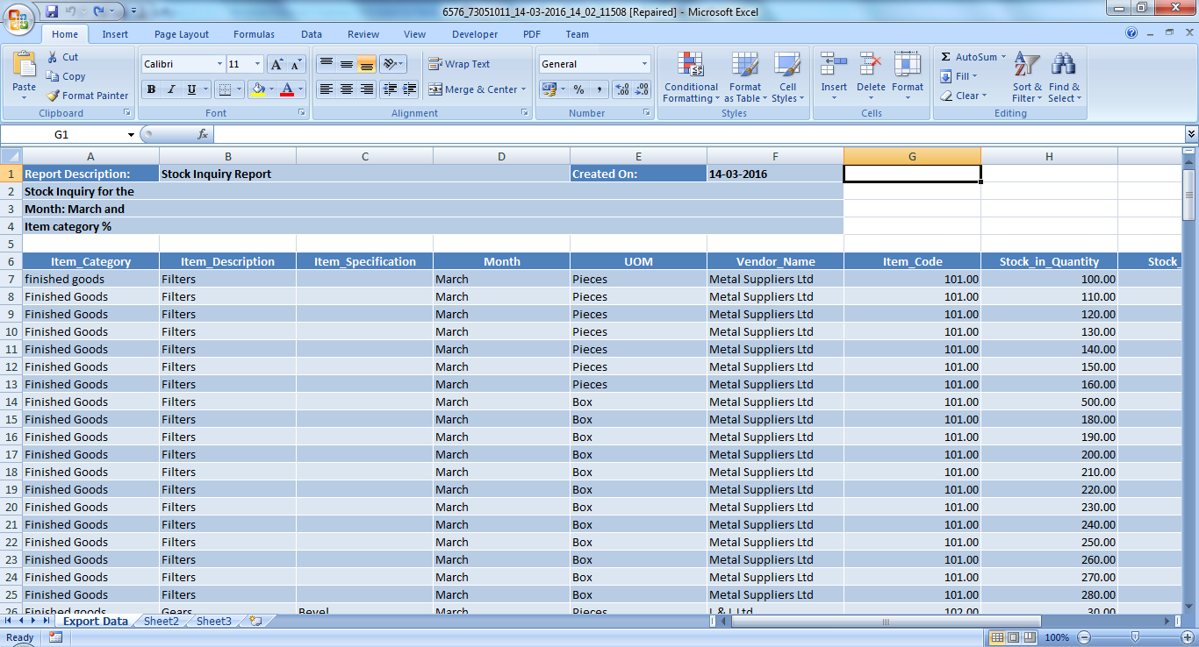

## Enabling Pivot Grid

To enable **pivot grid** right click 🡪 sheet name and select sheet property as shown below.

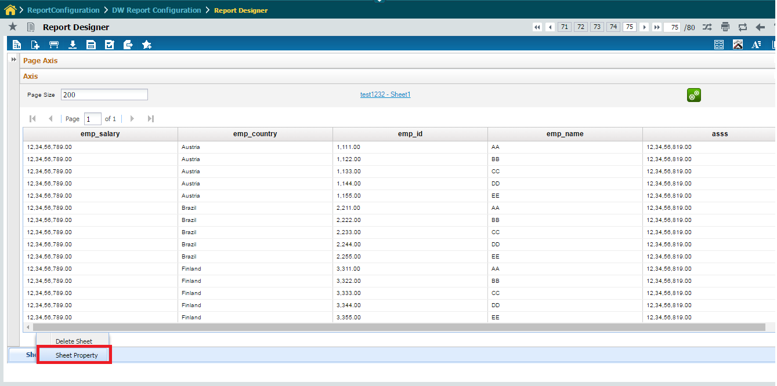

On selecting sheet property the screen will launch as below

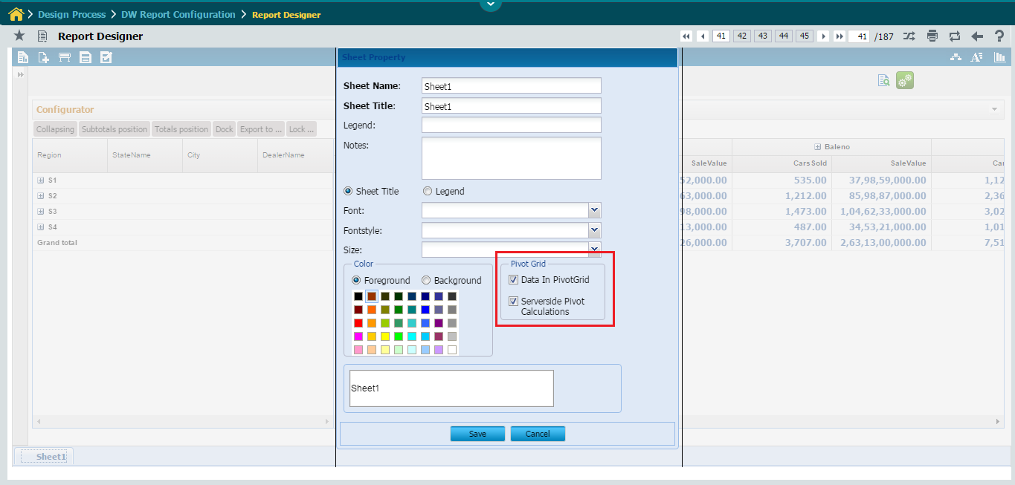

In the Sheet Property window, the following 2 check boxes will be shown

* Data In PivotGrid
* Serverside Pivot Calculations

In the above screen, Select ‘Data in Pivot Grid’ check box and click **save** button to enable pivot grid.

Similarly, In the above Sheet Property Screen, Select the ‘Serverside Pivot Calculations’ check box to enable Serverside Pivot Grid.

If the ‘Serverside Pivot Calculations’ check box is selected, then the Pivot Grid Calculations including Grouping and Aggregations will be performed in the Serverside itself and Only the Pivot Grid rendering will be done in the client side. No client side Pivot calculations will be done. This will increase the speed of Pivot Grid rendering at client side.

Currently In Serverside Pivot Grid, Filtering option is not enabled. Hence If the ‘Serverside Pivot Calculations’ check box is selected, then the User will not be able to do Value Filtering and Label Filtering in the rendered Serverside Pivot Grid.

On Selecting ‘Data in Pivot Grid’ checkbox and clicking save button the Empty Pivot Grid with all the dimension and measures loaded in Configurator Panel will be displayed as shown below

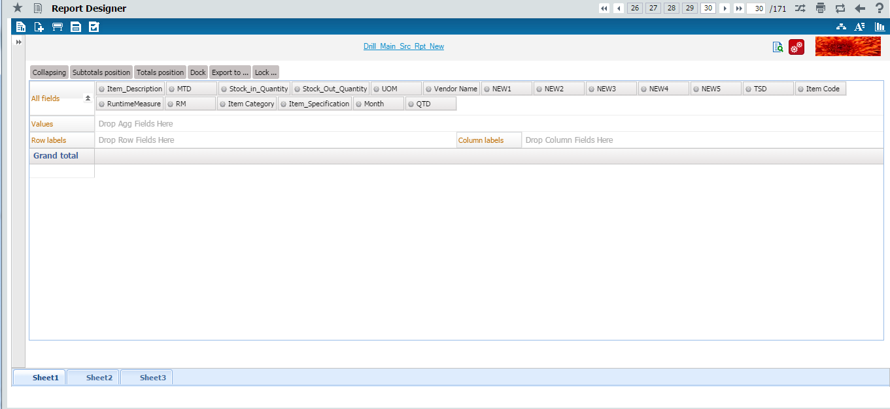

In the Serverside Pivot Grid, the User will be able to perform only the following list of aggregations namely

* Sum
* Min
* Max
* Count
* Average

**All Fields**

It displays both measures and dimensions for the selected Functional area and Analysis name.

Fields can be dragged and dropped in any of the axis such as Values, Row Labels, Column Labels as Shown below.

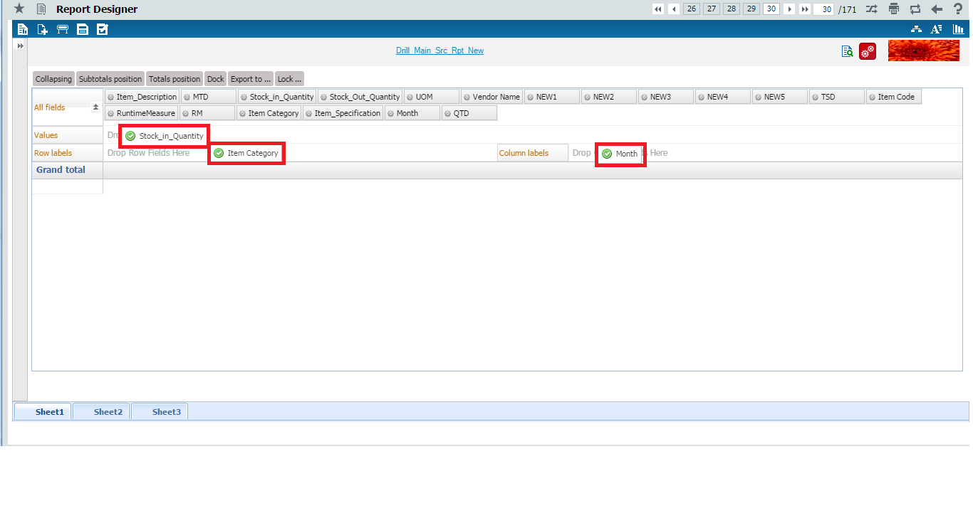

After Drag and Drop of fields the grid will look like below.

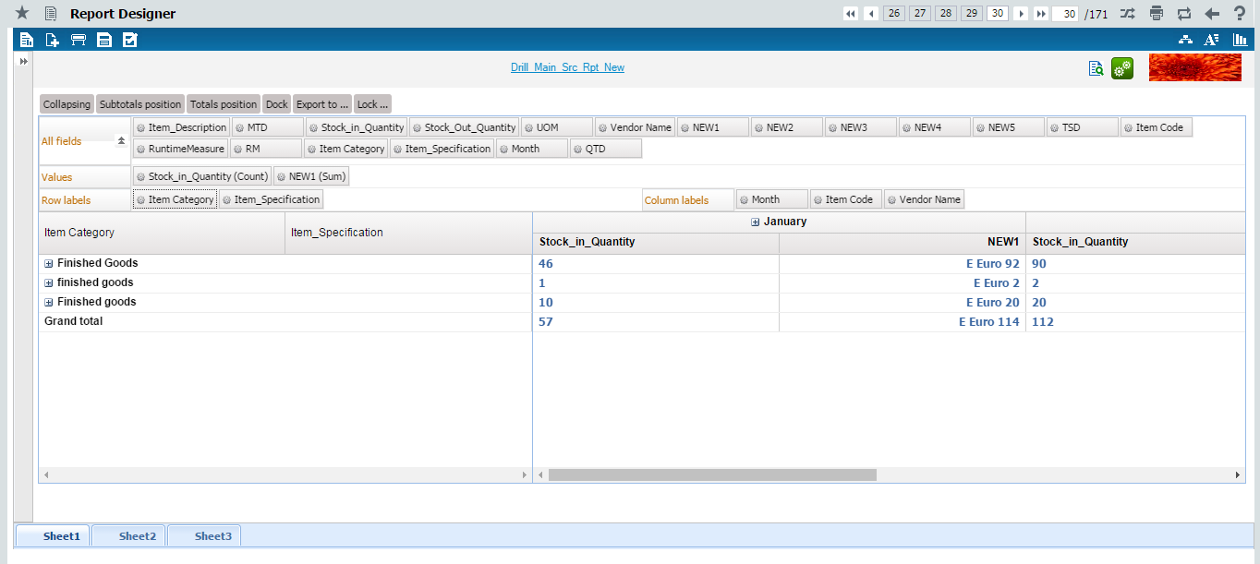

**Values**

Click any of the fields in the Values Axis. Menu as shown in the below picture will be shown. The Field in the Values Axis can be moved up or down, by clicking the ‘Move Up’ and ‘Move Down’ menu buttons.

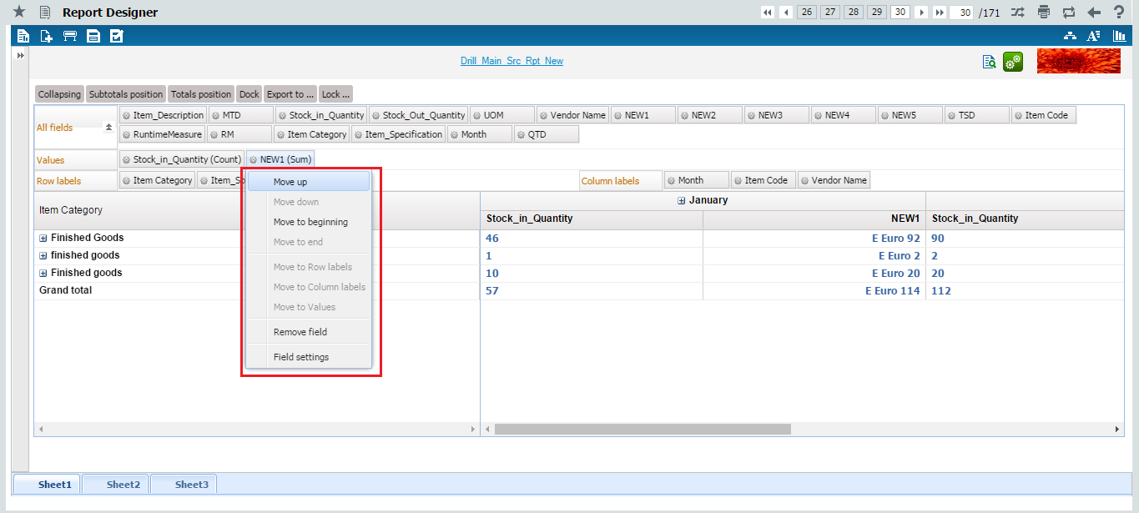

On clicking the ‘Field Settings’ menu option, sub window as shown in the below picture will be shown.

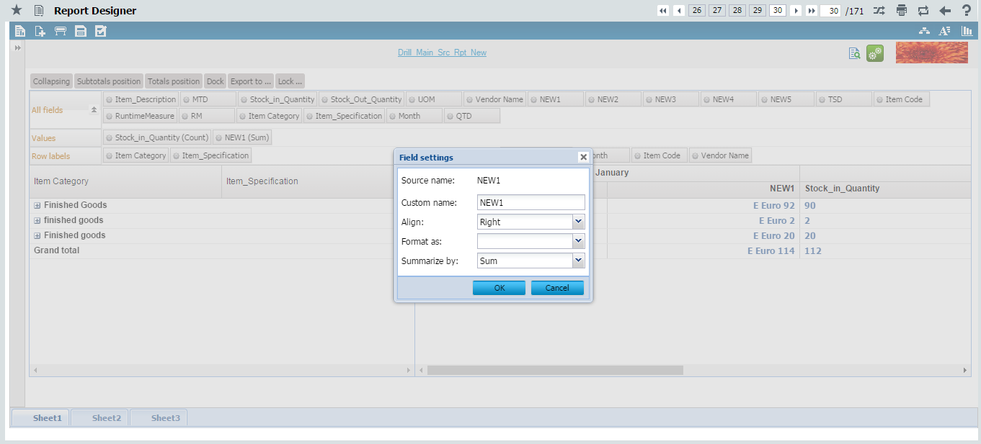

On expanding the ‘Summarize by’ combo, the list of Aggregates that can be applied on the Selected Field will be listed as shown in the below picture.

If the Selected Field is a Measure, then the following aggregates namely

* Sum, Average, Minimum, Maximum, Count, Group Sum Percentage, Group Count Percentage, Variance, VarianceP, Std Deviation, Std DeviationP
* If the User has selected the Pivot Calculations to be done in Serverside then In the Serverside Pivot Grid rendered, the User will be able to apply only the following aggregates namely Sum, Average, Minimum, Maximum and Count.

will be listed as shown below

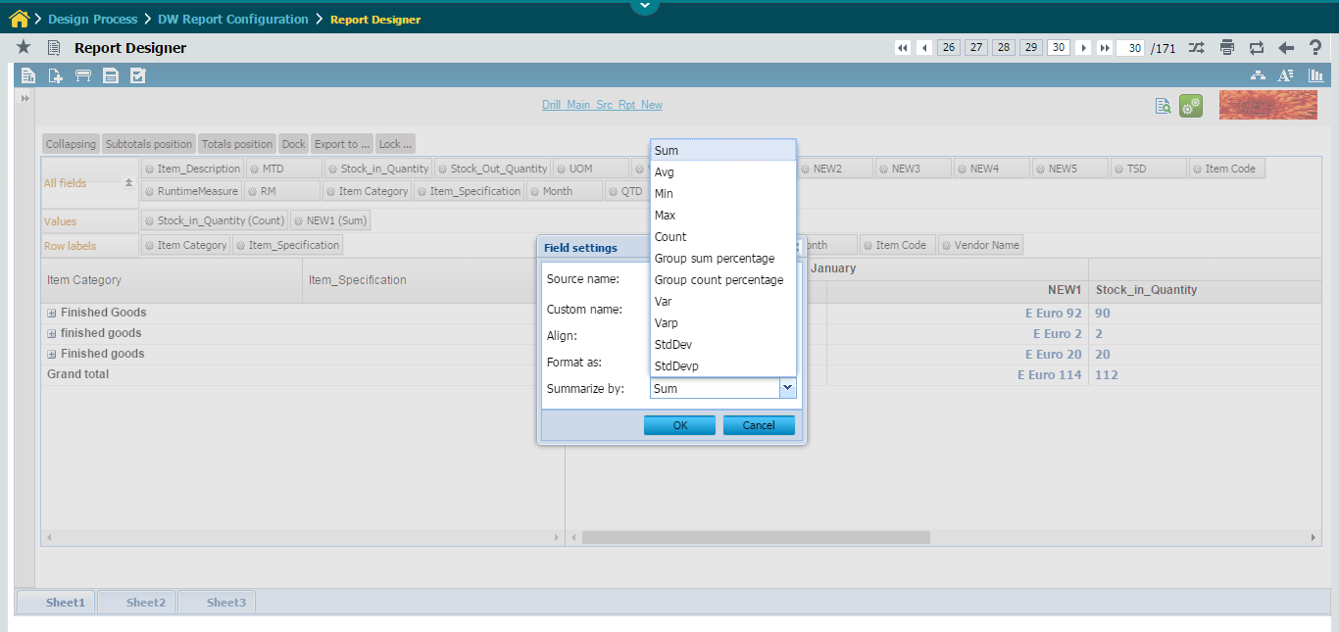

If the Selected Field is a Dimension then only Count will be listed as shown below

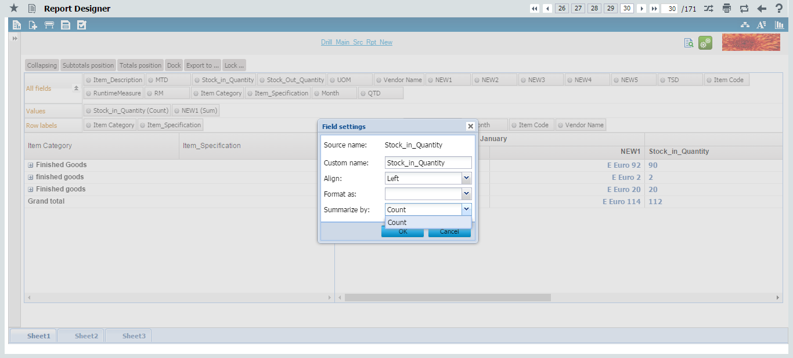

**Row Labels**

Fields in Row Label will display the data in row level as shown below.

Click this  icon to expand the data present in particular row.

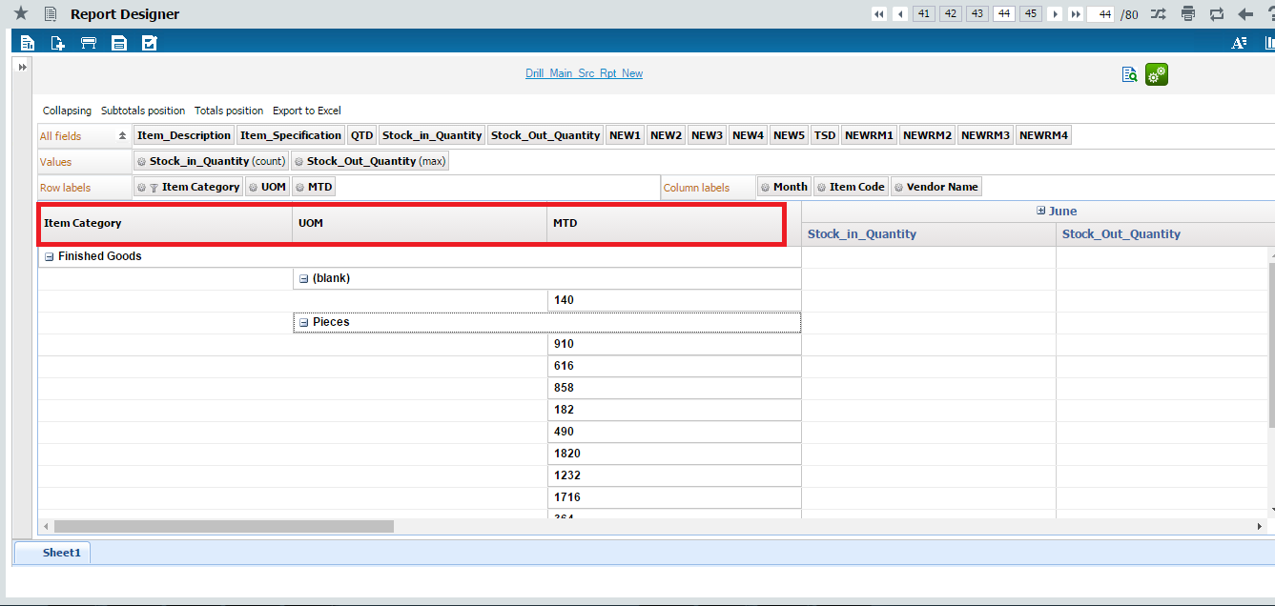

**Column Labels**

Fields in Column Label will display the data in column level as shown below.

Click this  icon to expand the data present in particular column.

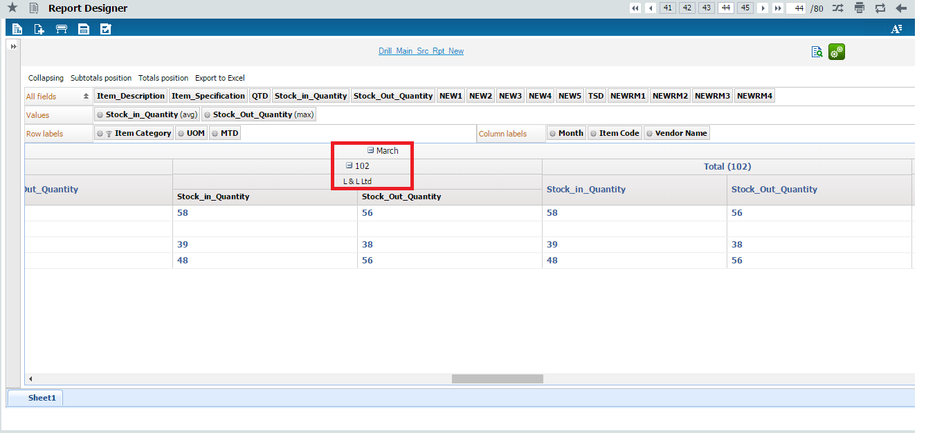

**Row Axis Locking / Unlocking**

The Row Axis Fields of the Pivot grid Can be locked or unlocked. By default the Row Axis Fields will be locked in the Pivot grid as shown in below screenshot

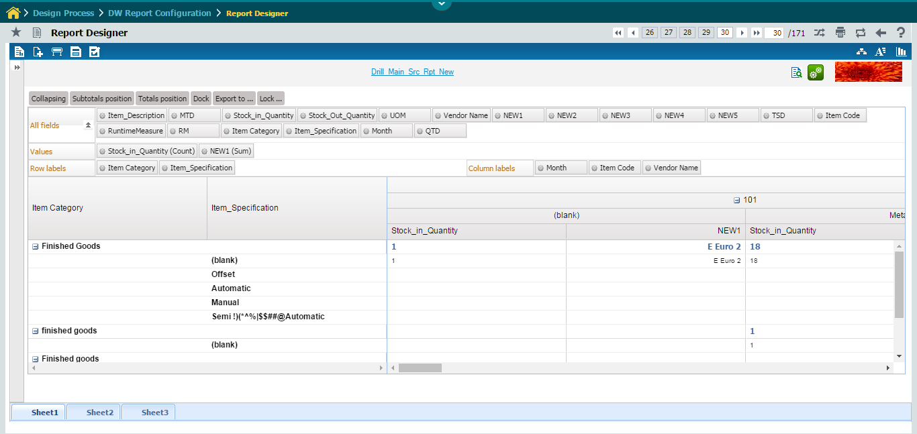

The Row Axis Fields of the Pivot grid can be locked or unlocked by selecting the Lock Row Axis / Unlock Row Axis menu as shown in the below screenshot

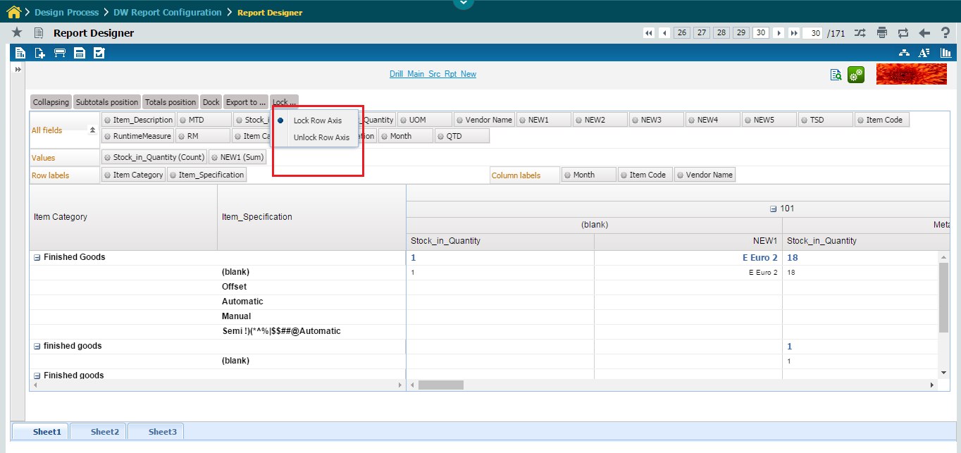

**Filtering**

Filters can be applied on the Row Axis Fields and Column Axis Fields. Currently Filtering is enabled only in Client Side Pivot Grid. If the User has selected the Pivot Calculations to be performed in Serverside, then the User will not be able to perform Filtering in the Serverside Pivot Grid.

On clicking any Field that has been added in the Row / Column Axis, Menu will be shown as in the below picture, wherein the User has to select either the option Label Filters or Value Filters.

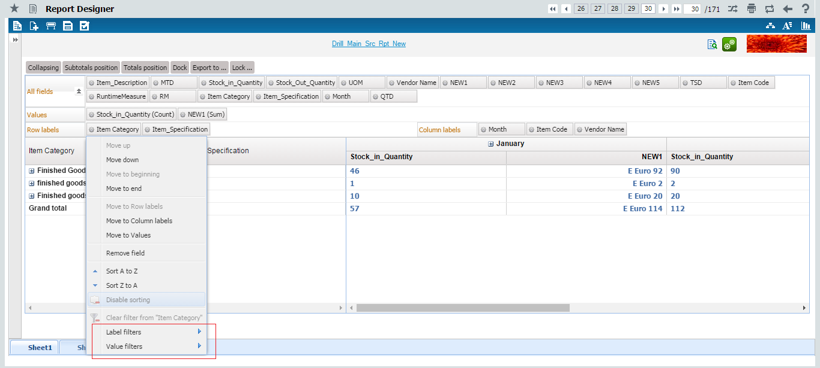

For applying Label Filters, the User has to Select the Menu option Label Filter and choose one of the Sub Menu options as shown in the below picture

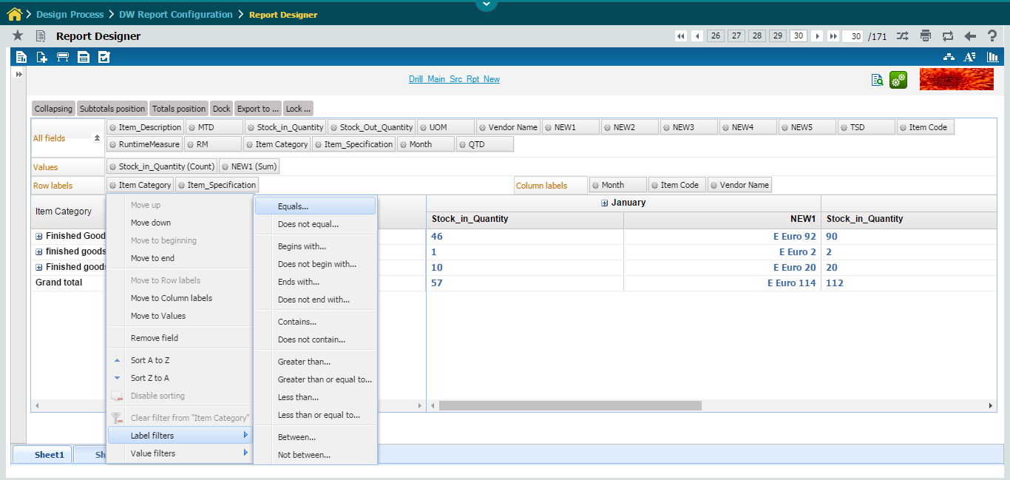

On Selecting Label Filter option a Sub window will be shown as in below picture. And the User can enter the Filter value as shown below

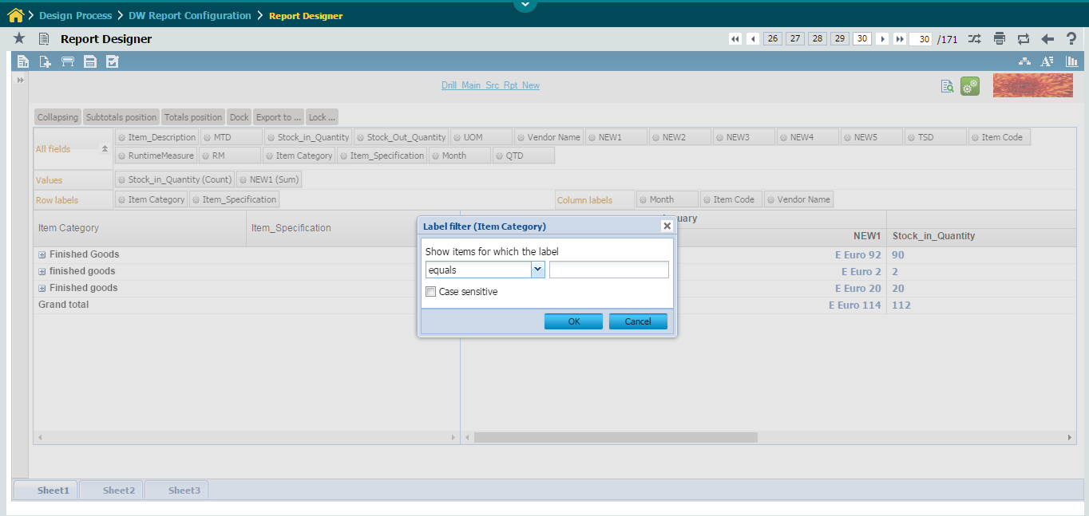

**Collapsing / Expanding All**

If you want to expand all the groups in a single click or if you want to collapse all the groups in a single click then **Collapsing** can be used. Expanded and collapsed data will appear in grid below.

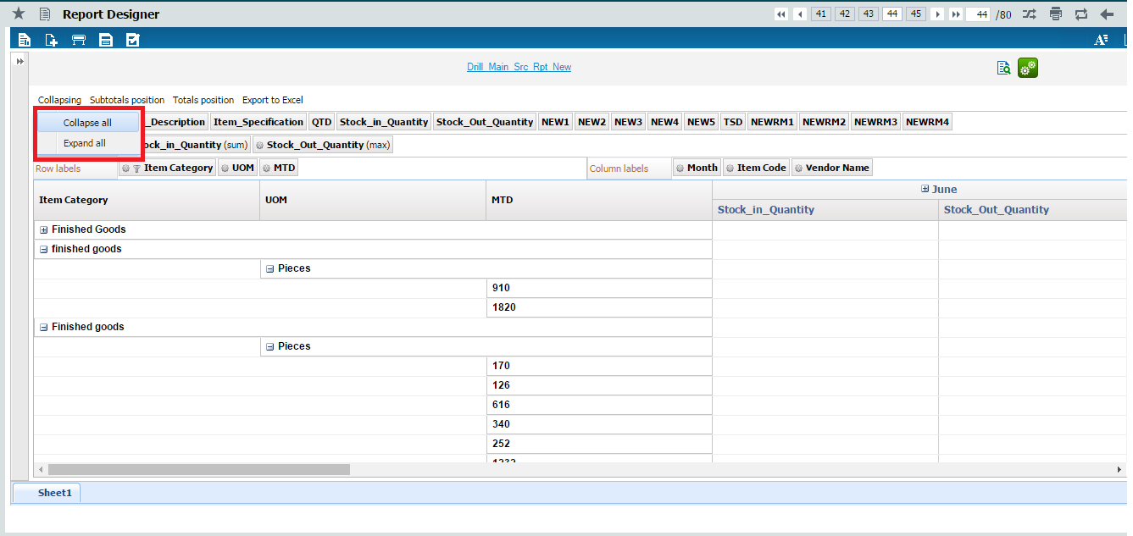

**Subtotals Position**

This enables the user to position the Subtotals in grid. If user selects first then first column of the grid will have the subtotals. If the user selects last then last column of the grid will have subtotals. If the user selects none then subtotals will not be available in the grid.

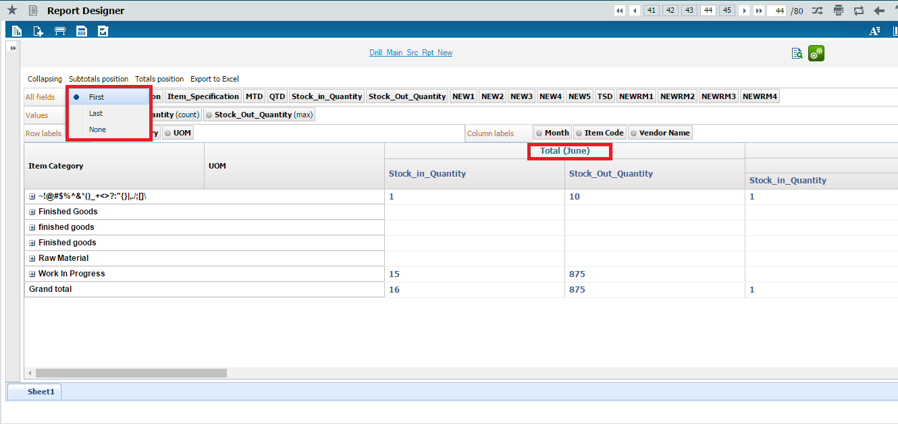

**Totals Position**

This enables the user to position the grand total in grid. If user selects first then first column of the grid will have the grand total. If the user selects last then last column of the grid will have subtotals. If the user selects none then grand total will not be available in the grid.

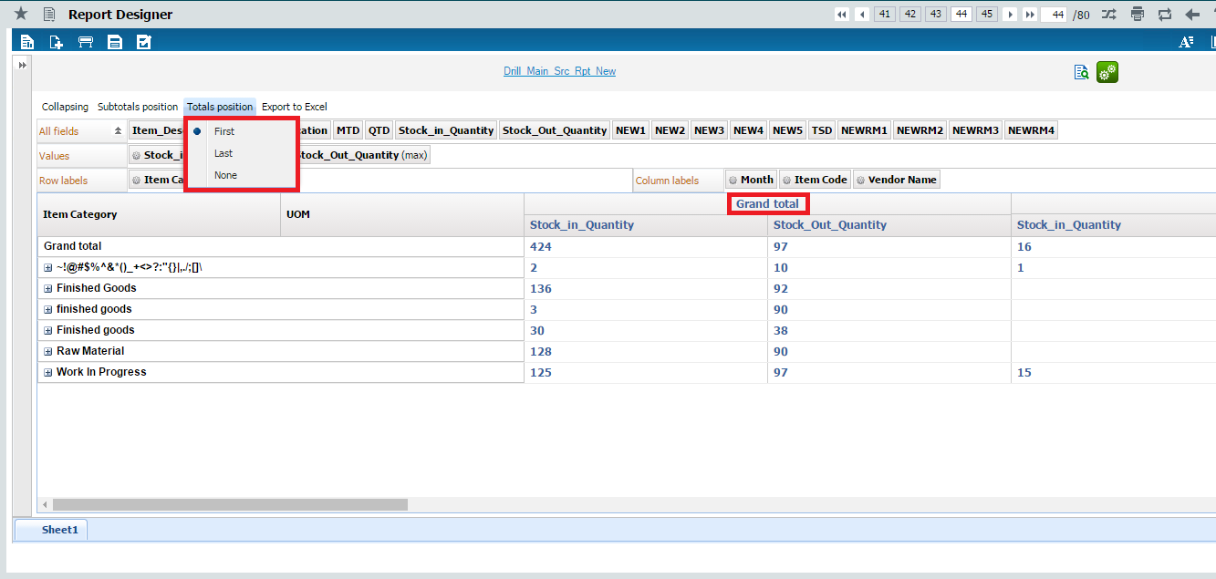

**Enabling Server-side Pivot Grid**

This enables the user to choose the option for performing Pivoting Calculations in the Server-side. Currently by default the Pivot Grid calculations are performed only in the client side browser. But the User has an option to specify that the Pivot Grid Calculations should be performed in the Server.

For this in the Sheet Property window, a checkbox with the option ‘Serverside Pivot Calculations’ is provided.

To enable the Serverside Pivot Grid, the User has to select the checkbox ‘Serverside Pivot Calculations’ option along with the ‘Data In Pivot Grid’ checkbox option as shown in the below screenshot.



Currently In Server-side Pivot Grid, the Filtering feature is not enabled. Users cannot perform Value based Filtering and Label based Filtering in Server-side Pivot Grid.

Also only the following the aggregations can be applied on the Measures in the Server-side Pivot Grid namely

* Sum
* Average
* Minimum
* Maximum
* Count

The User can apply on the Dimensions only the following Aggregations namely

* Count

**Export to Excel**

This enables the user to export the data present in the grid in excel format. The data will always be exported in expanded format only.

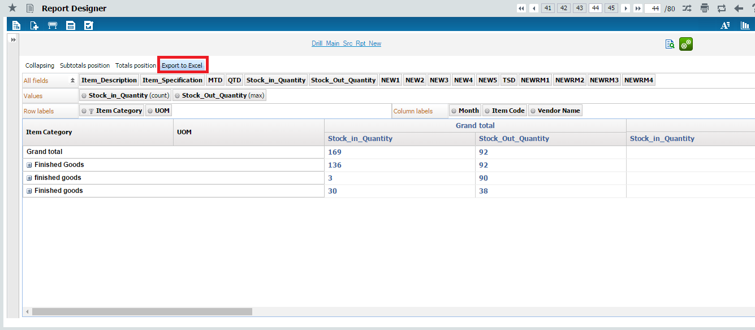

**Excel Output**

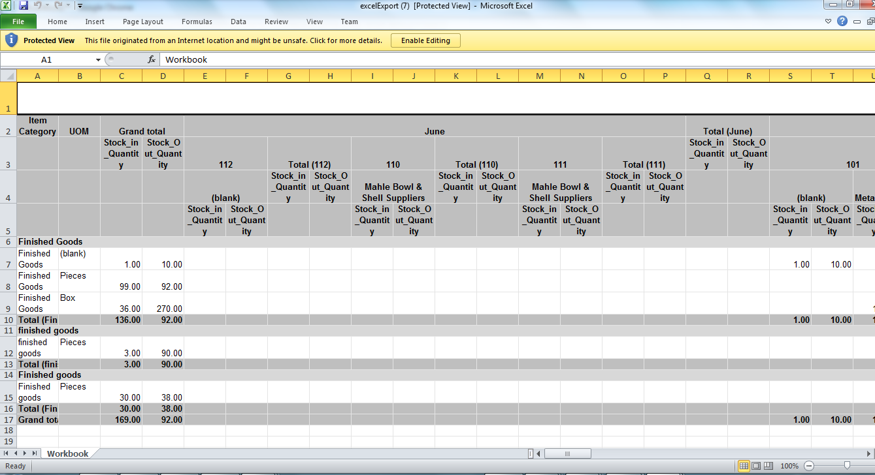

**Parameter Screen**

Input parameters can either be parameter based, using pre-defined parameter input screen (or) by giving custom conditions based on the available fields

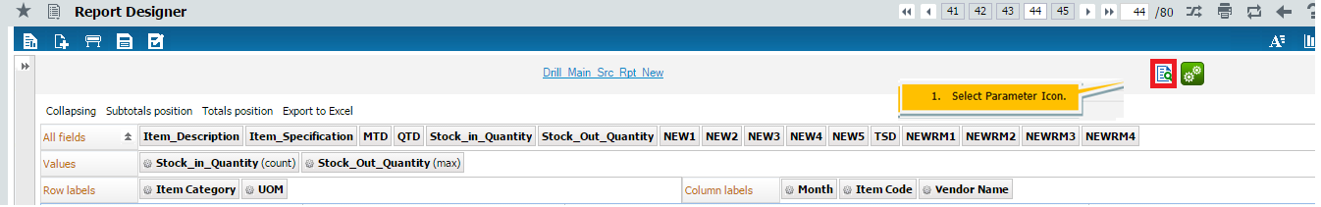

Input parameters screen



Input type can be Text field input (or) Combo Input (or) Date picker. Select/Enter the value and click OK button

**Custom Condition**

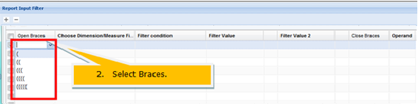

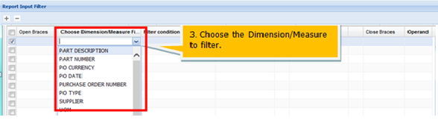

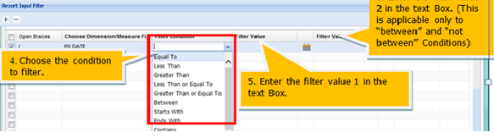

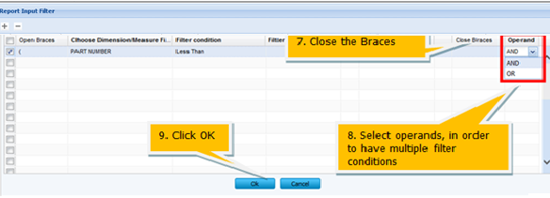

Run the Report.

## Runtime Measure

Using the already available measures, new computed Runtime measures can be created.

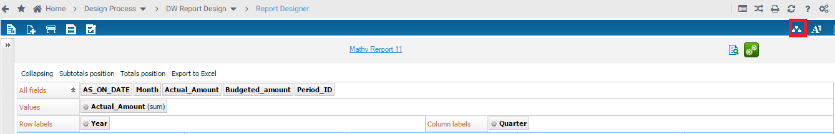



## Analytical Report

**Prerequisite tasks**

* Cubes should have been defined
* Functional areas should have been defined
* Data sources should have been defined

**Overview of analytical reports**

An Analytical report is cube / Mondrian based report wherein data can be

* Drill down
* Sliced and diced
* Pivoted (rotate)
* Drill through

**Data source Definition**

It is the process of defining a reference to the database where the required data resides. This database will be the source of information that is presented in the report.

The first step is the data source definition. The data source specifications are declared in this step.

**Menu**: 

**Data Source Configuration:**

The system displays the Data source Configuration page on the left pane as shown below:

This page displays a list of existing data sources in drop down list.



### Creating a data source

**To define a new data source, click the New button.**



Enter the following fields in the right pane:

Data Source Name A unique name assigned to a data source Mandatory.

Description The description of the data source.

Data Source Type Select the type of data source from the drop-down list box. The system displays “Database”, “Warehouse” and “OLAP".

Server Name The name of the database server .Mandatory

Database User Id A unique ID assigned to a user for the database server. Mandatory

Database Password The password for the user ID for the database server.

Port Number The port number for connecting to the data source. Mandatory

**Click the Get Databases button to get the database details.**

**Database Name** The system displays all databases in the drop-down list box.

Click the **Save** button to save the data source details.

### Edit the data source

Choose **Data Source name** from drop-down list box and Click the **Edit button** to modify the data source detail.

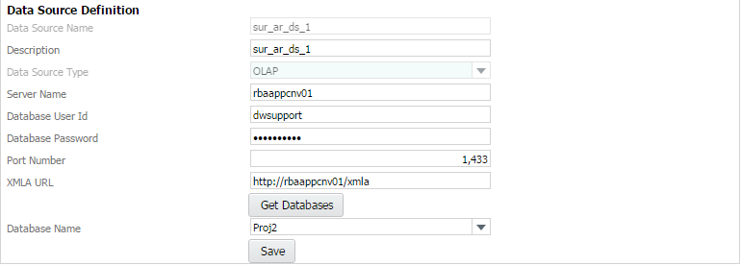

To modify the following fields:

Description The description of the data source.

Server Name The name of the database server .Mandatory

Database User Id A unique ID assigned to a user for the database server. Mandatory

Database Password The password for the user ID for the database server.

Port Number The port number for connecting to the data source. Mandatory

**Click the Get Databases button to get the database details.**

**Database Name** The system displays all databases in the drop-down list box.

Click the **Save** button to save the modified data Source details.

### Deleting the data source

Choose **Data Source name** from drop-down list box and Click the **Delete button** to delete the data source detail.

Data sources can be deleted only if they are not used in any report configuration.



### Data source Functional Area Mapping

Functional area is a logical or business name given to a group of reports based on subject area Viz., Sales, HR, and Finance.

In this step, you will know the functionality of Functional Area and configure the Functional Area Data source.



This page displays a list of functional areas in drop-down list box

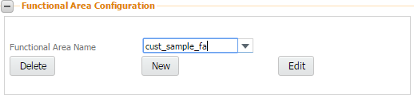

The system displays the following fields:

Functional Area Name Created functional Area name listed in drop- down list box.

***Delete*** Click on **delete** button, Functional Area can be deleted only if they are not used in any report configuration.

New Click on New button, user can create new functional area.

Edit Click on Edit button, user can modify the functional area definition.

### Creating a functional area

Click the **New** button system will display below screen.



Enter the following fields:

Functional Area Name A unique name assigned to a functional area. Mandatory.

Description The description of the functional area.

Data source Name to select the data source that you want to map to the functional area.

**Click the Save button to save the functional area details.**

The new functional area details are saved.

### Analysis Configuration

**Click the New button to create a new Analysis.**

The system displays the details of the Analysis Configuration page.

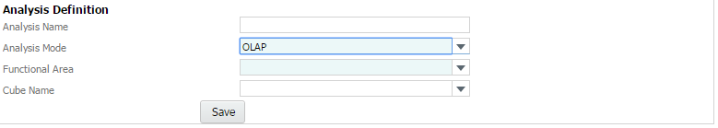

Analysis Name The name of the analysis of the functional area that is mapped to the stored procedure or query or web service.

Analysis Mode The mode of execution can be either a stored procedure or web service or View or query. Choose the mode as OLAP.

Functional Area Select functional area name from drop-down list.

Click the save button to save the Analysis configuration details.

### Edit Analysis Configuration

Select functional area and click the search button.

Choose analysis name from grid and click the edit button.

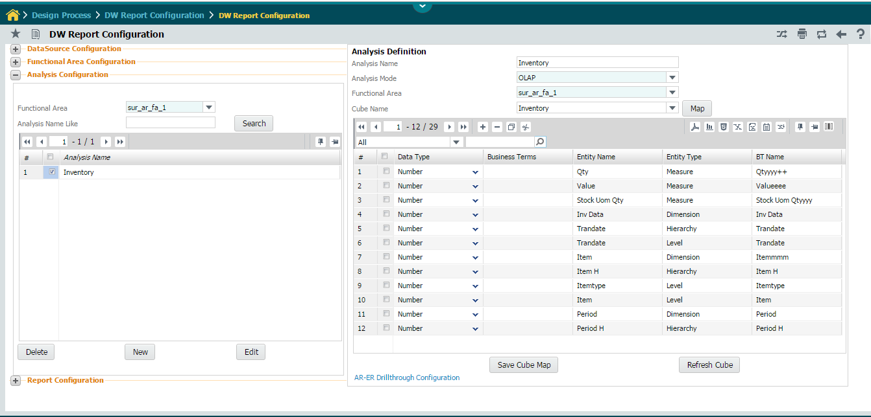

This page enables the user to select the business terms to be mapped to the cube. The user can also create new business terms through the same page.

**Click the SaveCubeMap button.**

The system saves the selected BT names and returns to the main page.

### Report Configuration

Click the menu Deployment process -> DW Report Configuration -> DW Report Configuration

**Click the New button to define a new analytical report.**

The system displays the **analytical** Report Definition page.

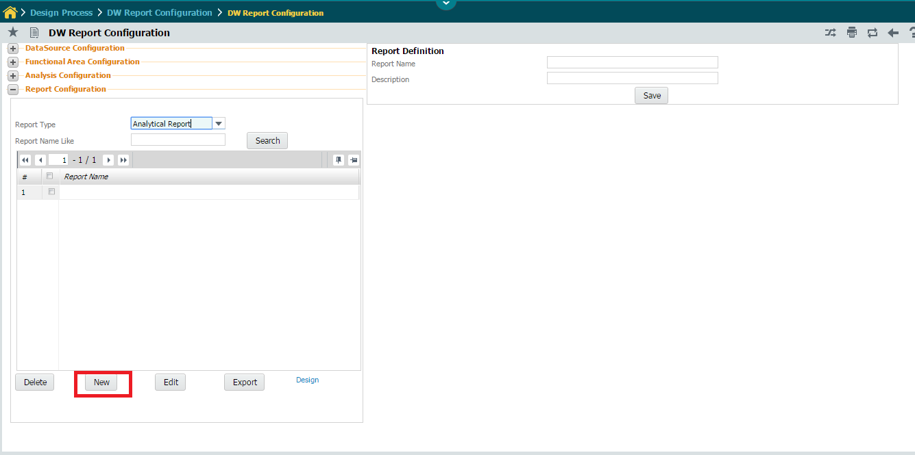

Enter the following fields in right pane.

Report Name The name of the enterprise report. Mandatory.

Report Description The description of the enterprise report.

Click the OK button.

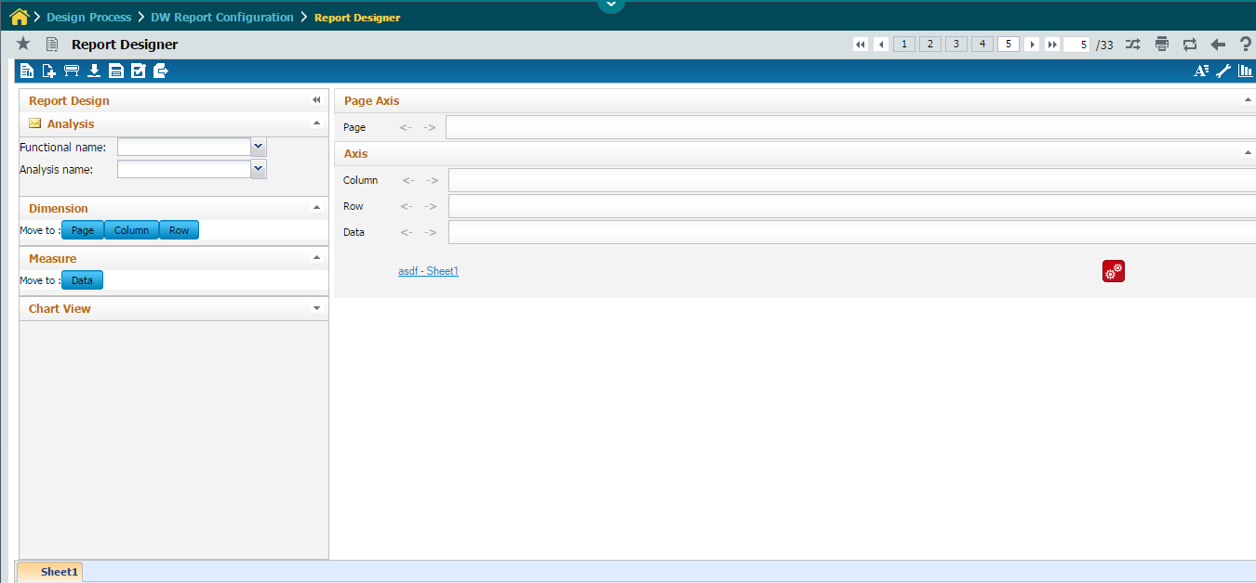

Select the Functional Name, followed by ‘Analysis Name’. The list of dimensions and measures to

which the user has security will be displayed.

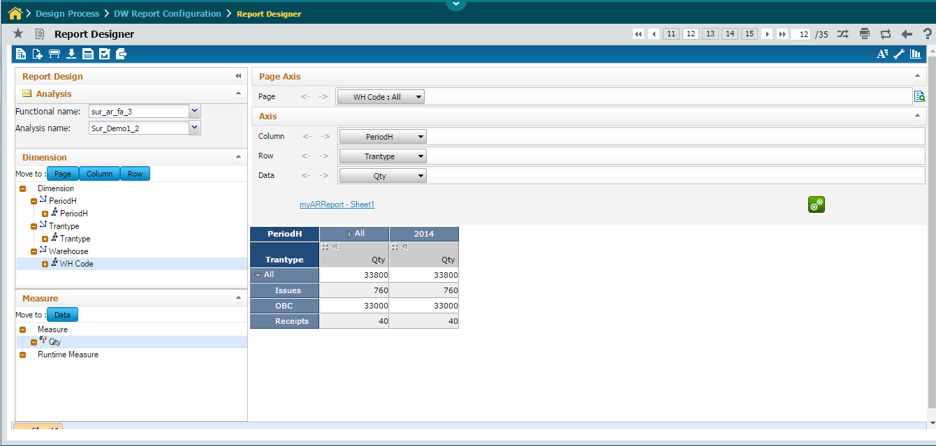

Drag a Dimension / click on dimension followed by ‘Page’ or ’Column’ or ’Row’ button to place the Dimension in Respective axis. The dimension placed in Particular axis will act as Filter to the report.

Drag a ‘Measure’ / click on ‘Data’ button to place a measure in ‘Data’ Axis.

Click the ‘Show data’ icon to launch the report.

For any dimension placed in column and row axis three features namely – Show level, show Data and custom Ordering are available.

**Show Level**

This specifies till what level in the hierarchy the data has to be displayed.

Click on the show level from drop down menu of dimension in axis will launch the screen as shown below

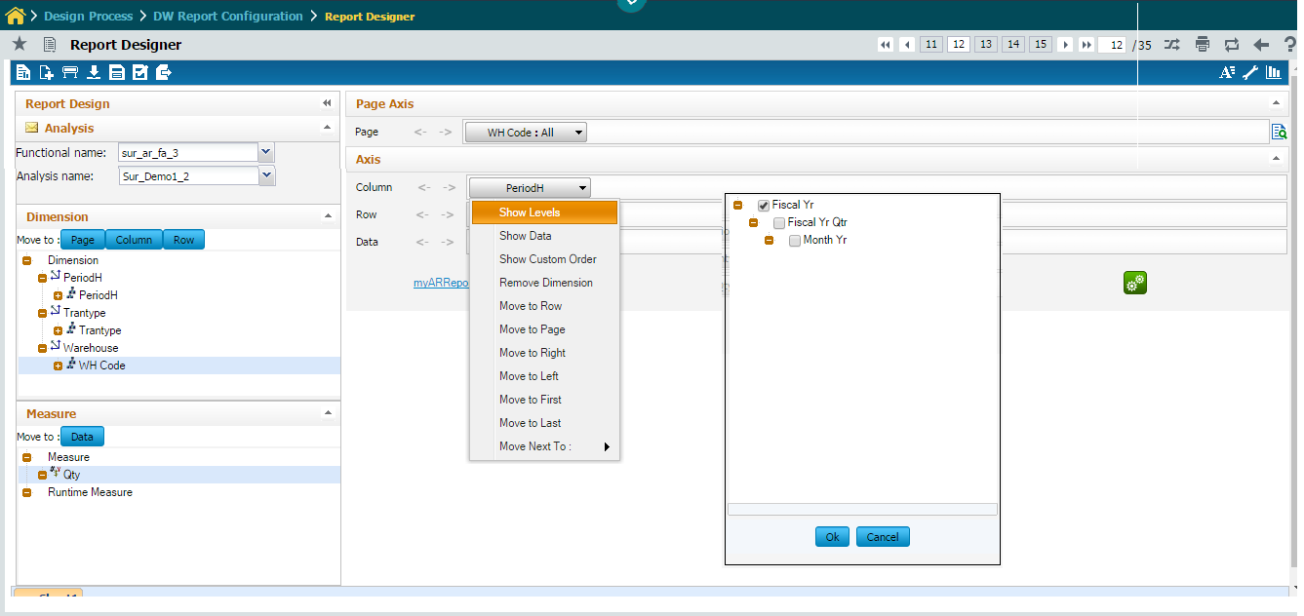

Click **RUN** Button.

The data is fetched according to the hierarchy level selected above.

**Show data**

This allows the user to select the data members that need to be displayed in the report.

Click on the show data from drop down menu of dimension in any of the axis will launch the screen as shown below.

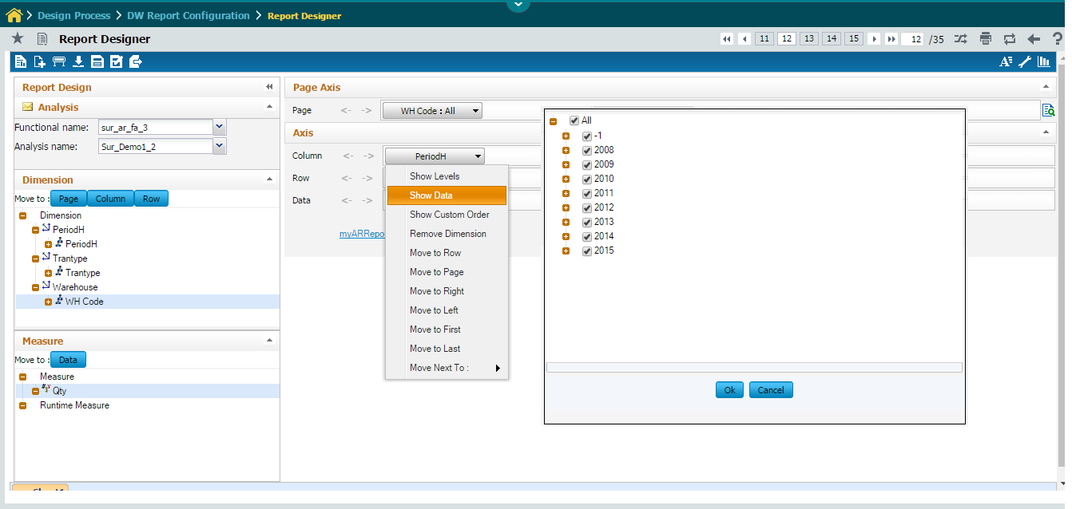

Click **RUN** Button.

The data is fetched according to the hierarchy level selected above.

**Show Custom Order**

This allows the user to rearrange the data members in the order as required for that report.

Click on the show custom order from drop down menu of dimension in any of the axis will launch the screen as shown below.

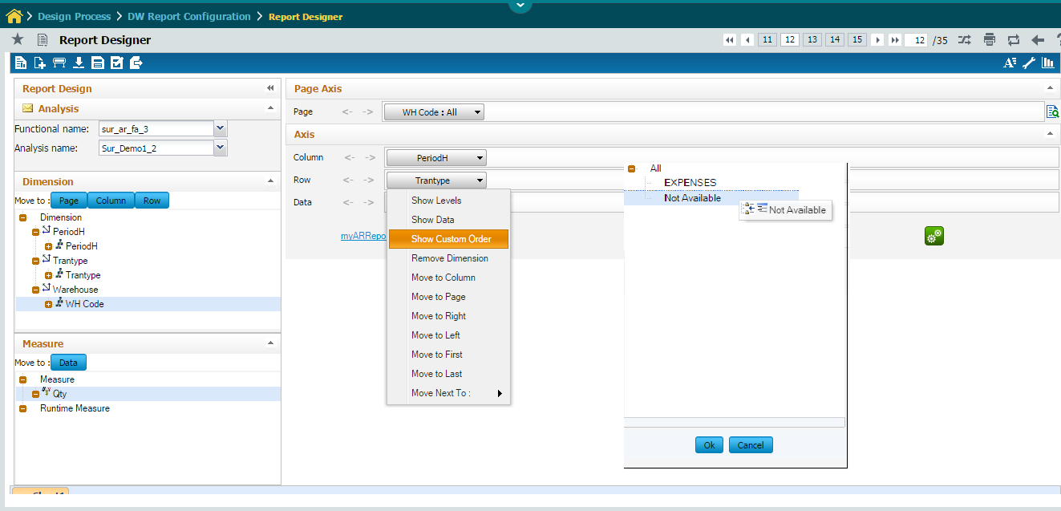

Click **RUN** Button.

The data is rearranged according to the given order.

**Report Definition**

Click this  icon from the list of icon displays on the top left of the Analytical Report Design Page to View/Edit the report definition details.

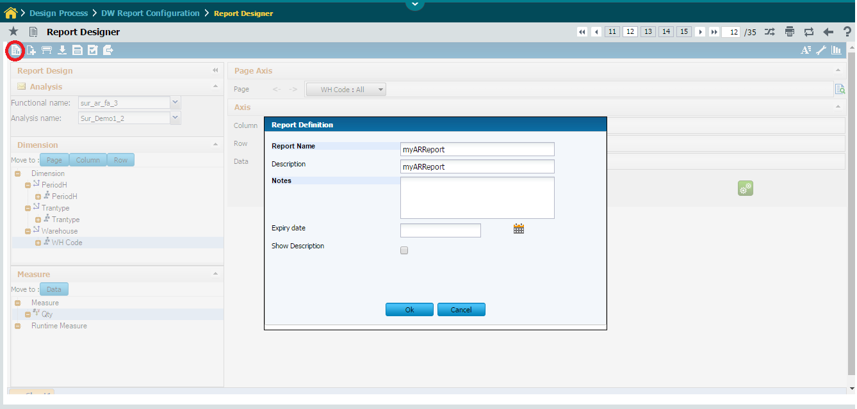

Report Name The name of the Analytical report. Mandatory.

Description The description of the report.

Notes Relevant notes for the report being defined.

Expiry Date The Expiry Date for the report.

Show Description To Show the Description of the Report.

**Creating New Sheets**

Click this  icon from the list of icon displays on the top left of the Analytical Report Design Page to create new sheets for the report.

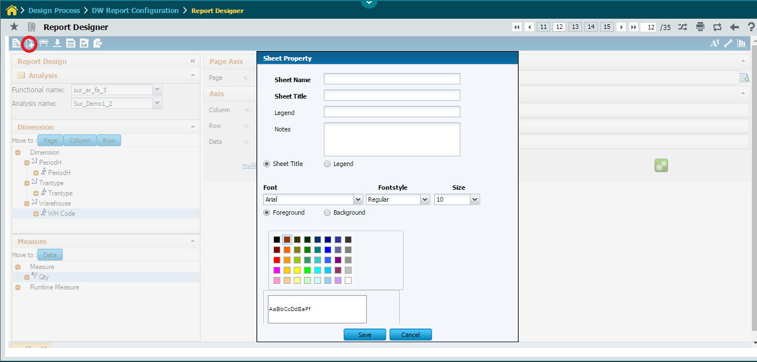

Sheet Name Enter Sheet Name.

Sheet Title Enter Sheet Title.

Notes Provide Relevant Notes for the new sheet.

Font Choose Required Font, Font Style.

Click Save Button.

The New Sheet will placed on right side of the current sheet.

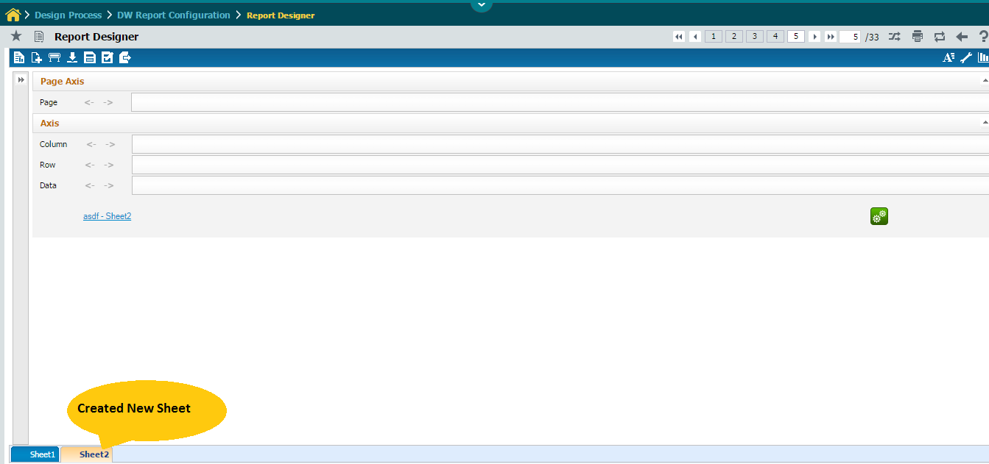

**Report Properties**

Click this  icon from the list of icon displays on the top left of the Analytical Report Design Page to Provide Report Properties.

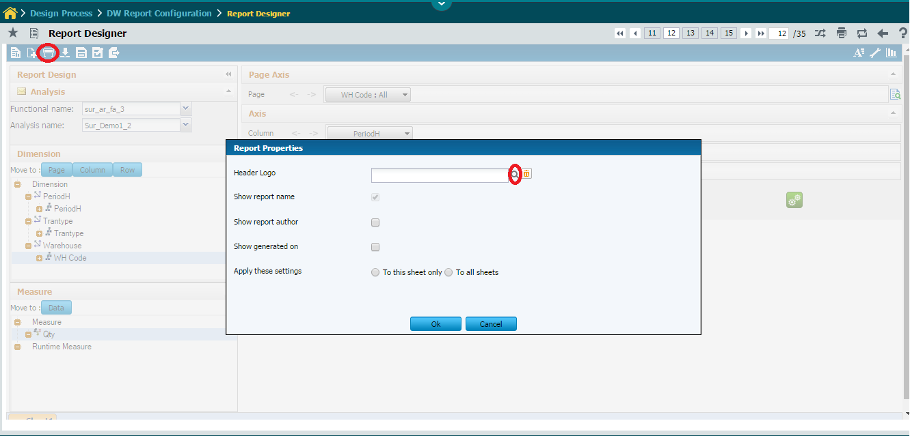

 This icon is used to Upload Header Logo for the report.

**Save Report**

Click this  icon from the list of icon displays on the top left of the Analytical Report Design Page to saves the report in current design.

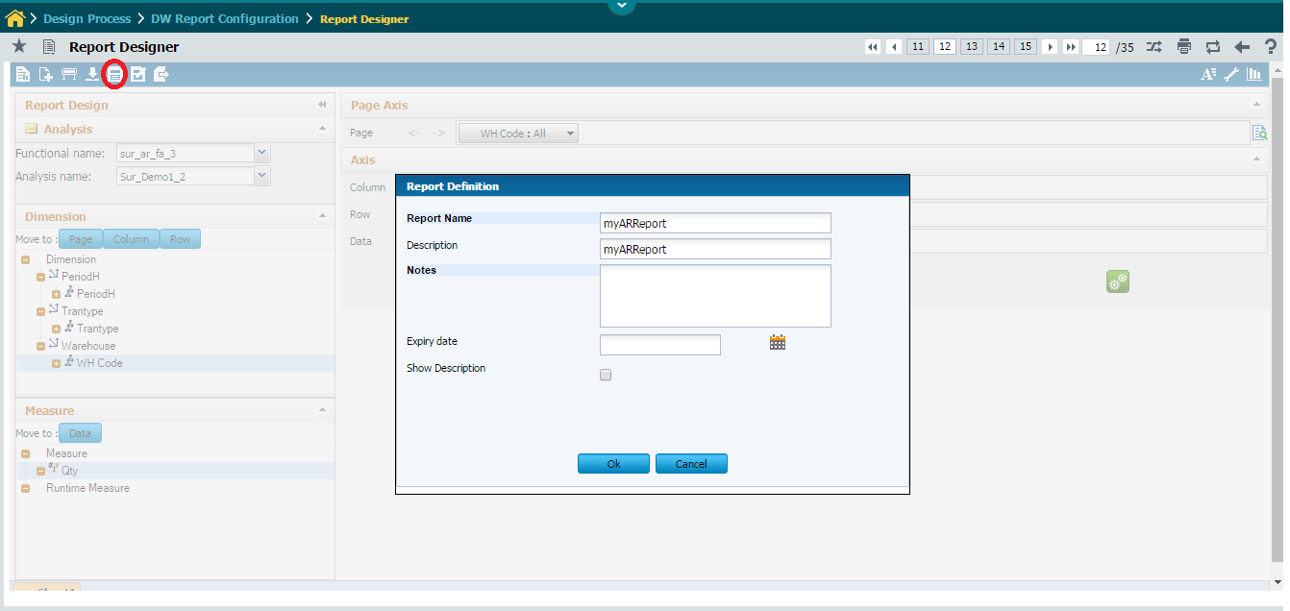

Provide relevant notes and Click OK Button to save the Report.

Save As Report

Click this  icon from the list of icon displays on the top left of the Analytical Report Design Page to save the report with different name.

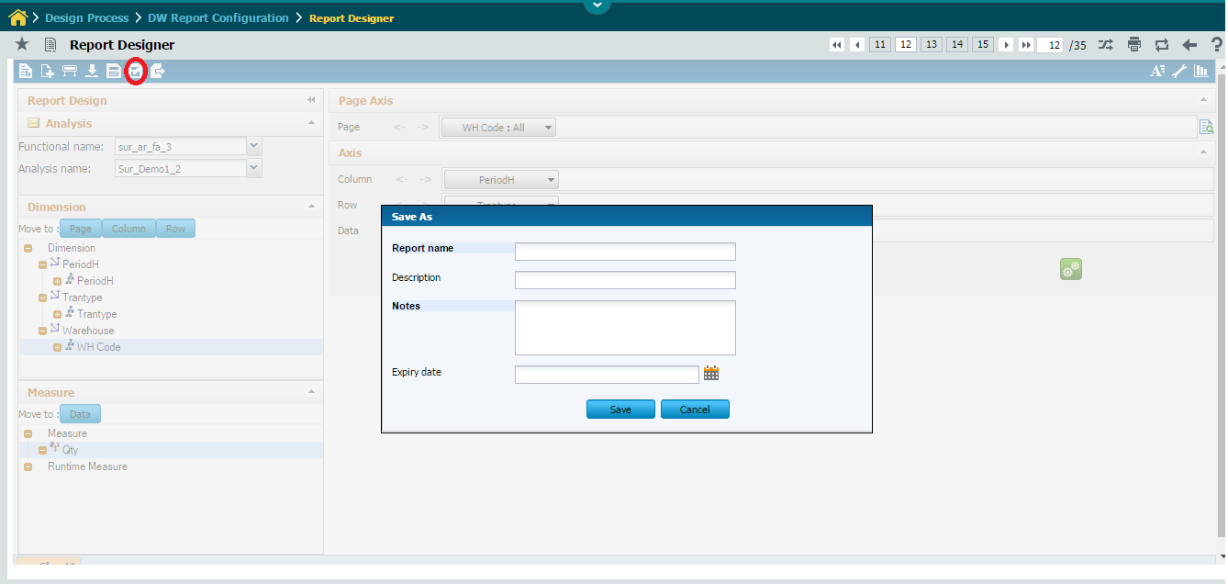

Provide report name, relevant notes and Click **SAVE** Button to save the report in different name**.**

**Export Data**

Click this  icon from the list of icon displays on the top left of the Analytical Report Design Page to export report.

Exporting Data can be done in two ways

* **Excel**
* **Pdf**

Both options provide two ways to export the data

* **What you see is what you get** – The report data visible to the user gets exported.
* **Full data** – The full data for the report gets exported.

**Export To Excel**

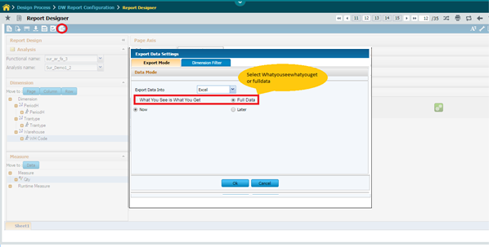

Click **OK** Button.

Excel Output

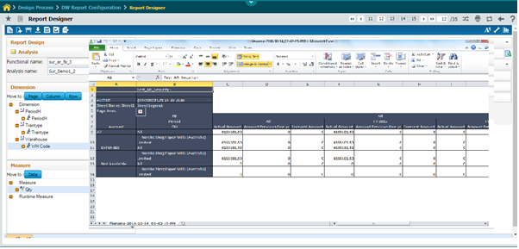

**Export To Pdf**

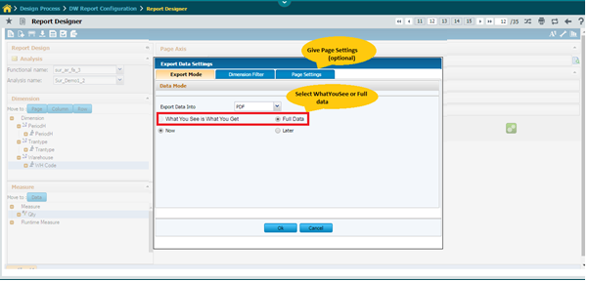

Click **OK** Button.

Pdf Output

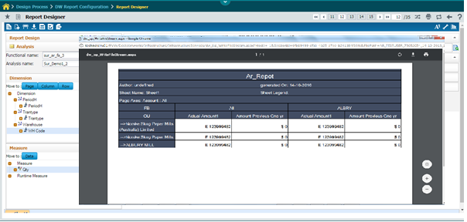

**Formatting**

Click this  icon from the list of icon displays on the top right of the Analytical Report Design Page for formatting the report sheets.

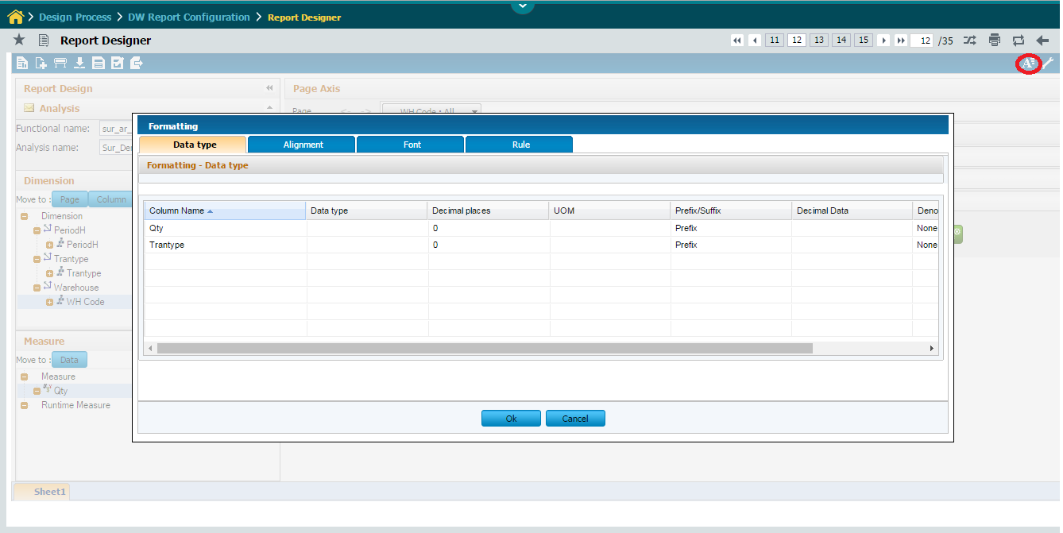

There are four tabs displayed namely, Data type, Alignment, Font and Rule.

Click the **Datatype tab** in the Formatting page.

The Datatype tab is displayed by default when you launch the Formatting page.

Enter the following:

Column Name The selected column name for which the data type should be specified is displayed by default.

Data type Data type will be defaulted automatically based on the Column Name selection. The following are the data types displayed as options in the drop-down list box: String, Currency, Text and Date.

Decimal places Select the number of decimal places that should be used from the list box.

UOM Based on the specified data type select the unit of measure from the drop-down list box. The options displayed are: “$”, “E Euro”, “Rs”, “F French” and “%”.

Prefix/Suffix Select an appropriate option from the drop-down list box to indicate whether the data type is Prefix or Suffix for the column name.

Decimal Data Select the decimal data format for the specified data type from the drop-down list box. The system displays a predefined list of decimal data formats as options.

Denomination Type Choose the denomination type based on the decimal data selected from the drop down list box. The Denominations for specified decimal data is listed as the options.

Click the OK Button to save the data type details.

Click the Alignment tab in the Formatting page.

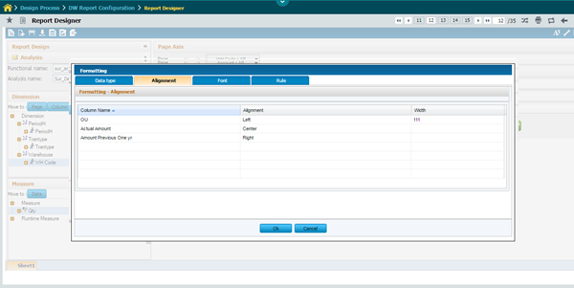

Enter the following:

Column Name The selected column name for which the alignment should be specified is displayed by default.

Alignment The default alignment is displayed. Select an appropriate option to align the column from the drop-down list box. The options displayed are: Left, Right and Center.

Width Enter the specific width (In pixels) for the corresponding column name. The default width is 100 pixels.

Click the OK Button to save the Alignment details.

Click the Font tab in the Formatting page.

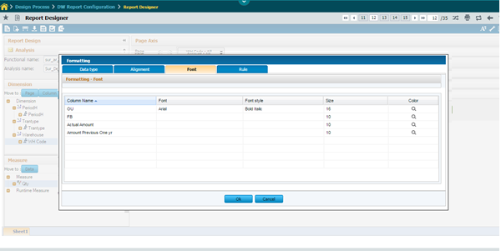

Enter the following:

Column Name The selected column name for which the alignment should be specified is displayed by default.

Font The default font is displayed. Select an appropriate font that you want to apply to the column name from the drop-down list box. A predefined list of font names is displayed as options.

Font Style Select the font style that should be used for the selected column from the list box. The options displayed are Regular, Bold, Italic, Bold Italic.

Size Select the size of the font that should be applied for the selected column from the list box. A predefined list of font sizes is displayed as options.

Color Click the lens icon to define the color for the font. The system launches the Font color palette page that enables you set the foreground and background color.

Foreground color Select the foreground color radio button option for specifying the color of the text in the report using the below displayed color palette

Background color Select the background color radio button option for specifying the color of the text in the report using the below displayed color palette.

Underline Select the check box to underline the data in the selected column.

Click the OK Button to save the Font details.

Click the Rule tab in the Formatting page.

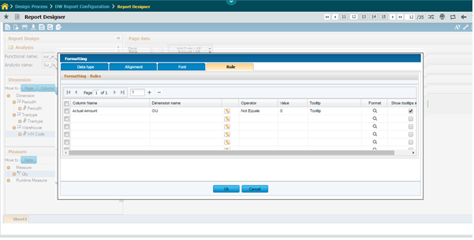

Enter the following details:

Column Name Select the name of the column of the report for which the rule has to be applied from the drop-down list box. Use the filter option to select the required member from dimension which will additionally be included in the rule.

Dimension Name Select the dimension in the report for which the rule has to be applied from the drop-down list box.

Operator Select the required operator that should be used in the rule from the drop-down list box. If the operator is “IN”, “NOT IN” or “BETWEEN” values should be separated with a comma.

Value The value in the column for the rule to be effective.

Tooltip The text that should displayed as tool tip when you hover around the dimension or measure for which the rule is applied.

Format Click the lens icon to select the color and font from the Font screen that should be applied to the cell of the report when the column data are affected by the rule.

Show Tooltips Click the checkbox to display the tooltips in the report.

Click the OK Button to save the Rule details.

Advanced Configuration

Click this  icon from the list of icon displays on the top right of the Analytical Report Design Page to specify Advanced Configuration for the reports.

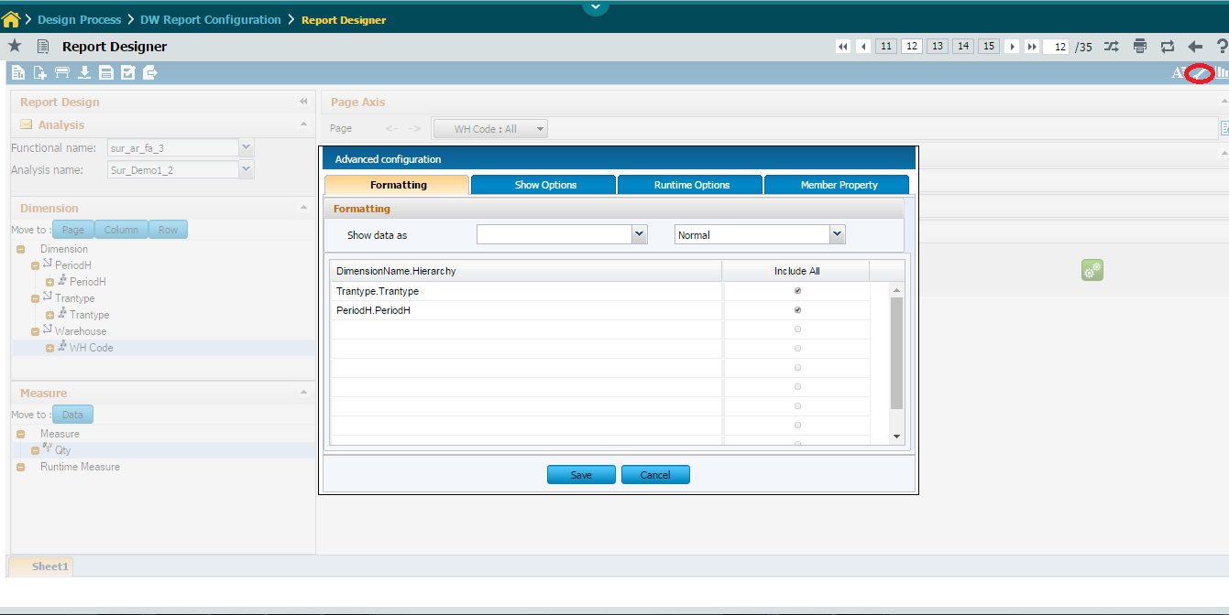

There are four tabs displayed namely, Formatting, Show Options, Runtime Options, Member Property.

Click the **Formatting tab** in the Advanced Configuration page.

The Formatting tab is displayed by default when you launch the Advanced Configuration page.

Enter the following:

Show data as Select an appropriate option from the drop-down list box to select the relevant measures for the specified analysis report to be displayed. Also select the measure in percentage or normal from the adjacent drop-down list box for the data to be displayed.

The following field is displayed:

Dimension Name.Hierarchy The dimension name and hierarchy which is used in the column and row axis of report layout.

Select the following field:

Include All By default the Include all option will be checked. Include all option is for choosing whether the totals to be displayed in the report or not. If the Grand Total (All Option) is not required in the report layout uncheck this option against the Dimension Hierarchy.

Click **Save** Button to save the specified details.

Click the **Show Options tab** in the Advanced Configuration page.

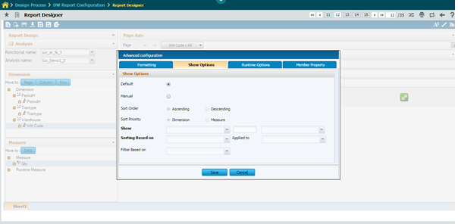

Enter the following:

Default This option is enabled by default at creation of report. All the records will be displayed as defined in the cube / warehouse.

Manual Select this option to set user defined view of report. Choose the top or bottom 5 /10 values to view the report.

Sort Select the option “Ascending” or “Descending”, if you want to sort the report by either ascending or descending order.

Show Select an appropriate option from the drop-down list box to select the either top or bottom values for the specified analysis report. Mandatory

Sorting Based On Select an appropriate option from the drop-down list box to select the Dimension – Hierarchy levels based on sorting. Mandatory

Applied to Select an appropriate option from the drop-down list box to select the measure to which the sorting needs to be applied to the report. . Mandatory

Filter Based On Select an appropriate option from the drop-down list box listing the dimension – hierarchy levels placed in column axis to indicate the filter based on any specific column in the report.

Click **Save** Button to save the specified details.

Click the **Runtime Options tab** in the Advanced Configuration page.

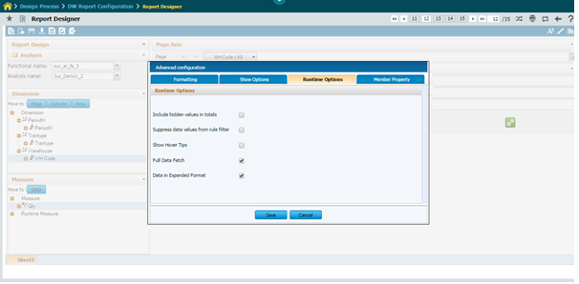

Enter the following:

Include hidden values in totals Click the checkbox to displaying the hidden values in a filtered AR report to total.

Suppress Data from rule Filter Click the Checkbox to suppress the data from rule filter.

Show Hover Tips Click the Checkbox to Show Hover Tips.

Full Data Fetch In analytical report (Microsoft OLAP route and Mondrian), on demand data retrieval has been implemented by default to fetch the data. Only Top level data will be retrieved and displayed in the report while launching the report or run

Data in Expanded Format Click the Checkbox to show the data in expanded format.

Click **Save** Button to save the specified details.

Click the **Member Property tab** in the Advanced Configuration page.

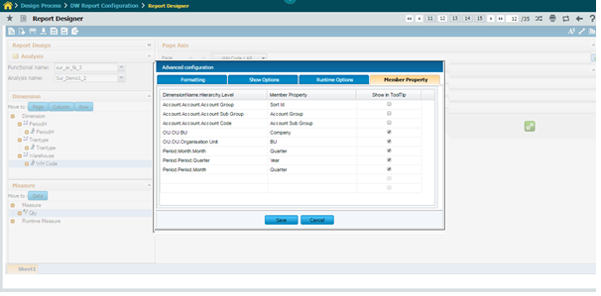

Enter the following:

DimensionName.Hierarchy The dimension and Hierarchy name which are in placed in row and column axis of a report will be displayed.

Member Property The additional attributes of dimensions is displayed here.

Show in ToolTip Click the checkbox to display the member property to be displayed on hover over the dimension as tooltip in the report.

Click **Save** Button to save the specified details.

**Charts**

Click this  icon from the list of icon displays on the top right of the Analytical Report Design Page to support variety of charts that can be included in reports.

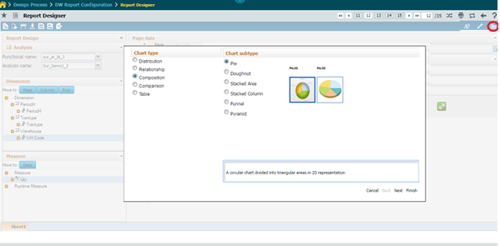

Click **Next** button



Select the required sheet from drop-down list box.

Click the required Dimension for X- Axis.

Click **Next** button



Click the required Measure for Y- Axis.

Click **Next** button



Select the required formatting changes like chart Title, Font, Format, Scale and Fill Effects.

Click **Next** Button.



**View Name** Enter View name.

**Enable Grouping** to view the chart with grouping.

Click **Finish** button

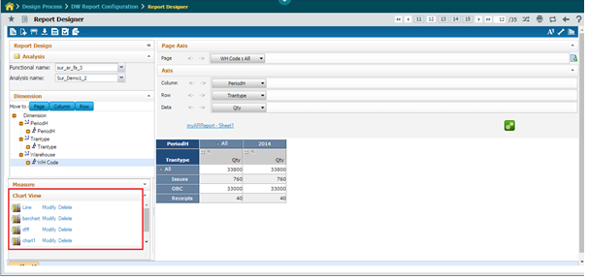

Chart view panel list all created charts in left pane. Click on the Modify link can modify the chart details.

Click on the delete link can delete the chart details.

Click on the view name chart will display in the right pane window.



Drill through Configuration

Click this  icon from the list of icon displays on the top left of the Analytical Report Design Page to specify the Enterprise reports (ER) which are to be available as drill through reports for the analytical report.

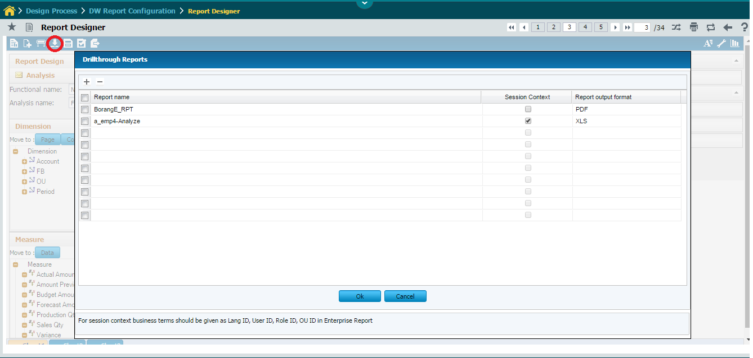

Report Name The name of the selected drill through report is displayed.

Session Context Click the checkbox to pass session context in the drill through report. For e.g., the details like User Id, Role ID, Language Id and OU ID are passed provided the report accepts these four parameters.

Report Output Format Select the format in which you want to view the drill through report output from the drop-down list box. The system displays “PDF”, “XLS” and “HTML” as options.

Click OK Button to save the specified details.

Click this  icon to select a drill through report from the Data source details page.

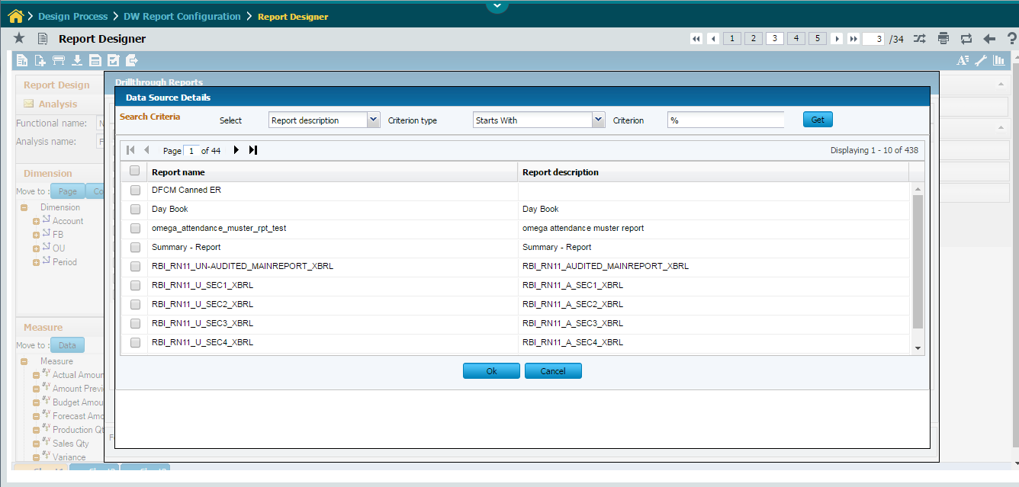

Click OK Button to save the selected ER report as drill through report for the Analytical report.

## AR – ER Drill through Configuration

Analytical reports can have drill through enterprise reports, which will provide more details about the analytical report content that you are viewing.

This enables the user to map a cube (analysis name) to a data source which contains the related ER reports.

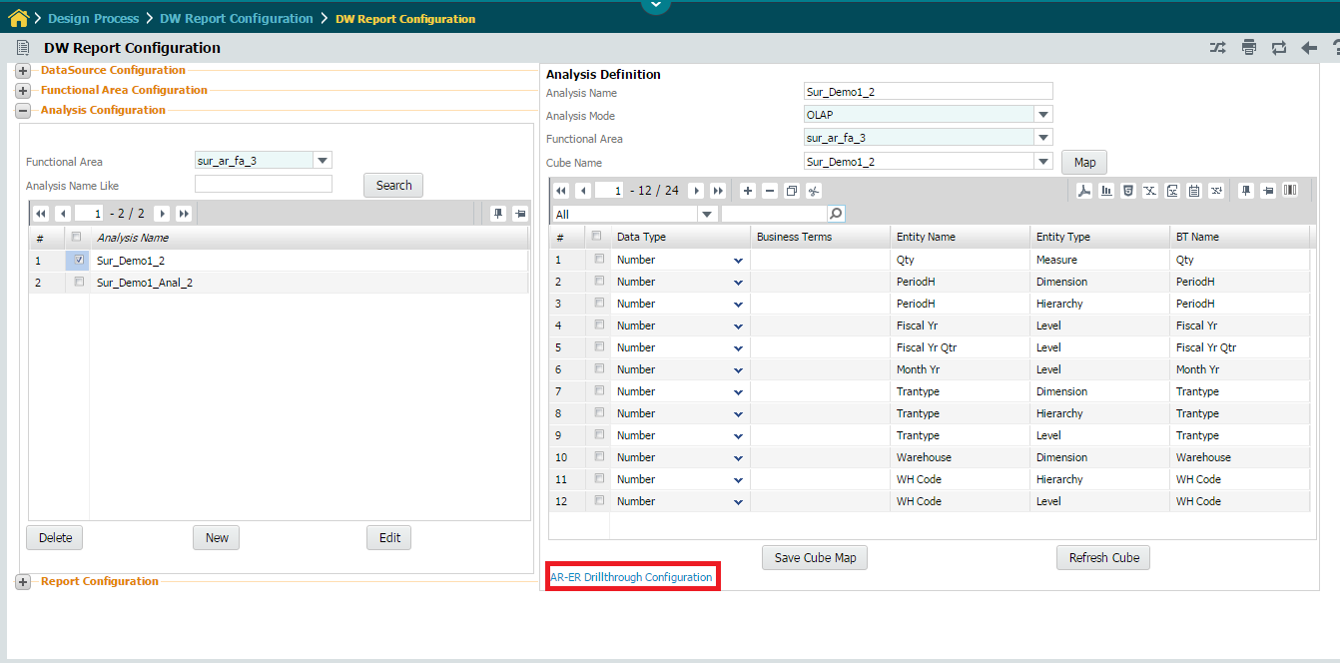

In Analysis Configuration screen click AR-ER Drill through Configuration as shown above.

The System will displays the below screen

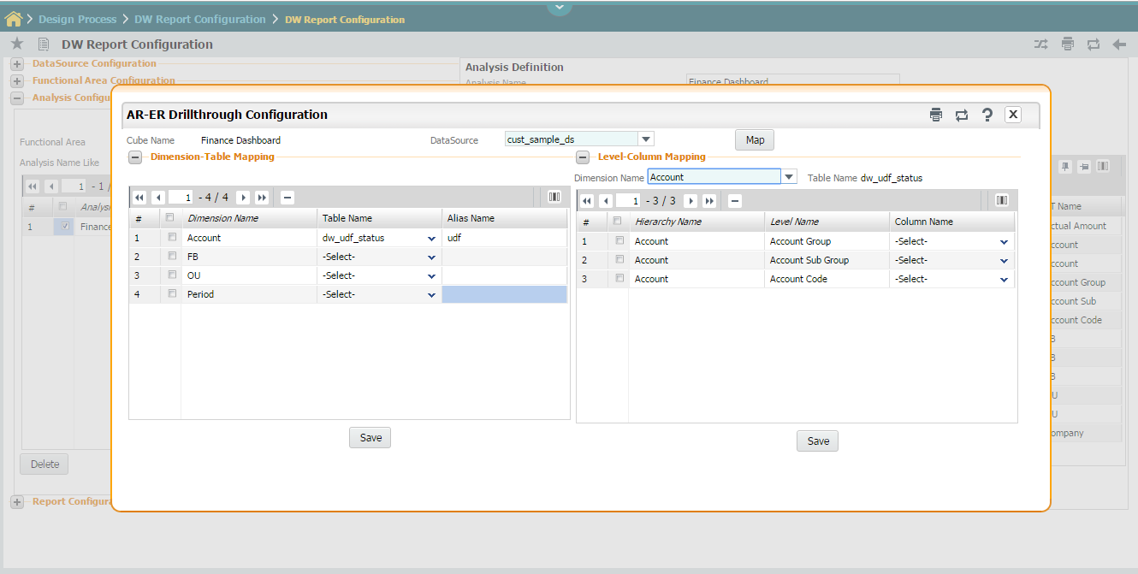

Select data source from the combo box and map to the particular cube.

Click MAP Button.

Once the data source is mapped to a cube the user have to map the dimension or level to the relevant table /column name in the ER data source, which is mapped (linked).

This will help in passing the linked parameters for a particular dimension and fetch the relevant data in the linked drill through report during designing the report (in runtime).

The following details are displayed in the multiline below:

***Data source*** Specifies the data source in which ER reports are available.

Dimension Name The name of the dimension to which the table needs to be mapped. If the shared dimension attribute is enabled a for a dimension, then the drill through mapping definition for the dimension will be a onetime definition and it need not be

Repeated across cubes or functional areas (This is applicable if same data source is selected).

Hierarchy / Level Name The hierarchy / level of the dimension. For example, for the “Account” dimension, the level is “Account Group”.

Table / Column Name Select the table that needs to be mapped with the dimension from the drop-down list box. The entire columns of the table of the data source is displayed as options.

Table Alias Name The alternative name for the table. You can edit the alias name.

Click Save Button to save the Drill through Details.

# 3. Package Reports

**Overview**

This option allows you to export Enterprise Report/ advanced Report from Report Configuration. The details are stored in the specified location which can be later retrieved by Importing them back to RDW through the Import to RDW option.

Click the Export button to export the required report.

The selected object data is stored as a (.zip) file in the specified folder.

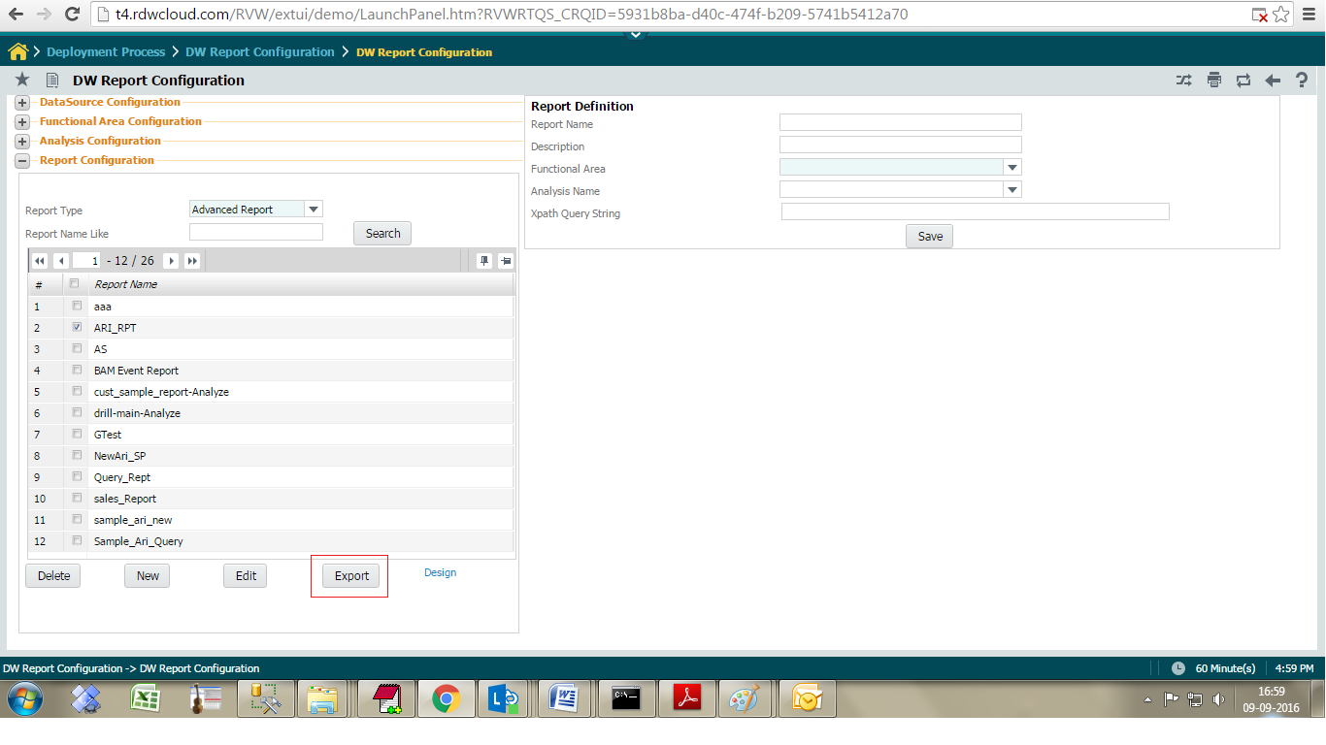

# 4. Deploy Reports

## Import to componentized RDW

**Enterprise report:**

Copy and paste .xml and jasper into target server. Execute the .sql script in RDW database.

Copy image file and paste into the target server report files path.

**Advanced Report:**

Execute the backend script RDW database.

## Import to Classic RDW

**Select the Import to RDW option from the Administer menu.**

The system displays the Import to RDW page.

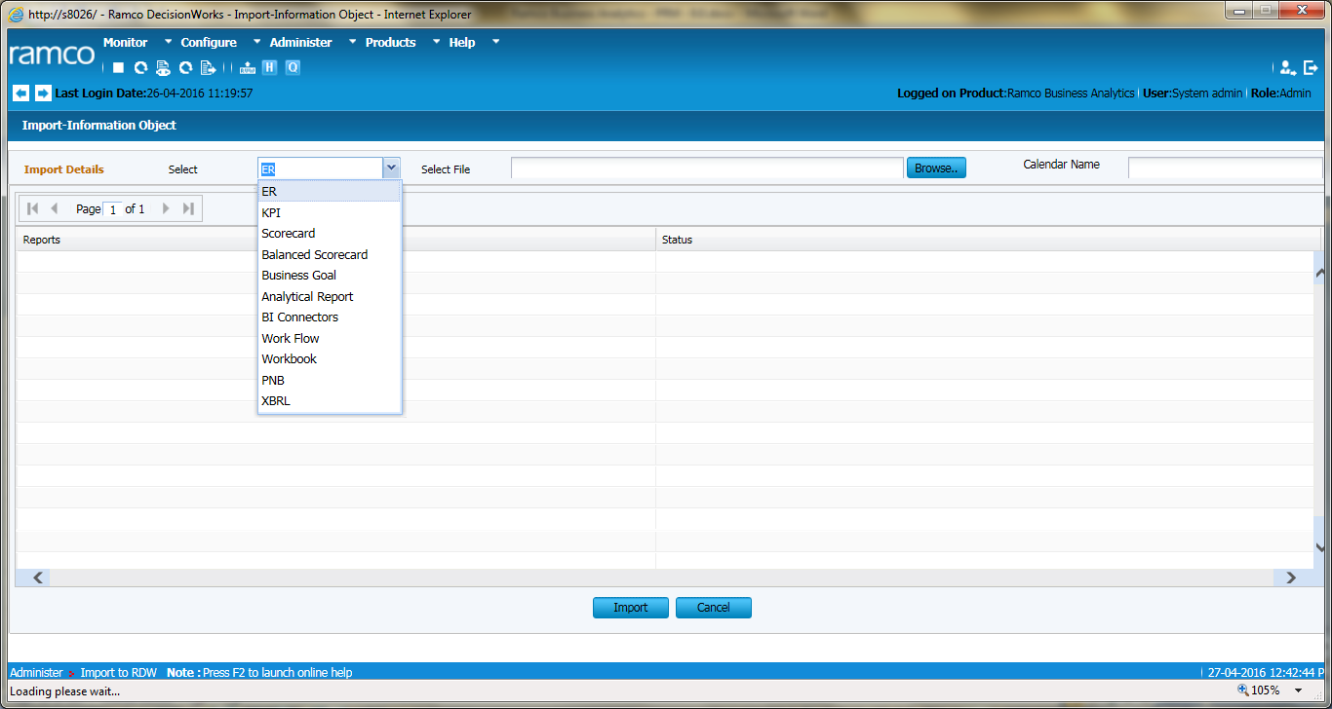

Enter the following details:

Object Type Select the object type from the drop-down list box. E.g. “ER” or “Analytical Report” etc.

Import to folder Enter the path of the file that you want to import. Click the Browse button to select the file.

Click the Import button to import the specified file.

The system imports the contents of the specified file into RDW.

Click the Cancel button to cancel the changes made.

# 5. Security

## Specify Report Permissions

This UI allows the admin user to specify the permissions for reports in two different ways as mentioned below.

* Select single Role/User-Role and provide permission to multiple reports.
* Select single Report and provide permission to multiple Roles/Users-Roles.

The reports mapped to the Role/User-Role only will be listed on ***Manage Reports*** UI to view it and on ***Manage Schedule*** UI to schedule it.

The UI can be launched with the menu sequence as follows.



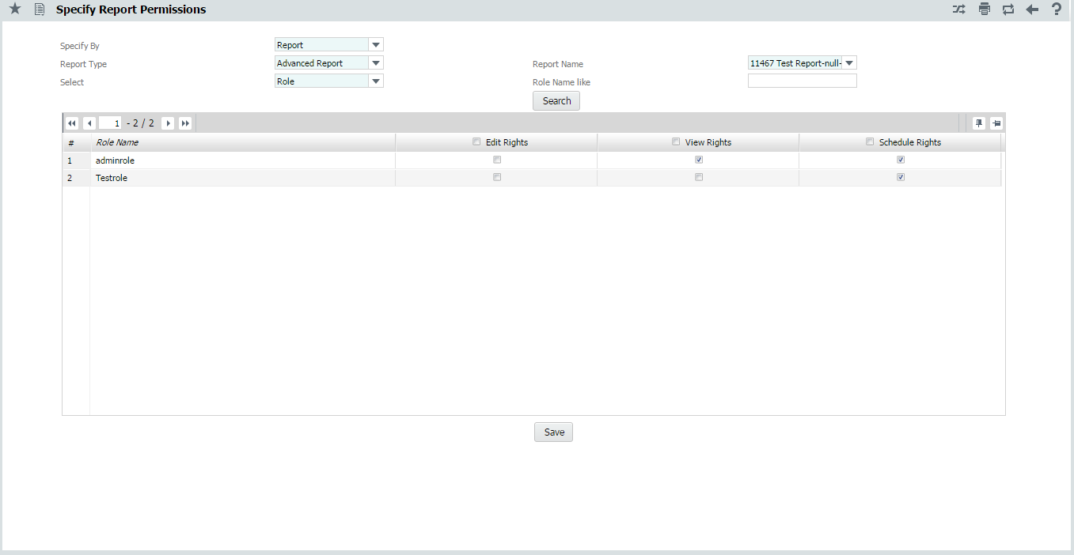

**Map Multiple Roles to Report:**

Select the following fields to search the list of Roles:

***Specify By*** Select Report.

***Report Type*** Select the Report Type.

***Report Name*** Select the Report Name.

***Select*** Select the Role.

***Role Name Like*** Specify the filter value to fetch the list of Roles. You can use wild card characters such as "%" along with a few letters to search more efficiently.

The system displays the list of Roles with the specified permissions as follows.

#### Role Name List the Roles.

#### Edit Rights Enabled if Edit Rights provided.

#### View Rights Enabled if View Rights provided.

#### Schedule Rights Enabled if Schedule Rights provided.

Click the **SAVE** button to save the permissions specified.





**Map Multiple Users-Roles to Report:**

Select the following fields to search the list of Roles:

***Specify By*** Select Report.

***Report Type*** Select the Report Type.

***Report Name*** Select the Report Name.

***Select*** Select the User.

***User Name Like*** Specify the filter value to fetch the list of Users. You can use wild card characters such as "%" along with a few letters to search more efficiently.

***Role Name Like*** Specify the filter value to fetch the list of Roles. You can use wild card characters such as "%" along with a few letters to search more efficiently.

#### The system displays the list of Users/Roles with the specified permissions as follows.

#### User Name List the Users.

#### Role Name List the Roles.

#### Edit Rights Enabled if Edit Rights provided.

#### View Rights Enabled if View Rights provided.

#### Schedule Rights Enabled if Schedule Rights provided.

Click the **SAVE** button to save the permissions specified.





**Map Multiple Reports to User-Role:**

Select the following fields to search the list of Roles:

***Specify By*** Select User.

***User Name*** Select the User Name.

***Role Name*** Select the Role Name.

***Report Type*** Select the Report Type.

***Report Name Like*** Specify the filter value to fetch the list of Reports. You can use wild card characters such as "%" along with a few letters to search more efficiently.

#### The system displays the list of reports with the specified permissions as follows.

#### Report Name List the Reports.

#### Edit Rights Enabled if Edit Rights provided.

#### View Rights Enabled if View Rights provided.

#### Schedule Rights Enabled if Schedule Rights provided.

Click the **SAVE** button to save the permissions specified.





**Map Multiple Reports to Role:**

Select the following fields to search the list of Roles:

***Specify By*** Select Role.

***Role Name*** Select the Role Name.

***Report Type*** Select the Report Type.

***Report Name Like*** Specify the filter value to fetch the list of Reports. You can use wild card characters such as "%" along with a few letters to search more efficiently.

#### The system displays the list of reports with the specified permissions as follows.

#### Report Name List the Reports.

#### Edit Rights Enabled if Edit Rights provided.

#### View Rights Enabled if View Rights provided.

#### Schedule Rights Enabled if Schedule Rights provided.

Click the **SAVE** button to save the permissions specified.





## Specify Data Security

This UI allows the admin user to specify the permissions to the Dimensions and Measures at role/user-role levels. The role level security permissions are applicable to all users mapped to the role only when security mappings doesn’t exist for that entity at user-role level, when the user level security mappings exist for an entity it takes precedence.

The UI can be launched with the menu sequence as follows.



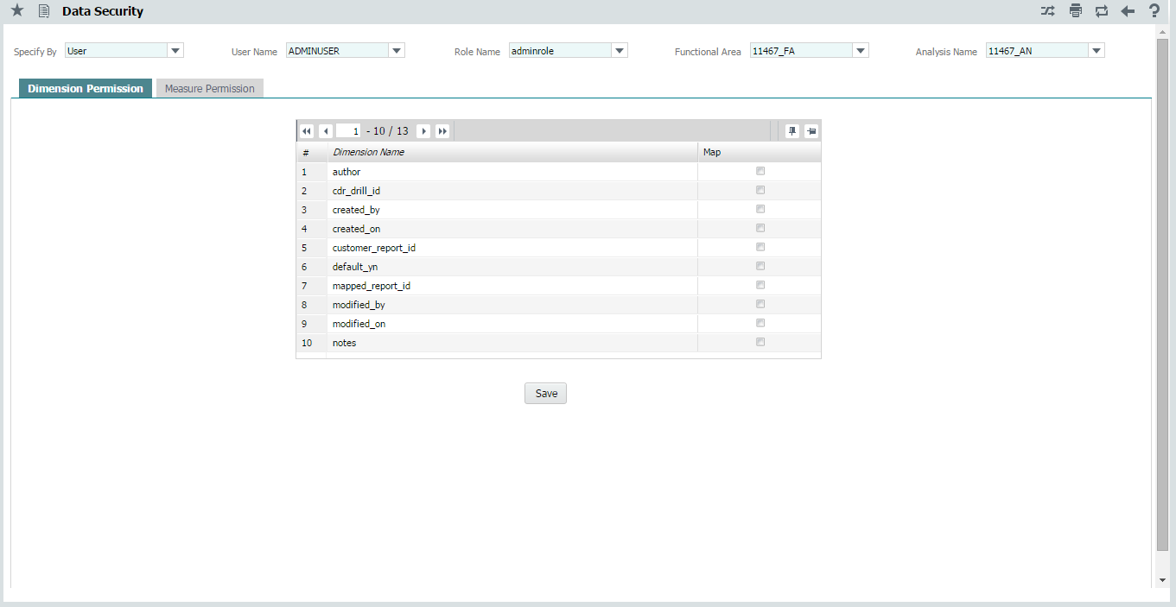

Select the following fields to search for permission provided at dimension level:

***Specify By*** Select the level (User/Role) to specify the permission.

***User Name*** Select the User Name.

***Role Name*** Select the Role when Role is selected on *Specify By* or Role associated to the selected User when User is selected on *Specify By*.

Select the Role when Role is selected on Specify By.

***Functional Area*** Select the Functional Area.

***Analysis Name*** Select the Analysis Name for the selected Functional Area.

## Advanced Reports

**Dimension Permission:**

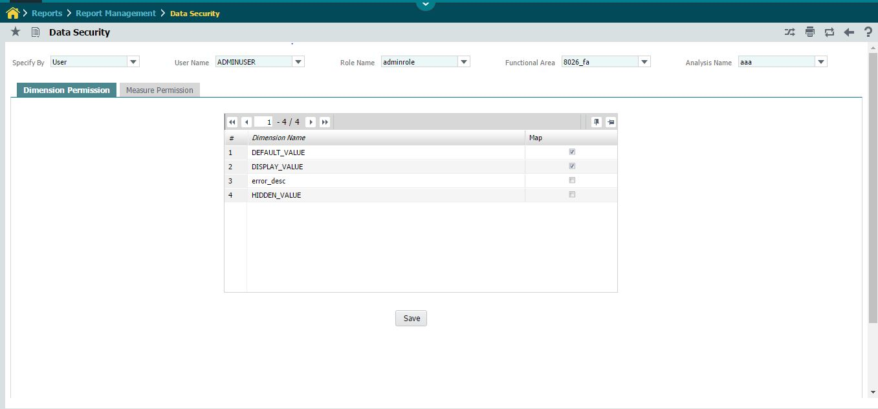

The system displays the list of dimensions with the specified permissions for each dimension as follows.

***Dimension Name*** Dimensions available under the selected Functional Area - Analysis Name.

***Map***  Permission specified for the selected Role/User-Role level.

Select the Dimensions through checkbox and click the **SAVE** button to save the dimensions permissions for the selected Role/User-Role level.

**Measure Permission:**

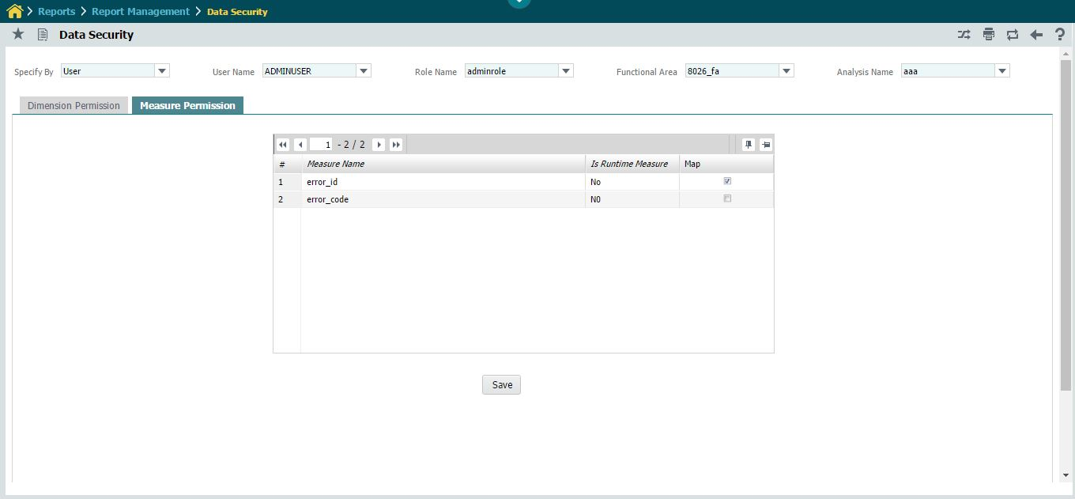

The system displays the list of measures with the specified permissions for each measure as follows.

***Measure Name*** Measure available under the selected Functional Area - Analysis Name.

***Is Runtime Measure*** Type of the measure.

***Map***  Permission specified for the selected User & Role.

Click the **SAVE** button to save the measure permissions for the selected Role/User-Role level.

**Analytical Reports**

**Dimension Permission:**

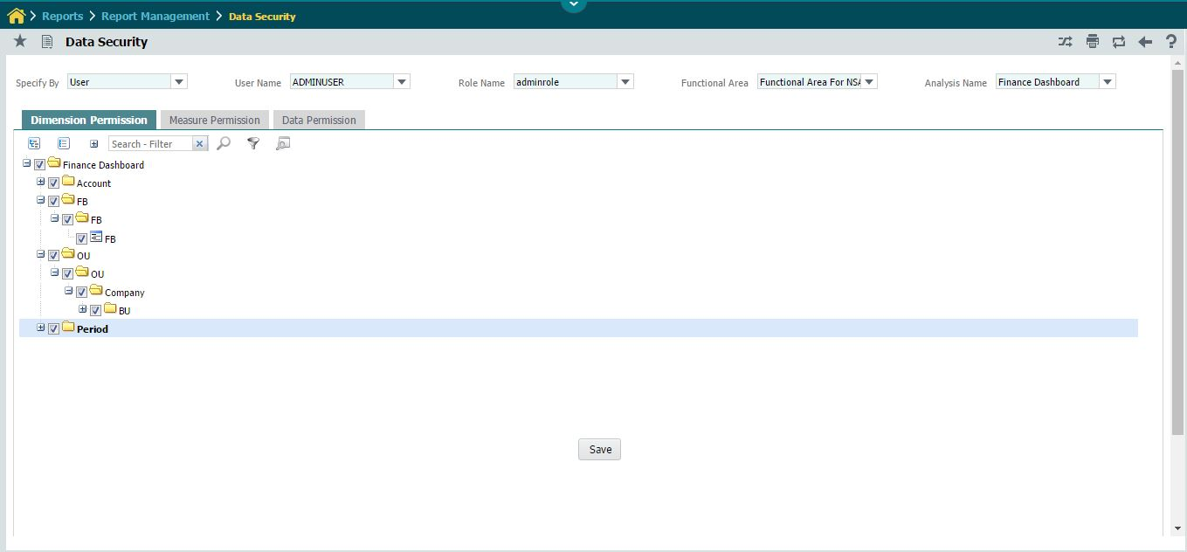

The system displays the list of dimensions with the specified permissions as follows.

***Tree*** Dimensions and their Hierarchy available under the selected Functional Area - Analysis Name.

***Check box*** Permission specified for the selected Role/User-Role level.

Click the **SAVE** button to save the permissions of dimensions, hierarchy and their levels for the selected Role/User-Role level.

**Measure Permission:**

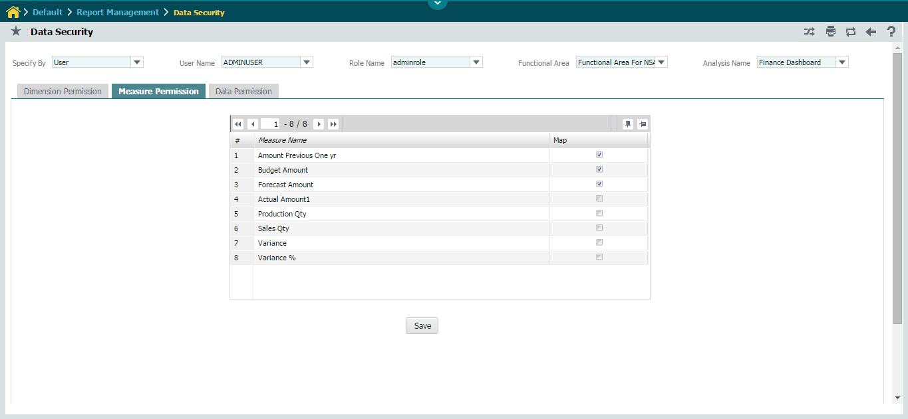

The system displays the list of measures with the specified permissions for each measure as follows.

***Measure Name*** Measure available under the selected Functional Area - Analysis Name.

***Map***  Permission specified for the selected User & Role.

Click the **SAVE** button to save the measure permissions for the selected Role/User-Role level.

**Data Permission:**

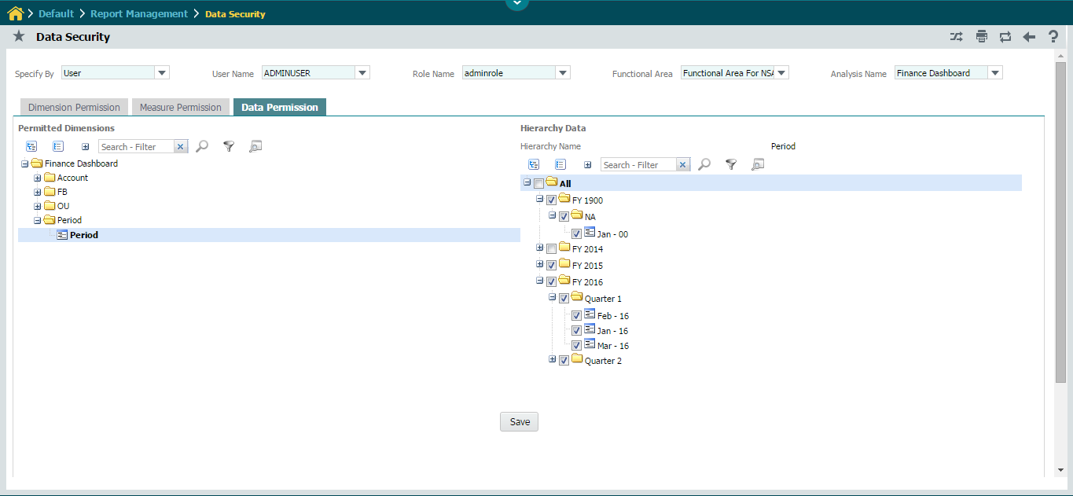

The system displays the list of permitted Dimensions - Hierarchy and Data of a selected Hierarchy with the specified permissions as follows.

**Permitted Dimensions**

***Tree*** Permitted Dimensions - Hierarchy available under the selected Functional Area - Analysis Name.

Click on respective hierarchy to display the ***DATA PERMISSIONS*** for the selected Role/User-Role level.

**Hierarchy Data**

***Hierarchy name*** Selected Hierarchy name.

***Tree*** Data of the selected Functional Area - Analysis Name - Hierarchy.

***Check box*** Permission specified for the selected User & Role.

Click the **SAVE** button to save the Data levels for the selected Role/User-Role level.

# 6. Manage Reports

This UI list the reports mapped to the currently logged in user based on search criteria among which the user can choose a report to view it.

The UI can be launched with the menu sequence as follows.



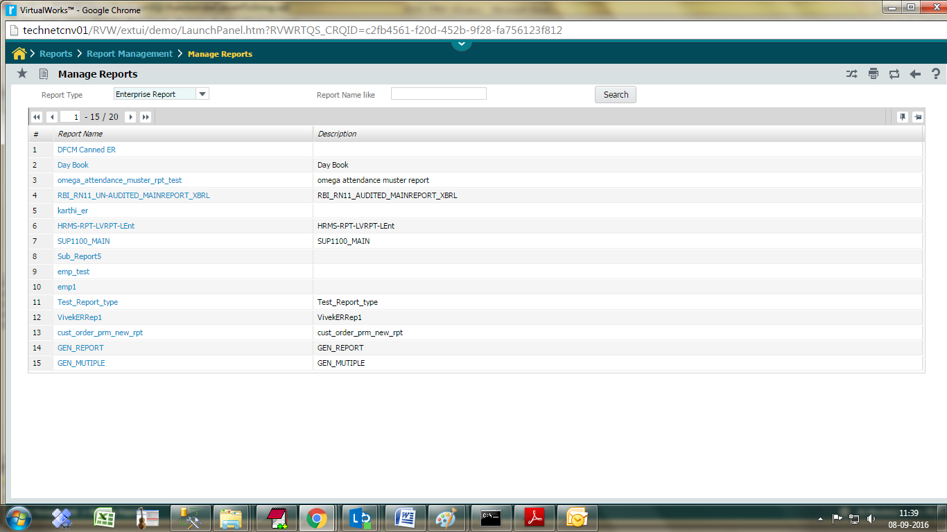

Enter the following fields to search for a report:

***Report Type*** Select the type of the report.

***Report Name Like*** Specify the filter value to fetch the list of Reports. You can use wild card characters such as "%" along with a few letters to search more efficiently.

Click the Search button to list the Reports.

The system displays the report matching your search criteria below.

***Report Name*** A unique name that identifies the report. Click the Report Name to launch the Designers/Viewers.

***Description***  The description of the report.

Click ***Report Name*** column to launch the designer/viewer corresponding to the report type as follows,

#### Enterprise Report – Enterprise Report Viewer UI will be launched.

#### Advanced/Analytical Report – Corresponding report designer will be launched

### Enterprise Report Viewer:

This UI list the parameters for the users to specify value for parameters and view it, and personalize the reports. And the UI launches in different mode, as mentioned below, depending upon the value specified for ***Generate Parameters*** UI under ***Report Configuration*** UI.

**1 .Generate Parameters Option** – Disabled:

The parameters will be listed in a multiline and the end-user have to specify the values in the second column against the parameters.

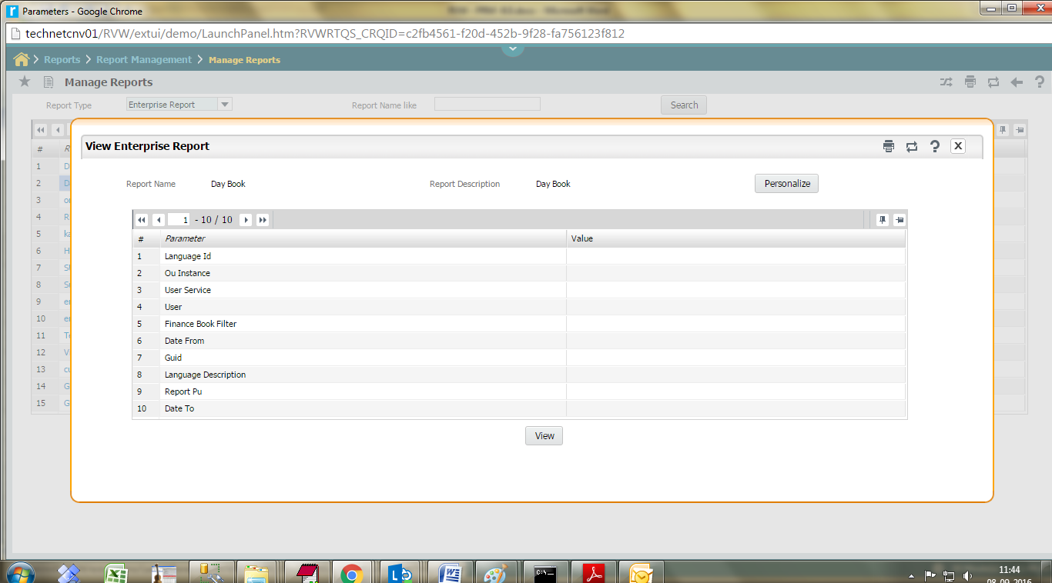

The following details are displayed:

Parameter The name of the parameter (for example: Product Name).

Value The value of the parameter (for example: Mercedes Benz).

Personalize personalize the parameter values.

**Click the View button.**

The system launches the Report page in PDF file format.

**2.Generate Parameters Option** – Enabled:

New Control will be created for each parameter with the control properties specified in ***Generate Parameters*** UI under ***Report Configuration*** UI.

The system launches the following parameter page if generate option is chosen in advanced options ER designer.

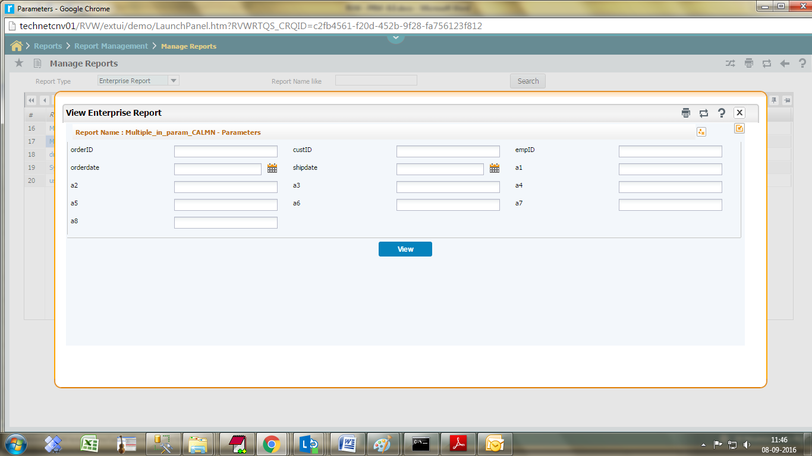

### Report Personalization:

Report personalization is to save the value of report’s input parameters against the currently logged in User-Role context, these personalized values will be applied for the subsequent report generation for this User-Role context.

When the Generate Parameters option is disabled, the UI is launched as shown below.

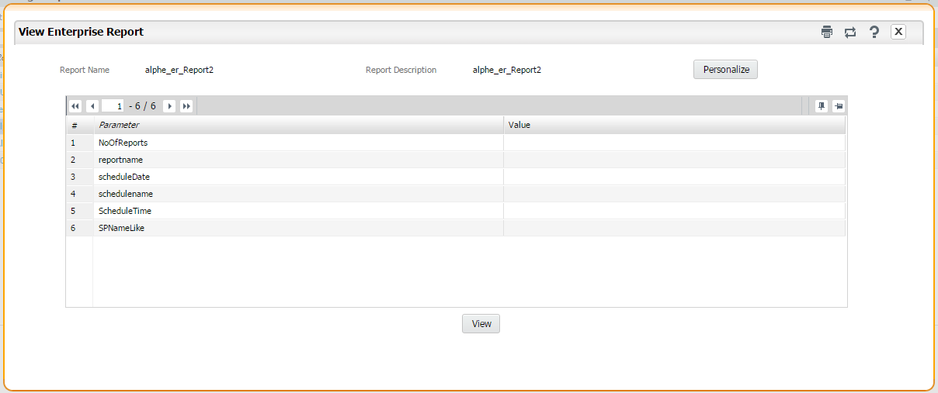

The System displays the parameter details as follows,

Parameter List the parameters in a multiline.

Value Specify the value for the parameters.

On Click of **View** button, the system launches the report page in the default file format specified. On Click of **Personalize** the report parameter values will be personalized for the currently logged in user and role.

When the Generate Parameters option is enabled, the UI is launched as shown below.



The System displays the parameter details as follows,

Controls Displays control for each parameter.

Value Specify the value for the controls.

On Click of **View** button, the system launches the report page in the default file format specified. On Click of icon the report parameter values will be personalized for the currently logged in user and role.

### Advanced Report Designer:

The selected Advanced Report will be launched in the report designer.

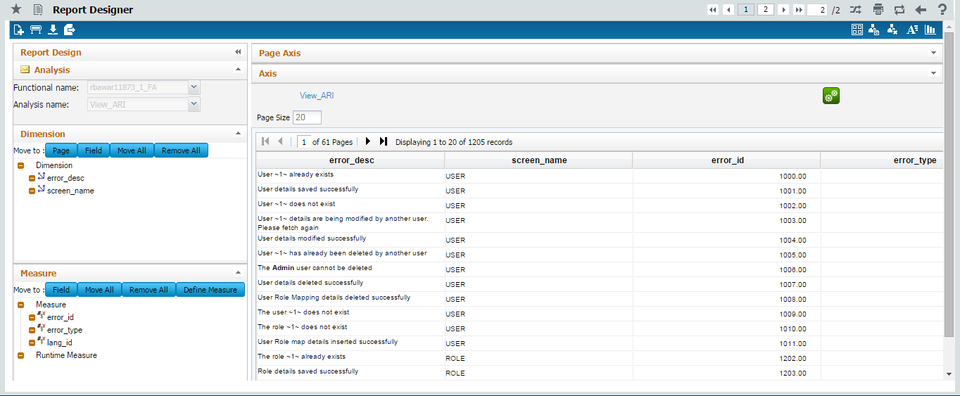

### Analytical Report Designer:

The selected Analytical Report will be launched in the report designer.

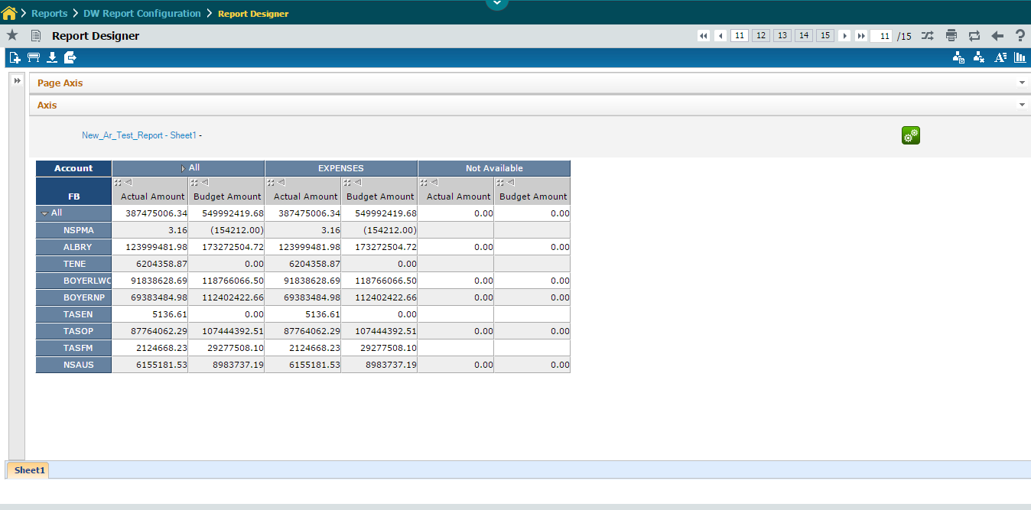

# 7. Schedule Report

## Manage Schedule

This UI list the schedules available for the selected report. The UI can be launched with the menu sequence as follows.



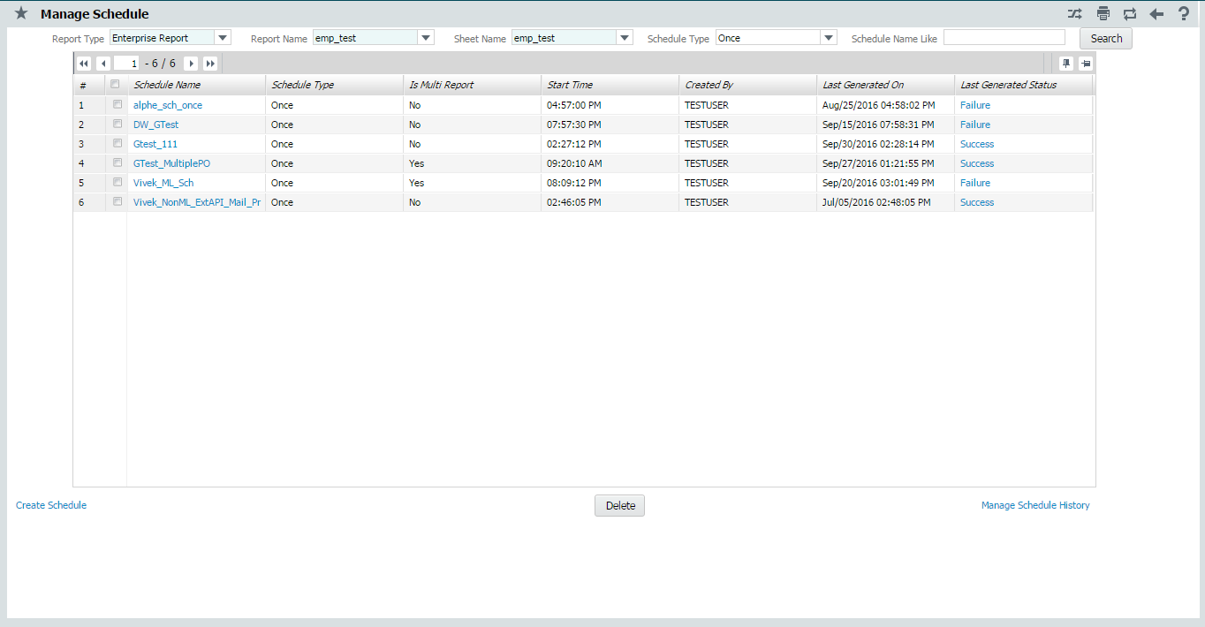

Enter the following fields to search for a report:

***Report Type*** Select the report type.

***Report Name*** Select the report name.

***Sheet Name*** Select the sheet name.

***Schedule Type*** Select the type of schedule.

***Schedule Name Like*** Specify the filter value to fetch the list of Schedule Name. You can use wild card characters such as "%" along with a few letters to search more efficiently.

Click the Search button to list the Schedules.

The system displays the schedules matching your search criteria below.

***Schedule Name*** A unique name that identifies the schedule. Click the Schedule Name to modify the schedule properties.

***Schedule Type***  The type of Schedule.

***Is Multi Report***  Displays Yes for Multiple BO and No for Single BO.

***Start Time***  Time to start executing the Schedule.

***Created By***  The user by whom the schedule is created.

***Last Generated On*** Date and Time of last run of Schedule.

***Last Generated Status*** Status (Success/Failure) of last run Schedule. On Click, View Schedule Status UI will be launched to see all the Scheduled instances with a detailed report.

Select a Schedule and click the **DELETE** button to remove a specific schedule instance.

#### Links:

#### Manage Schedule History - Launches the History Clearance Schedule UI.

#### Create Schedule - Launches the Schedule Report UI in Create mode.

#### Report Name Column - Launches the Schedule Report UI in Modify mode.

#### Last Generation Status Column - Launches the View Schedule Status UI.

### History Clearance Schedule:

This UI allows end-user to create a schedule to clear the generated report files and delete the clearance scheduler. The Clearance can be scheduled Daily/Weekly/Monthly/Once with specifying No of Days to retain the generated reports.

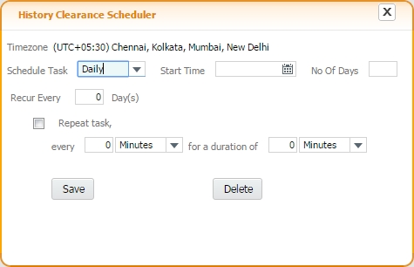

## Schedule Report

#### This UI creates a new schedule\modify the existing schedule depending upon the launching mode.

#### 

#### Enter the details for the following sections.

***Basic Schedule Details***  Specify the Schedule Name, Report Format Type, Multi Report, Output File Name and Stored Procedure Name for generating the reports.

***Scheduler*** Specify the Schedule Type, Start Time, Recur Duration, Repeat Interval, Repeat Duration, Days of the Week, Months, etc. for scheduling the report generation.

***User-Service Preferences*** Specify preferred User, Role, OU and Report Description to execute the schedule for a Service based Report.

***Printer Settings*** Specify the Local/Network/Google Cloud Printer details to schedule printing. Also settings can be configured to retrieve the details from external interface.

***FTP Settings*** Specify the FTP Server URL, Login Mode, User Id, Password, Key File Path, Directory Path to copy the generated report file.

***Mail Configuration*** Specify the mailing addresses or click  icon to launch the **Help on User** UI and fetch the mailing addresses, subject and body content to whom the generated report file to be mailed. Also settings can be configured to retrieve the details from external interface.

***SP Parameters*** Specify the values for the parameters listed.

Click the **SAVE** button to create/modify the schedule.

### Multiple Report generation

#### Users can choose Is multiple Report Yes,

#### This UI creates a multiple report instance for new schedule\modify the existing schedule depending upon the launching mode.

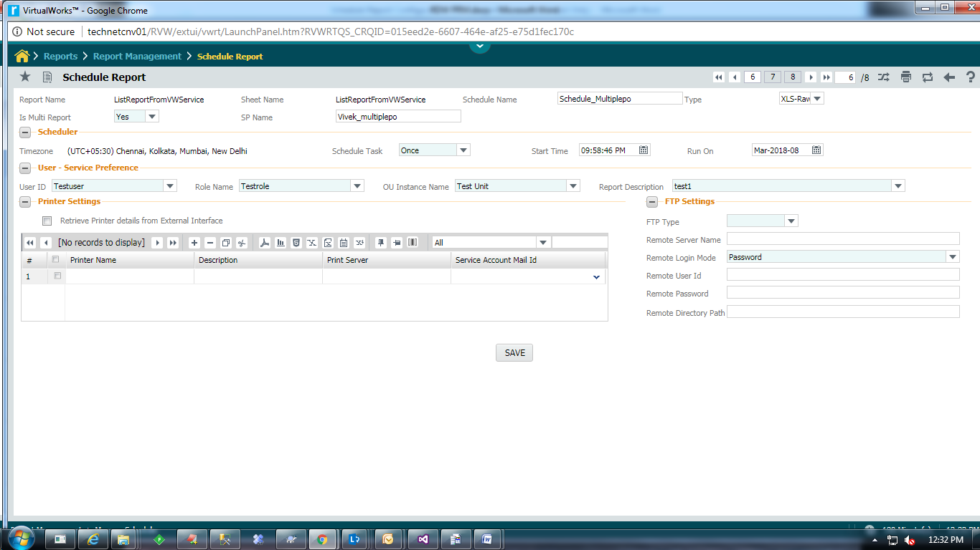

#### Enter the detail for following sections

***SP Name*** the user has to create a stored procedure, through which the different set of parameters has to send.

Parameter configuration, mail configuration, FTP settings and printer settings is not required to define in screen for multiple report generation. All this information taken from result set return from attached stored procedure.

The stored procedure’s input parameters name, number and order should be as follows:

CREATE PROCEDURE <<PROCEDURE_NAME>>

(

@a_i_lang_id integer ,

@a_s_user_id nvarchar(20),

@a_s_role_name nvarchar(100) ,

@a_n_ou_id numeric(10) ,

@a_s_ou_name nvarchar(100) ,

@a_n_report_id numeric(10) ,

@a_s_report_name nvarchar(200) ,

@a_s_instance_name nvarchar(200) ,

@a_s_rpt_in_params ntext,

@a_n_errorid numeric(10) output,

@a_i_apperrortype integer output,

@a_s_error_desc nvarchar(2000) output

)

as

begin

Declare @l_n_XMLDoc XML

Declare @xml XML

set @l_n_XMLDoc = cast(@a_s_rpt_in_params as xml)

set @xml=@l_n_XMLDoc

select 'File1' AS REPORT_OUTPUT_FILENAME ,

'' as FROM_USER_ID,

'' AS TO_USER_IDS ,

'' AS CC_USER_IDS ,

'' AS BCC_USER_IDS ,

'Sample SP' AS MAIL_SUBJECT,

'Hi,#N# Enclosed herewith Multiple report generation . Refer attached document for details.#N# Regards,#N# team' AS MAIL_DESCRIPTION ,

'\\technetcnv01\Share\Akila' as COPY_TO_FOLDER,

'Y' as ZIPPED_OUTPUT,

'Y' as ZIP_RPT_PWD_YN,

'' as ZIP_RPT_PWD,

'B0Trd92iiwbG2pZE0AnqIQ==' as RPT_PWD,

'all' AS 'Country'

end

* Sample Stored Procedure Output Result set for the above table should be as follows:

<RECORDSET>

<ROW>

<REPORT_OUTPUT_FILENAME/>

<TO_USER_IDS/>

<CC_USER_IDS/>

<BCC_USER_IDS/>

<MAIL_SUBJECT/>

<MAIL_DESCRIPTION/>

<PRINTER_NAME/>

<PRINTER_DESC/>

<PRINT_SERVER_IP/>

<SERVICE_ACCOUNT_EMAIL_ID/>

<FILE_NAME_PERSIST/>

<FTP_TYPE/>

<REMOTE_SERVER/>

<REMOTE_LOGIN_MODE/>

<REMOTE_LOGIN_USER/>

<REMOTE_LOGIN_PWD/>

<REMOTE_DIRECTORY/>

<COPY_TO_FOLDER/>

<ZIPPED_OUTPUT/>

<ZIP_RPT_PWD_YN/>

<ZIP_RPT_PWD/>

< RPT_PWD/>

<Supplier_Code />

<Supplier_Name />

<Product_Code />

</ROW>

<ROW>

<REPORT_OUTPUT_FILENAME />

<TO_USER_IDS/>

<CC_USER_IDS/>

<BCC_USER_IDS/>

<MAIL_SUBJECT/>

<MAIL_DESCRIPTION/>

<PRINTER_NAME/>

<PRINTER_DESC/>

<PRINT_SERVER_IP/>

<SERVICE_ACCOUNT_EMAIL_ID/>

<FILE_NAME_PERSIST/>

<FTP_TYPE/>

<REMOTE_SERVER/>

<REMOTE_LOGIN_MODE/>

<REMOTE_LOGIN_USER/>

<REMOTE_LOGIN_PWD/>

<REMOTE_DIRECTORY/>

<COPY_TO_FOLDER/>

<ZIPPED_OUTPUT/>

<ZIP_RPT_PWD_YN/>

<ZIP_RPT_PWD/>

< RPT_PWD/>

<Supplier_Code/>

<Supplier_Name/>

<Product_Code/>

</ROW>

</RECORDSET>

|  |  |  |  |
| --- | --- | --- | --- |
| S. No | Name | Mandatory | Description |
| 1 | REPORT_OUTPUT_FILENAME | N | Mail attachment file name |
| 2 | TO_USER_IDS | Y | To Mail ID. Multiple Mail ID’s should be separated by semicolon (;) |
| 3 | CC_USER_IDS | N | Cc Mail ID. Multiple Mail ID’s should be separated by semicolon (;) |
| 4 | BCC_USER_IDS | N | BCC Mail ID. Multiple Mail ID’s should be separated by semicolon (;) |
| 5 | MAIL_SUBJECT | N | Mail subject |
| 6 | MAIL_DESCRIPTION | N | Mail body description |
| 7 | PRINTER_NAME | N | Printer name that is added in google cloud print/Print server configure printer name |
| 8 | PRINTER_DESC | N | Provide description for Printer |
| 9 | PRINT_SERVER_IP | N | Print server IP / Name |
| 10 | SERVICE_ACCOUNT_EMAIL_ID | N | Google service account email id |
| 11 | FILE_NAME_PERSIST | N | The value is **“N”** means REPORT_OUTPUT_FILENAME added with Time Stamp. “**Y”** mean without add timestamp. |
| 12 | FTP_TYPE | N | The type of transfer protocol. The possible values are FTP / SFTP. |
| 13 | REMOTE_SERVER | N | IP Address of the Remote FTP/SFTP Server (Ex: 172.16.10.5) |
| 14 | REMOTE_LOGIN_MODE | N | Possible Values are Password/ Key. Key based authentication is currently enabled only for SFTP type. |
| 15 | REMOTE_LOGIN_USER | N | User Id to be used to login in to the Remote FTP/SFTP Server. |
| 16 | REMOTE_LOGIN_PWD | N | Password to be used for logging in to the Remote FTP/SFTP Server |
| 17 | REMOTE_DIRECTORY | N | Remote Folder Path. (Ex: /root/TestDir/) |
| 18 | COPY_TO_FOLDER | N | share path for save Generated report file |
| 19 | ZIPPED_OUTPUT | N | Generated output will compress into zip. Default value ‘N’. If ZIPPED_OUTPUT is ‘Y’ report will compressed into zip format. |
| 20 | ZIP_RPT_PWD_YN | N | ‘N’ is Default value. ‘Y’ means report should be password protected. |
| 21 | ZIP_RPT_PWD | N | Give Password for zip file. The flag ‘ZIP_RPT_PWD_YN’ must be ‘Y’. Value must be Encrypted. |
| 20 | RPT_PWD | N | ‘N’ is Default value. ‘Y’ means report should be password protected.PDF output type only supports. Value must be Encrypted. |

The elements in the above table are constant.

And, <Supplier_Code />, <Supplier_Name /> and <Product_Code /> are the report input parameters. These elements may vary number wise and name wise for report to report.

**Note:**

In case both ZIP_RPT_PWD, RPT_PWD contains value then RPT_PWD should take high priority.

### Help On User:

This UI list the available users, from deployment database, based on the search criteria from which the end-user can choose the required users which will be created as a comma separated list.

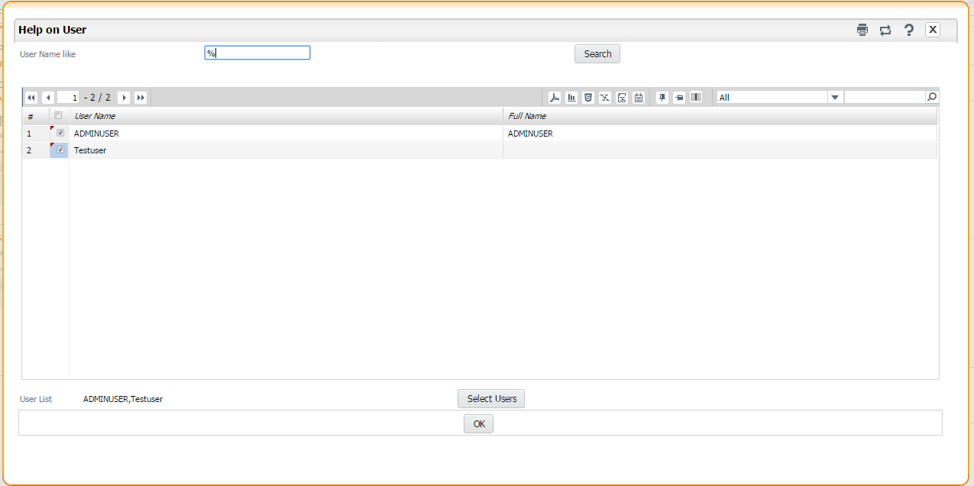

Enter the following fields to search for users:

***User Name Like*** Specify the filter value to fetch the list of Users. You can use wild card characters such as "%" along with a few letters to search more efficiently.

Click the Search button to list the users.

The system displays the users matching your search criteria as follows,

***User Name*** A unique name that identifies the User.

***Full Name***  Full Name of the User.

Select the users and click ***Select Users*** button to append selected users to the ***User List***. On click of ***OK*** button, the ***User List*** will be transferred back to the parent UI.

### View Schedule Status:

This UI lists status with a detailed report of all the executed instances of a specific schedule.

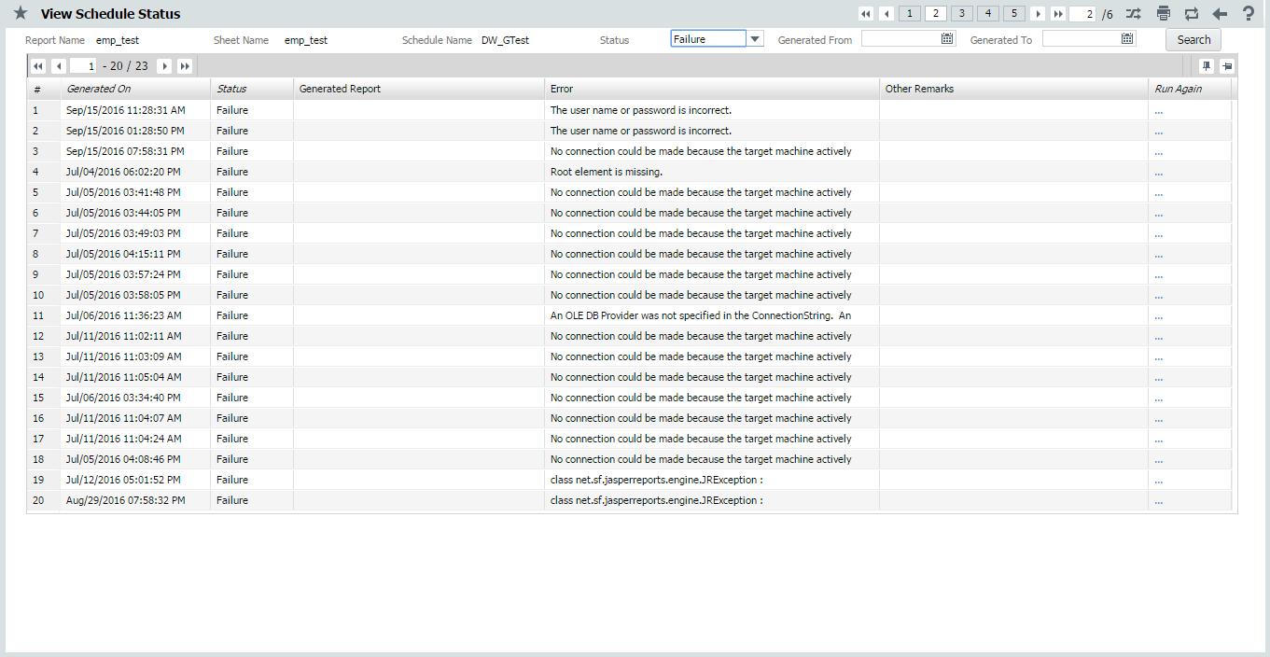

Enter the following fields to search for the status report of a schedule:

***Report Name*** Selected report name.

***Sheet Name*** Selected sheet name.

***Schedule Name*** Selected schedule name.

***Status*** Select the Status.

***Generated From*** Specify the Start Date of the executed instance.

***Generated To*** Specify the Date till the instance got executed.

Click the Search button.

The system displays the schedule status matching your search criteria as follows,

***Generated On*** The Date on which the schedule instance have been executed.

***Status***  Status of the execution (Success/Failure).

***Generated Report*** Generated Report file will be listed for download, in case of execution is success.

***Error*** Displays error information in case of execution failure.

***Other Remarks*** Log information collected during the execution will be listed.

***Run Again*** A link is listed to launch the Re-Run window, in case of execution failure.

### Re-Run Schedule:

Specify the values for the parameter and click **Run Again** button to execute the schedule instance once again. The schedule will get started executed with a 2 minutes delay time.

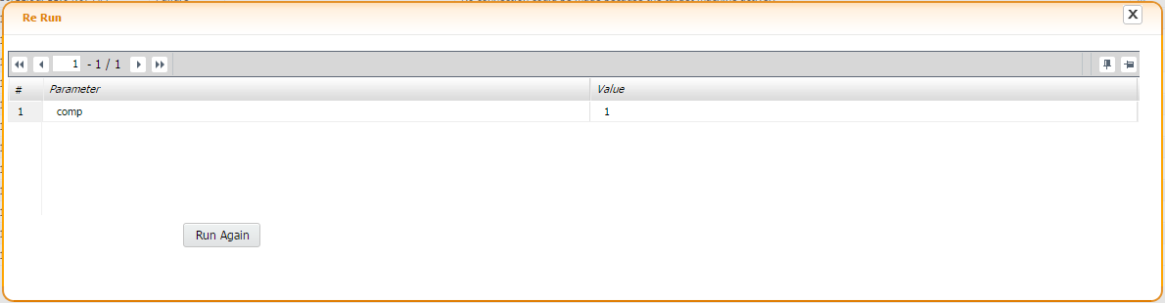

## View Schedule

#### This UI is provided for the end-users who will have permissions only to view/re-run a schedule and does not have permission to create a new schedule or modifying an existing one. The UI can be launched with the menu sequence as follows.

#### 

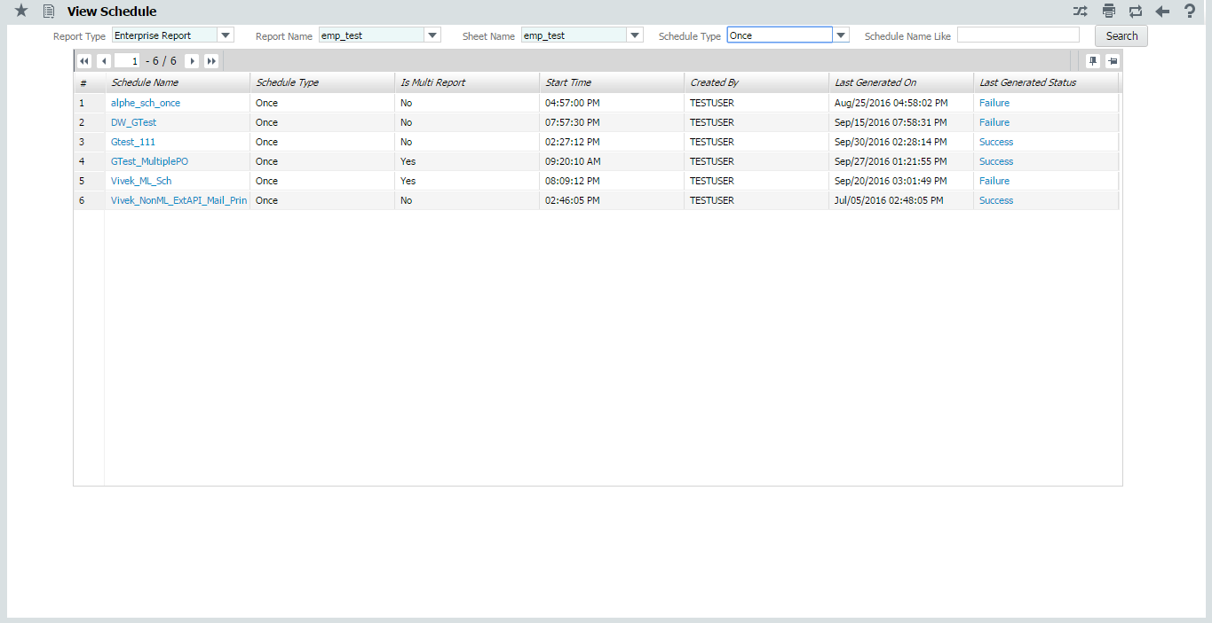

Enter the following fields to search for a report:

***Report Type*** Select the report type.

***Report Name*** Select the report name.

***Sheet Name*** Select the sheet name.

***Schedule Type*** Select the type of schedule.

***Schedule Name Like*** Specify the filter value to fetch the list of Schedule Name. You can use wild card characters such as "%" along with a few letters to search more efficiently.

Click the Search button to list the Schedules.

The system displays the schedules matching your search criteria below.

***Schedule Name*** A unique name that identifies the schedule. Click the Schedule Name to view the schedule properties.

***Schedule Type***  The type of Schedule.

***Is Multi Report***  Displays Yes for Multiple BO and No for Single BO.

***Start Time***  Time to start executing the Schedule.

***Created By***  The user by whom the schedule is created.

***Last Generated On*** Date and Time of last run of Schedule.

***Last Generated Status*** Status(Success/Failure) of last run Schedule. Click the status to launch **View Schedule Status** UI.